Government Degree College Ganderbal
Department of Islamic Studies

Attention UG 4th Sem (IS420) Students of Regular Batch 2022 and Backlog Batch 2016-19, Examination held in Sep-Oct 2022.

The below mentioned Roll no’s from GDC Ganderbal of UG 4th Sem (IS420) are absent in the examination already held in Sep-Oct 2022. If any student from the below mentioned Roll No’s claim that he/she has appeared in the said examination he/she is directed to mail on hodisgdc@gmail.com within 3 days i.e. by or before (11 February 2023) along with the proof of having appeared in examination of the said course. No claim whatsoever will be entertained after the same.

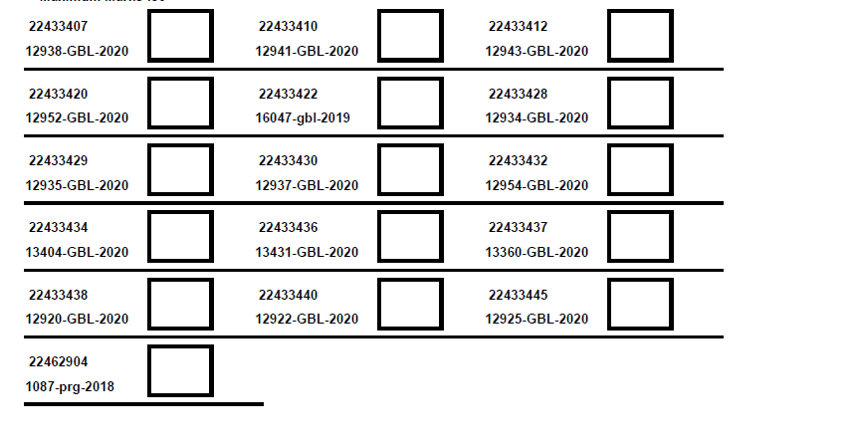

Sd/=

HOD Islamic Studies

