Extension activities:
GDC Ganderbal frequently conducts different programmes and activities pertaining to various different spheres in terms of impact and sensitising students to social issues and holistic development during the last five years.
2013-2014:
Celebration of World Environment Week:
The college organized World Environment Week from june 5 to june 11,2013 in which about 250 students participated in different activities like seminar, painting competition and cleanliness Drive.
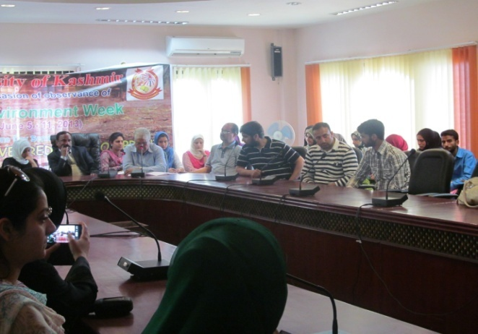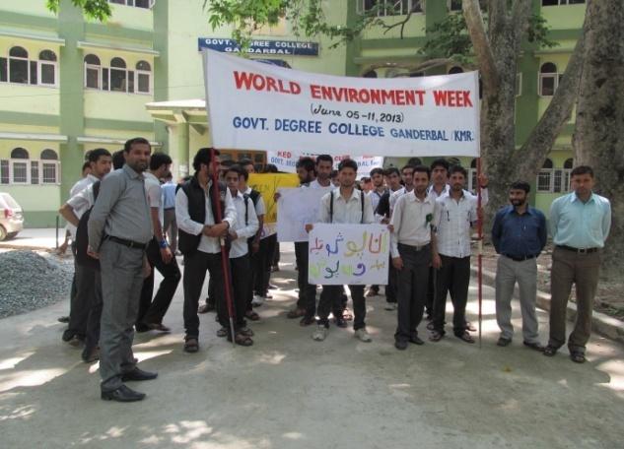
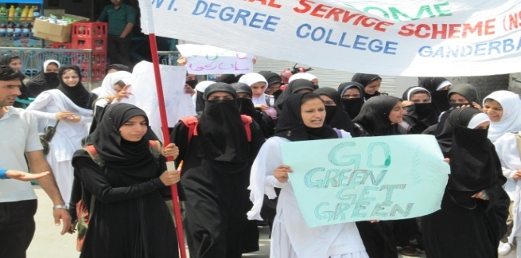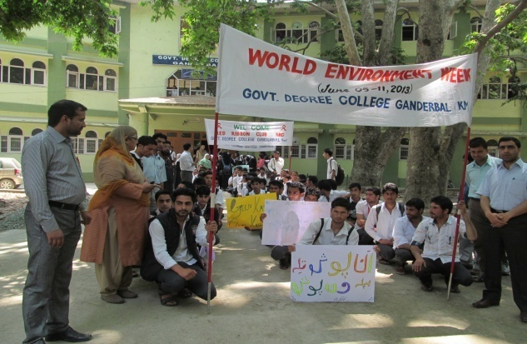
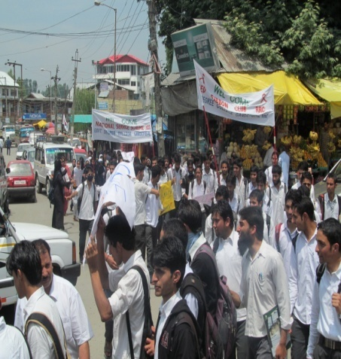
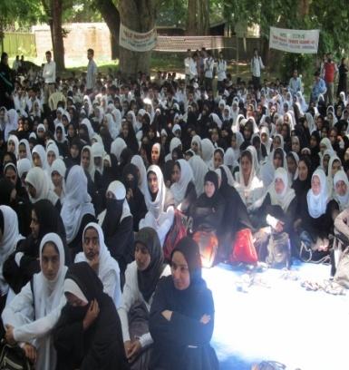

2014-2015:
One Day seminar on Free and Fair election- A Fundamental element of Healthy Democracy: 19th November 2014:
Elections are a central feature of democracy. For elections to express the will of the electorate, they must be free and fair which indeed helps in building a healthy democracy and a promising future for the Nation. In this perspective The college organized one day seminar in which students and teachers expressed their views about the topic. The worthy Principal of the college Prof. Nasreen Malik addressed the audience. Speaking on the occasion she said that a country cannot be truly democratic until its citizens have opportunity to choose their representatives through elections that are free and fair. She further added that ceratin civil liberties, such as freedom of speech, association and assembly are fundamentals of free and fair elections. About 65 students participated in the seminar and 20 students spoke on the occasion.
Celebration of World Aids day on 4th December, 2014.
“Prevention is better than cure, especially when something has no cure” and AIDS is an important component of that something which has no cure except death. To take a small step to fight this big menace, the Red Ribbon Club of the college celebrated World AIDS Day on the theme “HIV-AIDS-Scientific and religious perspective” to create wider awareness to masses and particularly to the younger generation. The worthy Principal of the college Prof. Nasreen Malik gave a welcome address and stressed upon the eradication of AIDS from the society. The Chief Guest of the function was Mr. Fayaz Ahmad Zaroo, Chairman Humsafar Marriage and counselling cell and Guest of Honour was Dr. Khursheed Ahmad Quirshi , SPM Department GMC Srinagar. Both of them gave illuminative lectures on the occasion. The powerpoint presentation gave by Dr. Khurshid Ahmad Quirshi was very informative. Almost 100 students from different streams participated in the seminar .Among which 13 students presented their views and were felicitated by the college administration.
Plantation Drive, 21st March, 2015:
Department of Botany organized plantation Drive on 21st March in which about 50 students teachers and locals participated. Later on, the participants were given saplings to plant them at home and spread the green message.
2015-2016:
One day Seminar on” Beti Bachao Beti Padho”( Save the girl child and educate the girl child) on 03-09-2015.
“Daughters spread happiness and joy in the home” To make the society to be blessed by this joy and be proud of a daughter, the college organized a seminar on the theme Beti Bachao Beti Padho to spread awareness among the local youth. The District Development Comissioner, Jenab Showkat Ajaz was the chief guest. While speaking on the occasion, Jenab Showkat Ajaz stressed that highlighting themes like this is the need of the hour and a son and a daughter are just like two eyes of a man. The Principal of the college Prof. Nasreen Malik highlighted the various aspects of the theme and stressed that girls should be protected, empowered and their rights should be given to them. About 65 students participated in the seminar and among which twenty students spoke their heart out on the occasion and were later felicitated by the college administration.

Principal addressing the audience on the seminar Beti Bachao Beti Padao on 03-09-2015.

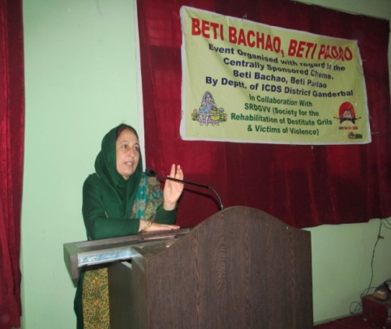

One Day seminar on Safai Nasf Imaan Hai on 19th October 2015:
“Cleanliness is next to Godliness’ This saying itself impresses upon the value of cleanliness and to bring its different aspects to surface the college organized one Day seminar in which about 45 students participated and highlighted the importance of cleanliness .

One day conference on: Global challenges to environment: “Social poltical and scientific Reforms”on 19-03-2016.

“Climate change you must not ignore or the future might be no more” The scary words of the quote itself reflect the essence of the awareness to be imparted in the society and be spread to far and wide to protect the earth from the climate change and its deadly consequences. To throw light on the topic and bring awareness about the consequences of climate change, the college organized one day conference Global challenges to environment: “Social poltical and scientific Reforms”. The conference broadly focussed on the present issues and challenges related to Global environment and its reforms. Prof. Yasmin Kawoos the worthy Principal of the college welcomed the guests and explained the purpose of the conference and shared the information on the present challenges to Environment and consequences thereof as felt across the world in the 21st Century. On this occasion the District Development Comissioner Ganderbal Jenab Showkat Ajaz Mir was the chief guest and Prof. (Dr.) B. A Ganie Director CORD University of Kashmir.Scholars and faculty members from different organizations presented their papers.
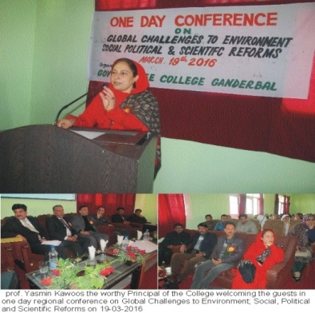
2016-2017:
One Day Regional Conference on Sustainable Development and Environmental issues in Jammu and Kashmir: Problems and Prospects on 20-03-2017.
Prof. (Dr) Yasmin Kawoos gave a welcome address and highlighted the significance of conducting such conferences in order to achieve excellence in sustainable Development in J & K. The welcome address was followed by a keynote address, presented by Prof. B. A Ganie, HOD Environmental Science, University of Kashmir who spoke about the management of ecosystems environment and water resources. The event was honoured by DC Ganderbal, Mr. Tariq Hussain Ganie who was the chief guest. Scholars and faculty members of different colleges presented their papers. The conference concluded with a vote of thanks.

Celebration of World No Tobacco Day, 31-05-2016.
“Each time you light a cigarette, it consumes the years of your life”. To help to save individuals from consuming their lives and transforming their years to smoke, the college celebrated World No tobacco Day and sensitised the students about multiple adverse effect of consuming various forms of tobacco. About 50 students participated in the seminar and 12 students spoke on the occasion. The students took a pledge to refrain from getting a prey to smoking and take the message far and wide to their families, relatives and friends.
World Environment Awareness Week, 5th to 11th June 2016:
“We won’t have a society, if we destroy the environment’’ To save the environment and thus our society we have to come out of the belief that someone else will save it. In this perspective to sensitize the students to the environmental issues, threats and challenges, Govt. Degree College Ganderbal celebrated World Environment Awareness Week. The inaugural function was held in the conference hall in which different dignitaries of the District participated. The worthy Principal of the college inaugurated the week long programme and stressed the need for a clean and healthy environment. About 200 students participated.
The following activities were performed to create awareness on Environmental issues:
- Cleanliness Drive.
- Paintaing Competition.
- Seminar on Environmental Protection.
- Quiz competition
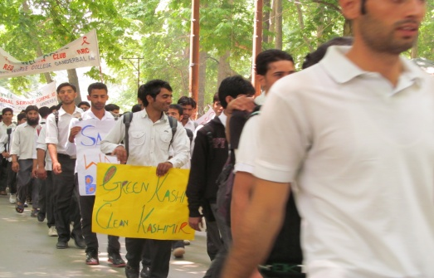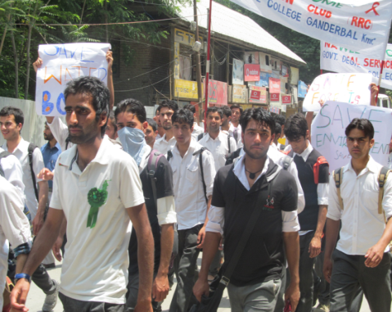

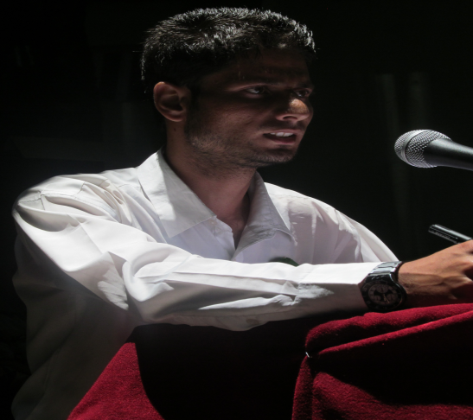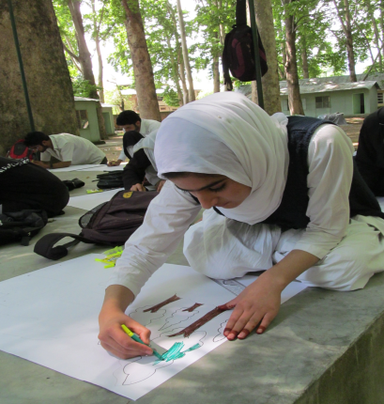
S tudents speaking on the seminar.
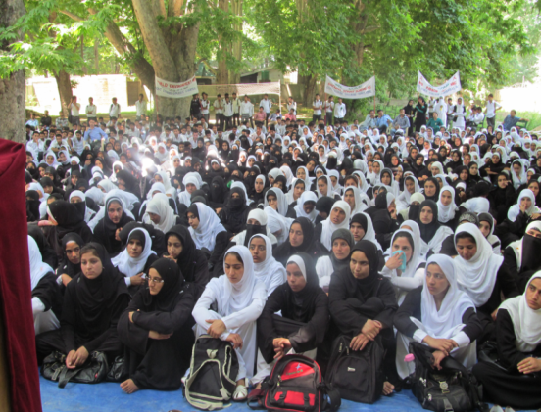
A glimpse of the audience.

Launching of Scooty scheme and encouraging Girl students, 7th March 2017:
Hon’ble Chief Minister Mehbooba Mufti visited the college in connection with launching of scooty Scheme for Girl students of the college. In her address, she said that the Govt. is committed to uplift the women of the state. She handed over scooty keys to the girl students Hon’ble Minister of Education, Syed Altaf Bukhari while speaking on the occasion that the Government is keen to enhance and uplift the economic dignity of the girls. He further added that he himself will do his best to help the students in every sphere of their education and holistic development. In her welcome address, the Principal of the college, Dr. Yasmin Kawoos thanked the chief Minister for choosing the girl students of this college to get benefited under scooty scheme as it will help the girls to boost their self-confidence and self-esteem.
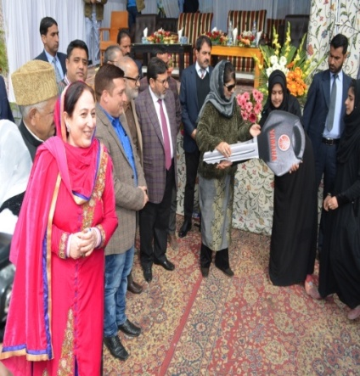
Adoption of Govt. Middle School Kullan (2016-2017): The NSS unit of this college adopted Govt. Middle School Kullan for financial and academic assistance.
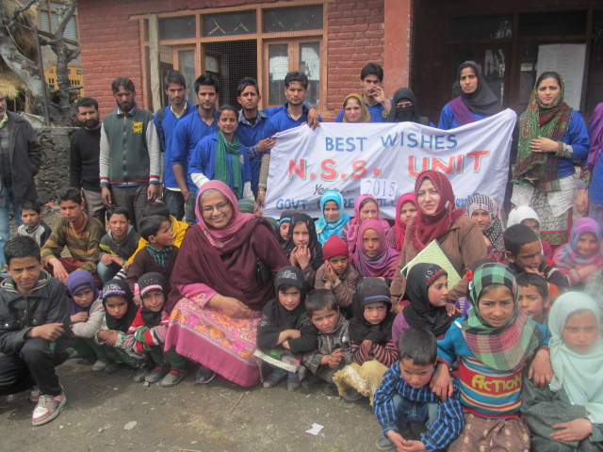
Plantation Drive on 15th March 2017:
“Make a difference and go green” will really make a difference if each one of us pledges to work for it the way it demands. But many a times this slogan finds its relevance only in hollow and lifeless words. To put some life to it, GDC Ganderbal in association with Department of Botany and NSS/NCC wing in collaboration with social Forestry Department, Division Ganderbal organized a plantation drive in which total of 60 members participated including Staff, students and locals and planted saplings in the college campus. Prof.(Dr.) Yasmin Kaswoos also highlighted the essence of planting trees and urged the students to plant more and more trees to counter the current global challenge the planet Earth is facing.
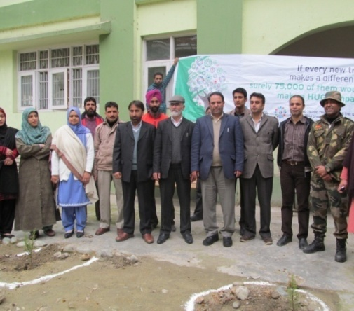
2017-2018
Visit to voluntary medical society, VMS, Bemina Bye pass Near Hajj House, Srinagar 190018 organised by the department of education:
The faculty members of the department of education and the students of BG 3rd year visited voluntary medical society, VMS, Bemina on 14 - 10 – 2017. Voluntary medical society is a socio-medical organisation meant for treatment, care and rehabilitation of physically and mentally challenged individuals. Irrespective of caste, colour, creed, gender and religion. The society treats hundreds of ailing patients and provides necessary treatment. The services offered and disabilities covered at VMS are: Home based training, Occupational therapy, Physico therapy, Speech therapy Vocational Training, Special Education.
The students of the BG 3rd year visited the classrooms where children with different disabilities were educated. The Braille system was also shown to them. The Braille is a tactile writing system used by people who are visually impaired. The students watched the system of writing and printing for blind or visually impaired people, in which varied arrangements of raised dots representing letters and numerals are identified by touch. The students interacted with the teachers who was teachers and learners. The students were also shown different decoration items made by specially abled children with the help of manual skills. The students were briefed as to how common people can come forward and volunteer to help many such NGOs to carry this noble mission. About 50 students participated in the visit.
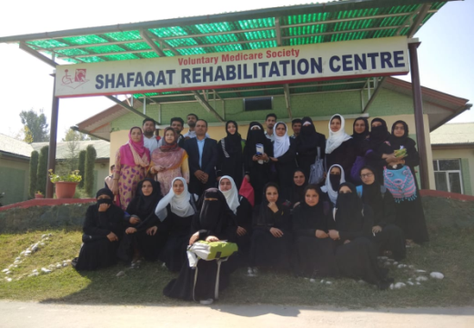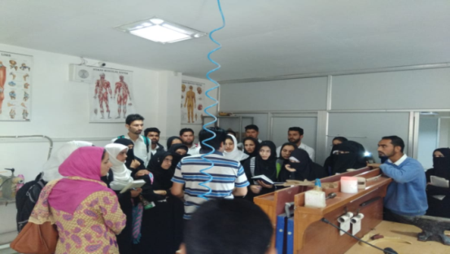

One Day programme on Swachta hi seva hai:26-09-17

In connection with the Nation vide programme of Swachta hi seva hai , the college organized a Painting cum seminar Competition on 26-09-17. During the first half , the painting competition was organized and in second half students participated in the seminar .The worthy Principal of the college addressed the students and highlighted the importance of such programmes for a healthy and Happy Nation. About 30 students participated in the programme.

Celebration of Iqbal Day,on 18-11-2017
Sir Muhammad Iqbal, widely known as Allama Iqbal, was a poet, philosopher and politician, as well as an academician, barrister and scholar. His intellectual genius continues to influence and inspire youth of all sects. Iqbal has addressed the youth in one the philosophical lines as “I have love for those youngsters who pull the stars down" To refresh this Iqbalian Ideology among the youth, the college seminar committee organized Iqbal Day on the topic “Iqbal ka paigam nawjawn nasl kay naam”( Iqbal’s message to the Youth). About 60 students participated and twelve students from different streams of the college participated in the said seminar and threw light on the Iqbalian Philosphy and its role in shaping the minds of young generation to lay foundation of a Iqbalian society with new aspirations, new dreams and new ambitions. The proceedings of the seminar were conducted by Mr. Manzoor Ahmad Parey Assistant Professor, Department of Education, GDC Ganderbal. The seminar ended with the vote of thanks by Prof. Asma Arshi, Head Department of English.
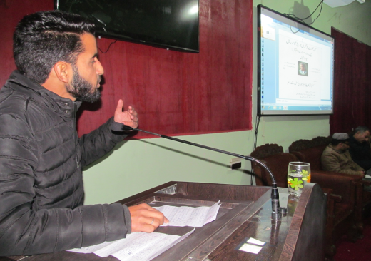
Students speaking on the Iqbal day.

