Faculty Member Profile

(Government Degree College Ganderbal)
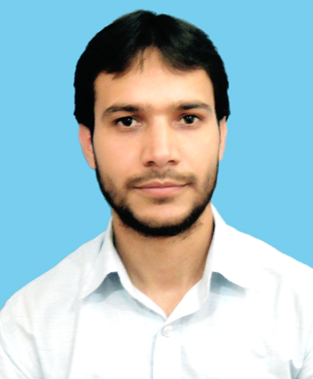 py
- Name : FEROZ AHMAD WANI .
- Parentage : GH MOHI UD DIN WANI .
- Date of Birth : 06/07/1982 .
- Marital Status : UNMARRIED .
- Residential Address:
Village NOWDAL Tehsil TRAL .
Town______________________ District PULWAMA Pin 192123 .
- Contact Address/No.:
Email: ferozwani@kashmiruniversity.net ; wferoz1@gmail.com .
Cell No.: 7006844384 ; ____________________
- Name of the Department: Geography .
- Designation: Lecturer (contractual) .
- Courses taught at:
UG level: Theory: (i) Elements of Physical Geography, (ii) Geography of India
Practical: (i) Cartography, (ii) Surveying, (iii) Quantitative Techniques and (iv) Map Projections.
PG level: No .
- Educational qualifications:
Qualification/Degree | Subject | University | Year of Passing
Ph. D. | Geography | University of Kashmir | Thesis Submitted
M. Phil. | Geography | University of Kashmir | 2014
M. Sc. | Geography | University of Kashmir | 2008
B. Sc. | Non-Medical  Eng., Maths, Geol., Geog | University of Kashmir | 2006
UGC-NET | Geography |  | 2015
- Service rendered in different Colleges:(Attach Experience Certificate)
College/University | From | to | No. of Years/Months
GDC, Ganderbal | 06-06-2017 | 31-03-2018 | 10 months
GDC, Ganderbal | 05-04-2018 | Till date | 01 year & 1 month
- Innovative processes developed in teaching and learning e.g. PPTs, Study material, video lectures, Smarts Boards used etc. :_____________________________________ _____________________________________________________________________
- Participation in Curricular development: _________________________________ _______________________________________________________(attach document)
- Participation in Co-Curricular development (NSS/NCC/Sports etc.): __________________________________________________________________ _______________________________________________________(attach document)
- Research, Scholarly, Professional and Scientific Activity (Give details as per format)

Total Research experience:__________05___________

No. of publications in peer-reviewed Journals:_____________(attach list)

No. of books/ book chapters published as author or co-author:___________(attach list)
- Major/Minor research projects completed: ________________
Sr. No. | Title of the project | Date of sanction and duration | Grant received | Funding agency | Status
1
2
- Participation in Conferences/Symposia/Workshops/Seminars: (Attach list)

No. of Conferences attended_______02____________

No. of Symposia attended______________________

No. of Seminars attended _______________________

No. of Workshops attended _______02____________
- Major Areas of Interest:________________________
- Orientation/Refresher Course attended
Year | From | To | Name of Academic Staff College

- Contribution towards Institution:
S. No. | year | Area of contribution | Convener/Member

Sign. Of faculty

Format for Research, Scholarly, Professional and Scientific Activity
S. No. | Name of Conference/ Seminar etc. | Organized by | Dates and Year | National/  International/  State/  University  level | Attended/  Paper presented/  Chaired session/Resource person etc.
1 | “Quantitative Techniques in Social and Allied Sciences” | Department of Geography and Regional Development, University of Kashmir in collaboration with Academic Staff College, University of Kashmir, Srinagar | 16 - 25 December 2013 | National Workshop | Attended 10 Day’s Workshop
2 | “Increasing Resilience to Environmental Hazards in Boarder Conflict Zones” | IERT, University of Jammu (J&K) and IRDR, University College London (UK) | 10 - 11  June  2017 | International Workshop  (held at Leh, J&K) | Presented paper on “Landslide Hazard Mapping of Bandipora-Gurez Road (J&K) using Remote Sensing and GIS”
3 | Recovery Strategies for Tourist Destinations in conflict studies | Department of Tourism Studies, Central University of Kashmir, Srinagar | 8 - 9 September 2017 | International Conference  (held at Leh, J&K) | Presented paper on “Evaluation of Tourism Potential Resources in Reasi District”
4 | Recent Developments in Science, Humanities & Management-2018 | Amar Singh College, Cluster University, Srinagar, J&K | 17 - 18  April  2018 | 1st International Conference  (held on A.S. College, Srinagar) | Presented paper on “Temperate Fruit Cultivation in Kashmir Himalayas: A Case of Dry Fruit Horticulture”
5

Sign. of faculty

