Faculty Member Profile
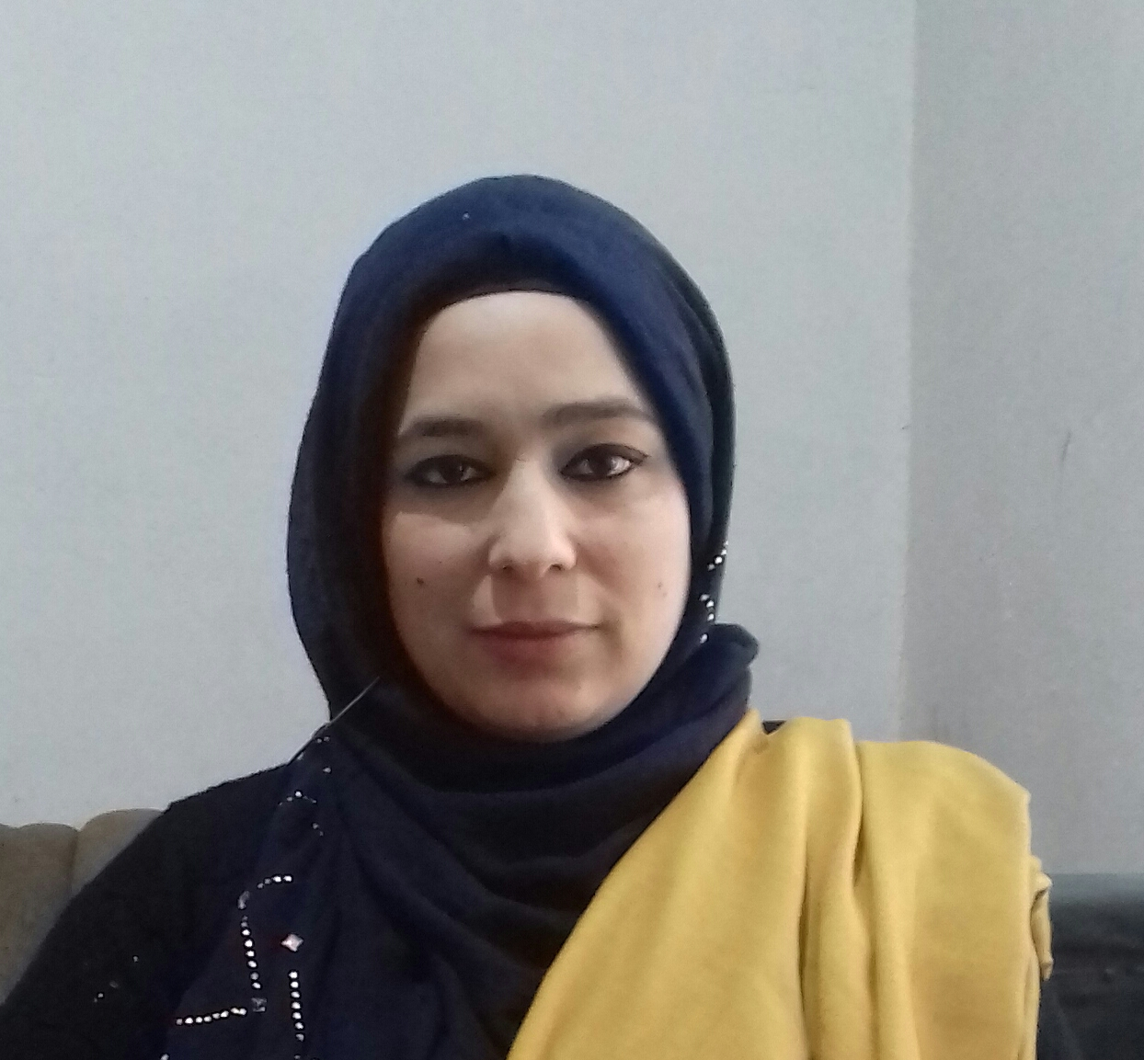
Paste your recent Photocopy

(Govt. degree College Ganderbal)
- Name :Dr. Irfana Jan
- Parentage : Late Abdul AhadAhangar
- Date of Birth : 01st Dec 1985
- Marital Status : Married
- Residential Address: Lane 8A Hamza Colony Illahibagh
Village: Illahibagh Tehsil:
Town:Illahibagh District: Srinagar :Pin: 190006
- Contact Address/No.:
Email:wfizafahed@gmail.com ; wfizafahed@rediffmail.com
Cell No: 7006242936; 9086015327
Name of the Department: Commerce
Designation:Assistant Professor.
- Courses taught at:
UG level: Financial Accounting, Managerial Economics, Business Management,
Business Law;
PG level :
- Educational qualifications:
Qualification/Degree | Subject | University | Year of Passing
P.hd | Commerce | University of Kashmir | 2015
M.Com | Commerce | University of Kashmir | 2009
NET | Commerce | UGC | 2013
SET | Commerce | University of Kashmir | 2013
- Service rendered in different Colleges:(Attach Experience Certificate)
College/University | From | to | No. of Years/Months
Govt. Degree College, Bemina | 22/04/2010 | 28/02/2011 | 10 Months
Govt. Degree College, Ganderbal | 16/02/2017 | Till date | 2 years & 2 months
- Innovative processes developed in teaching and learning eg. PPTs, Study material, video lectures, Smarts Boards usedetc:PPTs, Preparation of study material.
- Participation in Curricular development: Discussions, interactive sessions & lecture demonstrations.(attach document)
- Participation in Co-Curricular development(NSS/NCC/Sports etc.):Promotion of NCC activities and motivated students for social services & national integration in the capacity of NCC Caretaker.(attach document)
- Research, Scholarly, Professional and Scientific Activity (Give details as per format)

Total Research experience: 4 years

No. of publications in peer-reviewed journals: 04 (attach list)

No. of books/ book chapters published as author or co-author: Nil (attach list)
- Major/Minor research projects completed: Nil
Sr. No. | Title of the project | Date of sanction and duration | Grant received | Funding agency | Status
1 | - | - | - | - | -
2 | - | - | - | - | -
- Participation in Conferences/Symposia/Workshops/Seminars: (Attach list)

No. of Conferences attended: 05

No. of Symposia attended: Nil

No. of Seminars attended: 02

No. of Workshops attended: 01
- Major Areas of Interest: Human Resource Management, Finance
- Orientation/Refresher Course attended
Year | From | To | Name of Academic Staff College
2017 | 06/09/2017 | 06/10/2017 | University of Kashmir

- Contribution towards Institution:
S. No. | year | Area of contribution | Convener/Member
01 | 2017-18 & 2018-19 | Conducted various porgrammes/activities under NCC. | Convener NCC
02 | 2017-18 & 2018-19 | Helped in organizing Sports activities and events in the institution | Member of College Sports Committee
03 | 2017-18 & 2018-19 | Helped in organizing various seminars, debates, symposia in the institution. | Member of College Debate Committee
04 | 2017-18 & 2018-19 | Facilitates discipline and maintenance in the college. | Member of discipline Committee
05 | 2017-18 & 2018-19 | Helped in the admission process and counselling of students. | Member of college Admission Committee.
06 | 2017-2018 & 2018-19 | Calculation of taxation of employees. | Member of college tax Committee

Sign. Of faculty

Format for Research, Scholarly, Professional and Scientific Activity
S. No. | Name of Conference/ Seminar etc. | Organized by | Dates and Year | National/  International/  State/  University  level | Attended/  Paper presented/  Chaired session/Resource person etc.
1 | 3-Day National Conference on Contemporary Issues in Business, Mgt. and Finance (CIBMF-2012) University of Kashmir | University of Kashmir | Sept. 21-23, 2012 | National | Paper presented
2 | 3-Day National Conference on Contemporary Issues in Business, Mgt. and Finance (CIBMF-2012) University of Kashmir | University of Kashmir | Sept. 21-23, 2012 | National | Paper presented
3 | 3-Day National Conference on Contemporary Issues in Business, Mgt. and Finance (CIBMF-2012) University of Kashmir | University of Kashmir | Sept. 21-23, 2012 | National | Paper presented
4 | 3-Day National Conference on Contemporary Issues in Business, Mgt. and Finance (CIBMF-2012) University of Kashmir | University of Kashmir | Sept. 21-23, 2012 | National | Paper presented
5 | National Seminar on ‘Assessment and Evaluation’ | College of Education | March. 19th& 20th , 2018 | National | Paper presented
6 | 01-Day Seminar on the theme ‘Drug Addiction: Consequences and Remedies’ | Govt. Degree College, Ganderbal. | 23rd July 2018 | State | Attended

Sign. Of faculty

