Faculty Member Profile
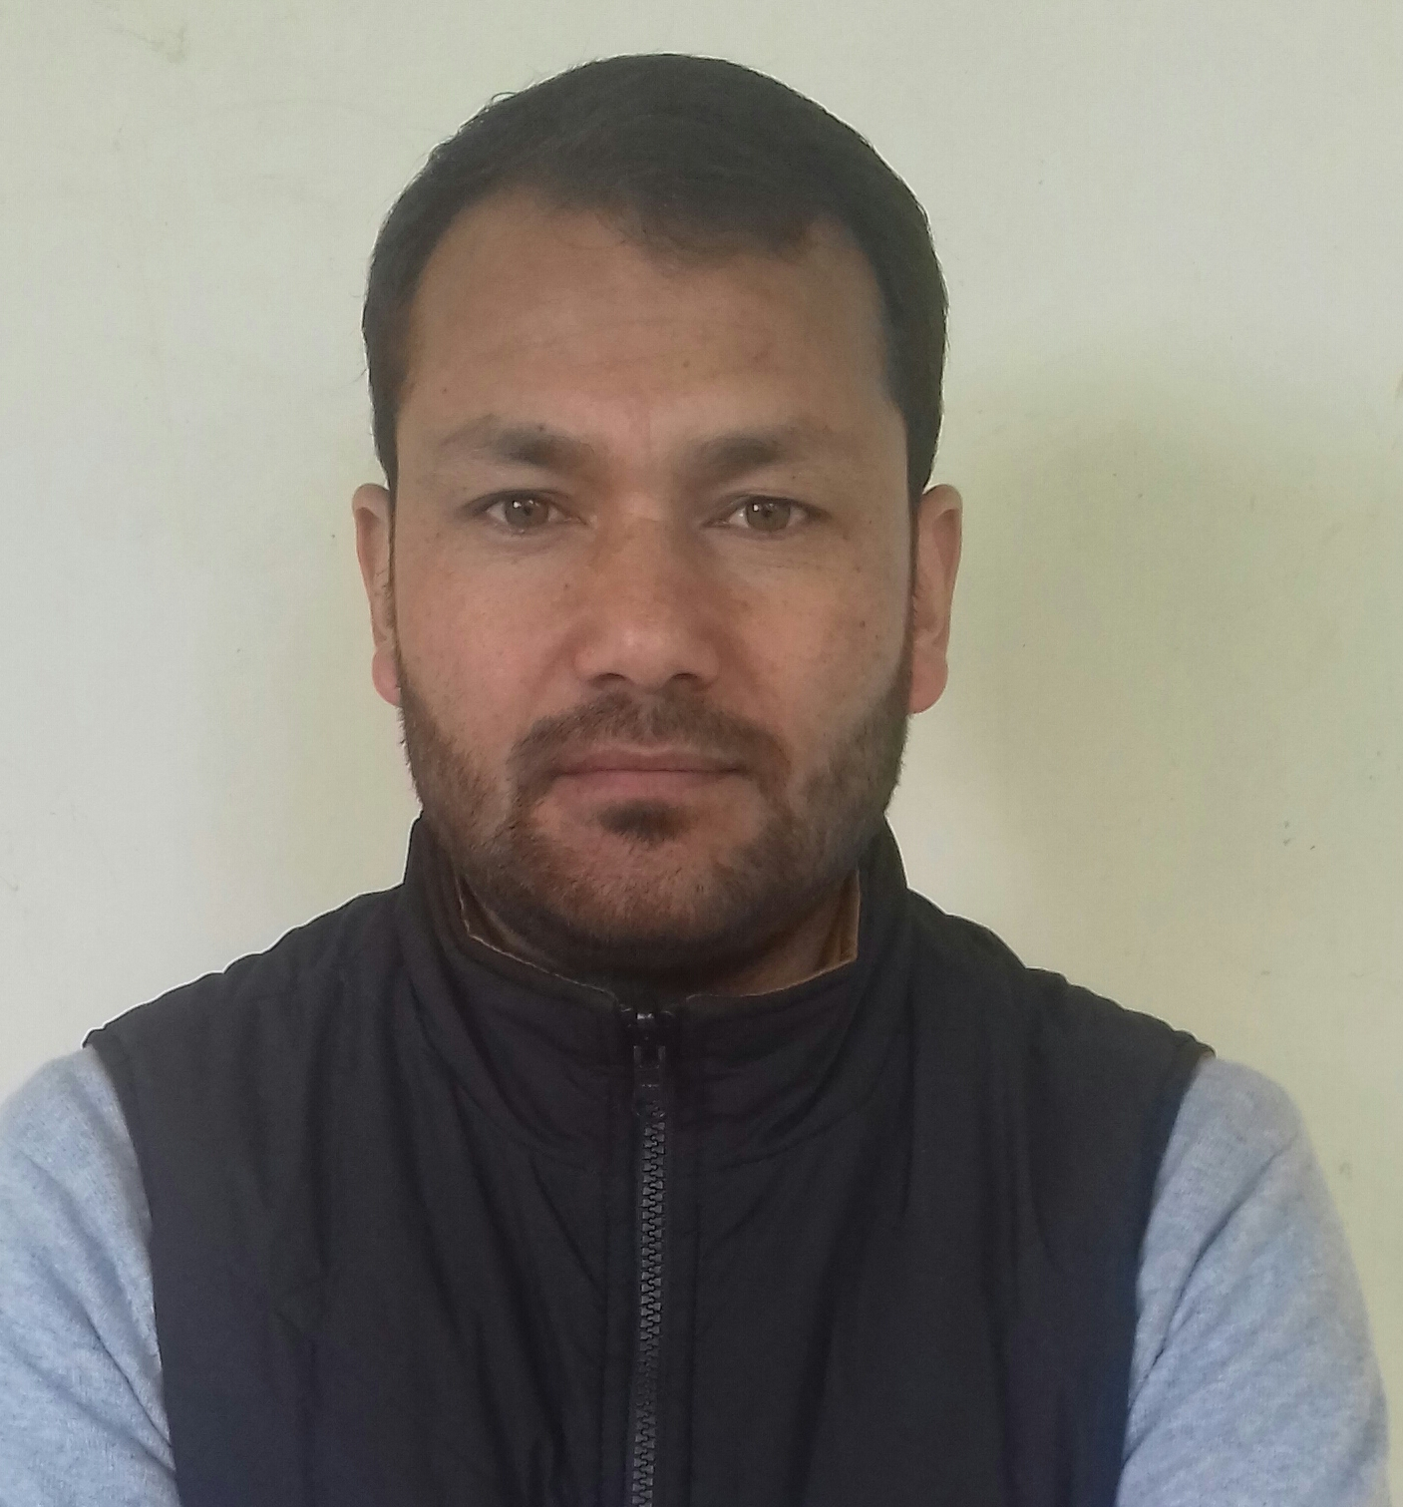
Paste your recent Photocopy

(Govt. degree College Ganderbal)
- Name : Abazar
- Parentage :Haji Mohd
- Date of Birth : 3rd June, 1984
- Marital Status :
- Residential Address:Tumail, Kargil Ladakh-194103
Email: abazar.ap@gmail.com
Cell No: 7051691433
- Name of the Department: Commerce
- Designation:Assistant Professor
- Courses taught at:UG level:
  - Business Org. & Management
  - Company Law
  - Cost Accounting
  - Banking and insurance
  - Micro economics

Qualification/Degree | Subject | University | Year of Passing
JRF NET | COMMERCE | UGC NEW DELHI | 2011
SET | COMMERCE | JAMMU UNIVERSITY | 2011
Post Graduate | COMMERCE | KASHMIR UNIVERSITY | 2010
Graduation | COMMERCE | KASHMIR UNIVERSITY | 2008
- Service rendered in different Colleges:(Attach Experience Certificate)
College/University | From | to | No. of Years/Months
Govt. Degree College Kargil | 01.03.2011 | 28.02.2012 | 01 year
Govt. Degree College Leh | 01.03.2017 | 30.04.2017 | 02 months
Govt Degree College Ganderbal | 01.05.2017 | present | 01 year,11 months
- Innovative processes developed in teaching and learning eg. PPTs, Study material, video lectures, Smarts Boards used etc. :Suggest students updated study material, books and relevant and useful websites.
- Participation in Curricular development: NIL (attach document)
- Participation in Co-Curricular development (NSS/NCC/Sports etc.): As a member of college sports committee contribute to facilitate and organize sports events in the college. (attach document)
- Research, Scholarly, Professional and Scientific Activity (Give details as per format)

Total Research experience: NIL

No. of publications in peer-reviewed journals:NIL

No. of books/ book chapters published as author or co-author:NIL

Major/Minor research projects completed: NIL
Sr. No. | Title of the project | Date of sanction and duration | Grant received | Funding agency | Status
1 | - | - | - | - | -
2 | - | - | - | - | -
- Participation in Conferences/Symposia/Workshops/Seminars: (Attach list)

No. of Conferences attended: NIL

No. of Seminars attended:NIL

No. of Workshopsattended : NIL
- Major Areas of Interest:COST ACCOUNTING
- Orientation/Refresher Course attended
Year | From | To | Name of Academic Staff College
2018 | 20.02.2018 | 19.03.2018 | UGC-HRDC UNIVERSITY OF JAMMU
- | - | - | -

- Contribution towards Institution:
S. No. | year | Area of contribution | Convener/Member
01 | 2017 | Sports activities and events organization | Member of College Sports Committee
02 | 2018 | Help in arranging in Annual College Picnic | Member of college picnic Committee
03 | 2018 | Helped in Annual college Road race | Member of College Sports Committee

Sign. Of faculty

Format for Research, Scholarly, Professional and Scientific Activity

S. No. | Name of Conference/ Seminar etc. | Organized by | Dates and Year | National/  International/  State/  University  level | Attended/  Paper presented/  Chaired session/Resource person etc.
1 | NIL | NIL | NIL | NIL | NIL

Sign. Of faculty

