Faculty Member Profile
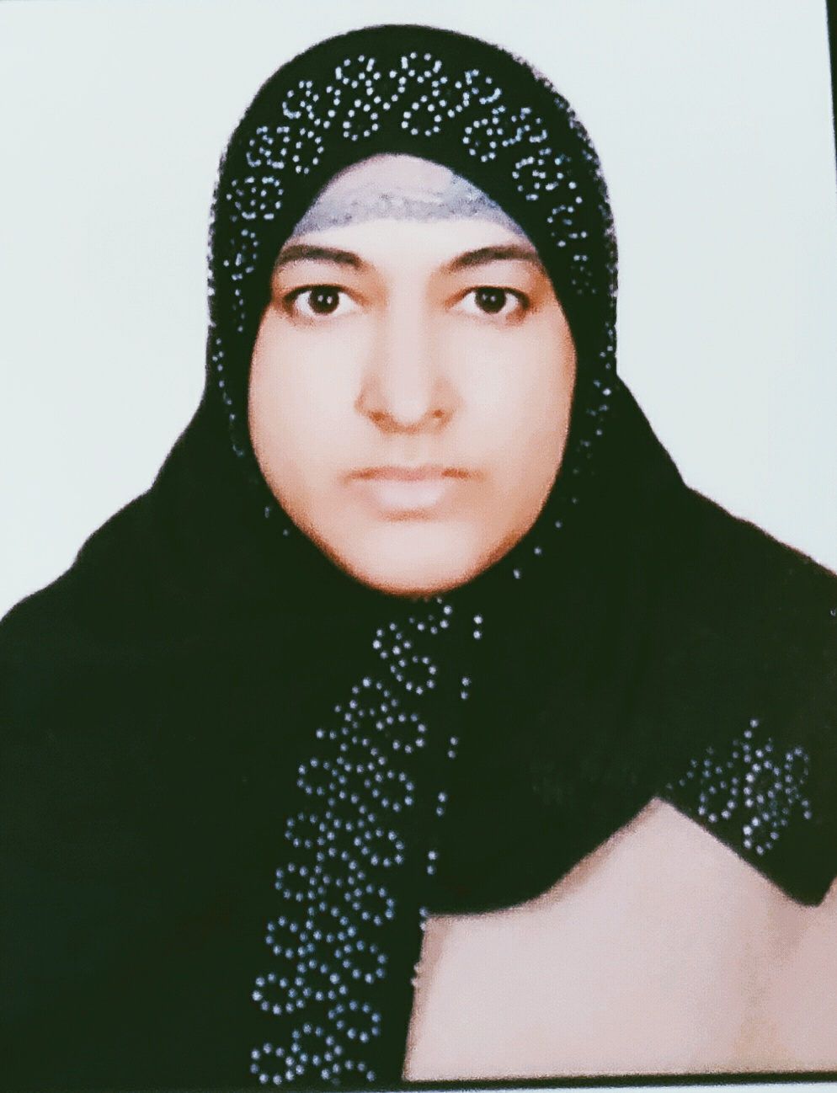
Paste your recent Photocopy

(Govt. degree College Ganderbal)
- Name : ___DR NUSRAT JAN________________________________
- Parentage :_____NOOR UD DIN SHAH______________________________
- Date of Birth :______1/11/1977____________________________
- Marital Status :_________MARRIED___________________________
- Residential Address:
Village_______GOJWARA_______________________Tehsil___SRINAGAR______________________________
Town_________GOJWARA______________District_______SRINAGAR_________________Pin______190002________
- Contact Address/No.: 9419530547
Email:iqbalnusrat85@gmail.com__________________________.______________________________
CellNo..___9419530547___________________________ .______________________________
- Name of the Department: _______KASHMIRI________________________________________
- Designation: ______ CONTRACTUAL LECTURER___________________________________________________
- Courses taught at:
UG level:_____KASHMIRI________________________________________________________
PG level______________________________________________________________
- Educational qualifications:
Qualification/Degree | Subject | University | Year of Passing
Ph.D | KASHMIRI | UNIVERSITY OF KASHMIR | 2015
M.phill | KASHMIRI | UNIVERSITY OF KASHMIR | 2007
M.A | KASHMIRI | UNIVERSITY OF KASHMIR | 2003
- Service rendered in different Colleges:(Attach Experience Certificate)
College/University | From | to | No. of Years/Months
WOMEN COLLEGE M A ROAD | 15/05/2009 | 13/06/2009 | 1 MONTH
DEGREE COLLEGE BANDIPORA | 1/5/2010 | 22/01/2011 | 8 MONTHS
DEGREE COLLEGE BEERWAH | 23/4/2011 | 29/02/2012 | 10 MONTHS
DEGREE COLLEGE GANDERBAL | 8/05/2012 | 13/12/2012 | 8 MONTHS
DEGREE COLLEGE GANDERBAL | 11/04/2016 | 31/03/2017 | 12 MONTHS
DEGREE COLLEGE GANDERBAL | 12/04/2017 | 31/03/2018 | 12 MONTHS
DEGREE COLLEGE GANDERBAL | 5/04/2018 | TILL DATE | CONTINUE
- Innovative processes developed in teaching and learning eg. PPTs, Study material, video lectures, Smarts Boards used etc. :_____________________________________ _____________________________________________________________________
- Participation in Curricular development: _________________________________ _______________________________________________________(attach document)
- Participation in Co-Curricular development(NSS/NCC/Sports etc.): __________________________________________________________________ _______________________________________________________(attach document)
- Research, Scholarly, Professional and Scientific Activity (Give details as per format)

Total Research experience:________________

No. of publications in peer-reviewed journals:_3____________(attach list)

No. of books/ book chapters published as author or co-author:___3__________(attach list)
- Major/Minor research projects completed: ________________
Sr. No. | Title of the project | Date of sanction and duration | Grant received | Funding agency | Status
1
2
- Participation in Conferences/Symposia/Workshops/Seminars: (Attach list)

No. of Conferences attended____2_________________

No. of Symposia attended_____4________________

No. of Seminars attended _____3__________________

No. of Workshops attended ______1_______________
- Major Areas of Interest:________________________
- Orientation/Refresher Course attended
Year | From | To | Name of Academic Staff College

- Contribution towards Institution:
S. No. | year | Area of contribution | Convener/Member

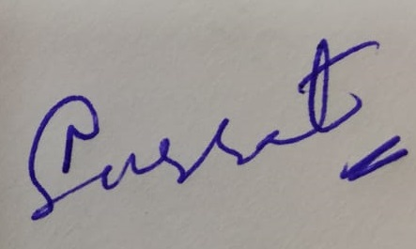

Sign. Of faculty

Format for Research, Scholarly, Professional and Scientific Activity

S. No. | Name of Conference/ Seminar etc. | Organized by | Dates and Year | National/  International/  State/  University  level | Attended/  Paper presented/  Chaired session/Resource person etc.
1 | KOUR ZENI AAYE AALAMS SHOUB | JAMIA FALAHI NISWA AND CENTRE FOR SHEIKHUL ALAM STUDIES | 21/01/2015 | UNIVERSITY | PAPER PRESENTED
2 | REVISITING THE LEGACIES OF SHEIKH UL ALAM AND KABIR | ICSSR CHANDIGARH AND CENTRE FOR SHEIKH UL ALAM STUDIES | 11,12 DEC. 2015 | NATIONAL | PAPER PRESENTED
3 | INTERNATIONAL MOTHER TONGUE DAY | CENTRE FOR SHEIKH UL ALAM STUDIES | 22 FEB. 2014 | REGIONAL | PAPER PRESENTED
4 | BASIC ASPECTS OF FOLK LITERATURE AND SHEIKH UL ALAM AS A LEADER OF RESHI MOVEMENT | J&K CULTURAL ACADEMY OF ART CULTURE AND LANGUAGES AND CENTRE FOR SHEIKHUL ALAM STUDIES | 13/08/2015 | REGIONAL | PAPER PRESENTED
5 | PARTICIPATED FIVE DAYS TRANSLATERS ORIENTATION PROGRAMME | CIIL MYSORE | 3,4,5,6,7, JUNE 2013 | NATIONAL | PARTICIPATION
6 | NATIA MUSHAIRAH | J&K CULTURAL ACADEMY OF ART CULTURE AND LANGUAGES | 29/06/2015 | REGIONAL | PARTICIPATION
7 | TWO DAYS KASHMIRI CONFERENCE | J&K CULTURAL ACADEMY OF ART CULTURE AND LANGUAGES | 29,30 DEC 2015 | REGIONAL | OBSERVER
8 | TWO DAYS KASHMIRI CONFERENCE | J&K CULTURAL ACADEMY OF ART CULTURE AND LANGUAGES | 18,19 MARCH 2017 | REGIONAL | OBSEVER
9 | NEW VOICES | J&K CULTURAL ACADEMY OF ART CULTURE AND LANGUAGES |  | REGIONAL | PAPER PRESENTED

