Faculty Member Profile
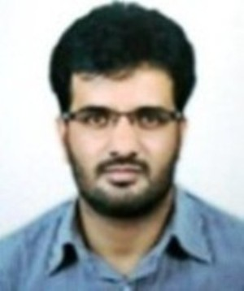
Paste your recen t Photocopy

(Govt. degree College Ganderbal)
- Name : Shahnawaz Mustafa
- Parentage : Gh. Mustafa Bhat
- Date of Birth : 08/11/1981
- Marital Status : Married
- Residential Address:
Village: Awaneera Tehsil: Frisal Town: Frisal District: Kulgam Pin:192232
- Contact Address/No.:
Email: petro.shahnawaz@gmail.com
Cell No.7006451241
- Name of the Department: Geology
- Designation: Assistant Lecturer
- Courses taught at:
UG level: Mineralogy, Petrology, Petroleum Geology, Geophysics, Paleontology
PG level:
- Educational qualifications:
Qualification/Degree | Subject | University | Year of Passing
M.Tech | Petroleum Geology | Dibrugarh University Assam | 2009
M.Sc | Applied Geology | University of Kashmir | 2005
B.Sc | Earth Science | University of Kashmir | 2003
- Service rendered in different Colleges:(Attach Experience Certificate)
College/University | From | to | No. of Years/Months
Govt. Degree College Ganderbal | 17th May 2018 | Till date | 1 yr continue
- Innovative processes developed in teaching and learning eg. PPTs, Study material, video lectures, Smarts Boards used etc. :_____________________________________ _____________________________________________________________________
- Participation in Curricular development: _________________________________ _______________________________________________________(attach document)
- Participation in Co-Curricular development(NSS/NCC/Sports etc.): __________________________________________________________________ _______________________________________________________(attach document)

- Research, Scholarly, Professional and Scientific Activity (Give details as per format)

Total Research experience:________________

No. of publications in peer-reviewed journals:_____________(attach list)

No. of books/ book chapters published as author or co-author:_____________(attach list)
- Major/Minor research projects completed: ________________
Sr. No. | Title of the project | Date of sanction and duration | Grant received | Funding agency | Status
1
2
- Participation in Conferences/Symposia/Workshops/Seminars: (Attach list)

No. of Conferences attended_____________________

No. of Symposia attended______________________

No. of Seminars attended _______________________

No. of Workshops attended _____________________
- Major Areas of Interest:________________________
- Orientation/Refresher Course attended
Year | From | To | Name of Academic Staff College

- Contribution towards Institution:
S. No. | year | Area of contribution | Convener/Member

Sign. Of faculty

Format for Research, Scholarly, Professional and Scientific Activity

S. No. | Name of Conference/ Seminar etc. | Organized by | Dates and Year | National/  International/  State/  University  level | Attended/  Paper presented/  Chaired session/Resource person etc.
1
2
3
4
5
6

Sign. Of faculty

