Faculty Member Profile
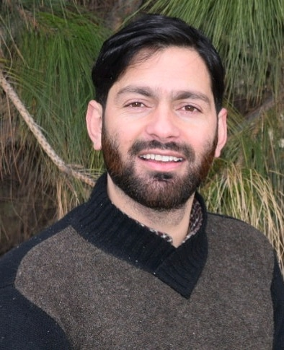
Paste your recent Photocopy

(Govt. degree College Ganderbal)
- Name : NAZIR AHMAD SHAH
- Parentage : GH. NABI SHAH
- Date of Birth : 13TH NOV.1983
- Marital Status : MARRIED
- Residential Address :
Village : SOIBUGH Tehsil : BUDGAM
Town : BUDGAM District : BUDGAM Pin : 191111
- Contact Address/No.:
Email: naaznabi83@gmail.com
Cell No.. 7006354004, 9906685867
- Name of the Department: HISTORY
- Designation: ASSISTANT LECTURER
- Courses taught at:
UG level: B.A
PG level: M.A (IGNOU)
- Educational qualifications:
Qualification/Degree | Subject | University | Year of Passing
M.A | HISTORY | BARAKATULLAH UNIVERSITY BHOPAL | 2009
M.PHIL | HISTORY | AWADHESH PRATAP SINGH UNIVERSITY REWA | 2012
M.ED | EDUCATION | UNIVERSITY OF KASHMIR | 2015
D C A | COMPUTER | DOEACE CHANDIGRAH | 2006
- Service rendered in different Colleges:(Attach Experience Certificate)
College/University | From | to | No. of Years/Months
GDC KHANSAHIB | MAY 2010 | DEC 2010 | 6 MONTHS
GANDHI MEMORIAL COLLEGE SRINAGAR | 27TH MARCH 2012  12TH MAY 2017 | 30TH APRIL,2015  28TH 2018 | 3 YEARS  9 MONTHS
GDC BUDGAM | 18TH JUNE 2015 | 28TH FEB. 2017 | 1 YEAR & 8 MONTHS
GDC GANDERBAL | 20TH APRIL 2018 | TILL DATE | 1 YEAR
- Innovative processes developed in teaching and learning eg. PPTs, Study material, video lectures, Smarts Boards used etc. :_____________________________________ _____________________________________________________________________
- Participation in Curricular development: _________________________________ _______________________________________________________(attach document)
- Participation in Co-Curricular development(NSS/NCC/Sports etc.): __________________________________________________________________ _______________________________________________________(attach document)
- Research, Scholarly, Professional and Scientific Activity (Give details as per format)

Total Research experience:________________

No. of publications in peer-reviewed journals:_____________(attach list)

No. of books/ book chapters published as author or co-author:_____________( attach list)
- Major/Minor research projects completed: ________________
Sr. No. | Title of the project | Date of sanction and duration | Grant received | Funding agency | Status
1
2
- Participation in Conferences/ Symposia/ Workshops/ Seminars: (Attach list)

No. of Conferences attended_____________________

No. of Symposia attended______________________

No. of Seminars attended _______________________

No. of Workshops attended _____________________
- Major Areas of Interest:________________________
- Orientation/Refresher Course attended
Year | From | To | Name of Academic Staff College

- Contribution towards Institution:
S. No. | year | Area of contribution | Convener/Member

Sign. Of faculty

Format for Research, Scholarly, Professional and Scientific Activity

S. No. | Name of Conference/ Seminar etc. | Organized by | Dates and Year | National/  International/  State/  University  level | Attended/  Paper presented/  Chaired session/Resource person etc.
1
2
3
4
5
6

Sign. Of faculty

