Faculty Member Profile
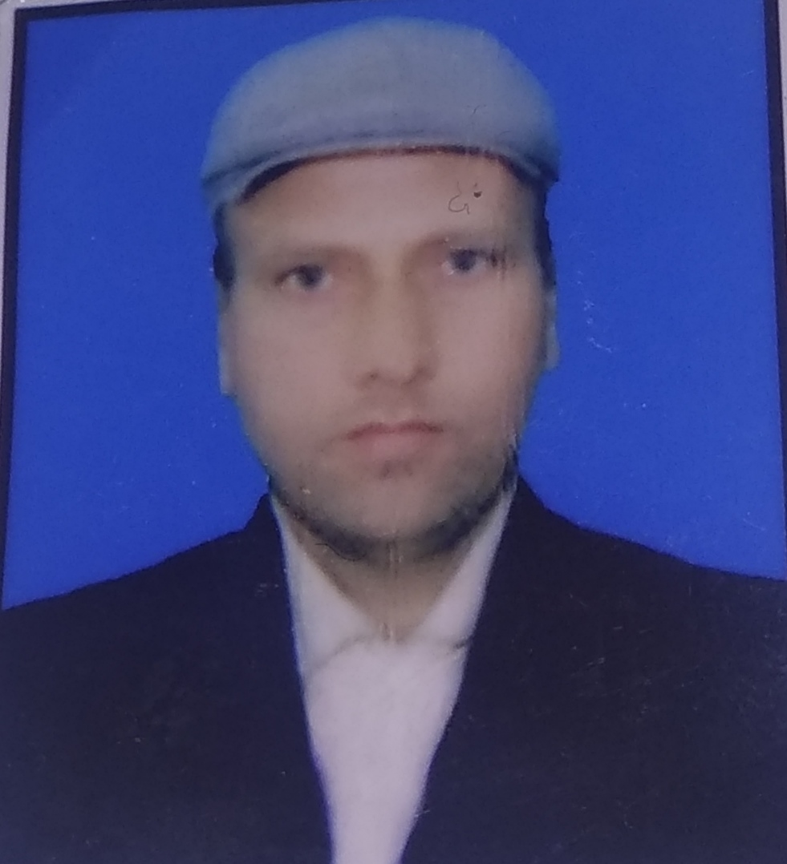
Paste your recent Photocopy

(Govt. degree College Ganderbal)
- Name : ______Dr.Syed Ibrahim Rizvi_________________
- Parentage :___________Syed Mustafa Rizvi________________
- Date of Birth : _____04-04-1965___________________________
- Marital Status :_______Married____________________________
- Residential Address : _____Magam,Budgam, Jammu and Kashmir__
Village: ______Magam_________ Tehsil: ____Magam____________
Town ______Magam__ District____Budgam_________Pin___193401___________
- Contact Address/No: 9419766799/9149578760
Email: .______ibrahimrizvi09@gmail.com_______
Cell No: __________9419766799__________
- Name of the Department: _________Persian___________
- Designation: ________Contractual Lecturer_________________
- Courses taught at:
UG level: __Persian Language and Literature___
PG level: _1. Indo-Persian literature_ 2. Modern spoken Persian______
- Educational qualifications:
Qualification/Degree | Subject | University | Year of Passing
B.A | G.E, Edu, Urdu, Persian | Kashmir University | 1995
M.A | Persian | Kashmir University | 1997
M.PHIL | Persian | Kashmir University | 2007
P.H.D | Persian | Kashmir University | 2014
- Service rendered in different Colleges:(Attach Experience Certificate)
College/University | From | to | No. of Years/Months
P.G Deptt of Persian,Kashmir University | 2003 | 2012 | 7 years
G.D.C Khansahab | 2014 | 2016 | 2 years
G.D.C Ganderbal | 2016 | Till date | 3years
- Innovative processes developed in teaching and learning eg. PPTs, Study material, video lectures, Smarts Boards used etc. :______________NO_______________________
- Participation in Curricular development: ______NO_____________________ ___________________________________________________(attach document)
- Participation in Co-Curricular development(NSS/NCC/Sports etc.): _____________________________________NO_____________________________ _______________________________________________________(attach document)
- Research, Scholarly, Professional and Scientific Activity (Give details as per format)

Total Research experience:________________

No. of publications in peer-reviewed journals:_____________(attach list)

No. of books/ book chapters published as author or co-author:_____________( attach list)
- Major/Minor research projects completed: ________________
Sr. No. | Title of the project | Date of sanction and duration | Grant received | Funding agency | Status
1
2
- Participation in Conferences/ Symposia/ Workshops/ Seminars: (Attach list)

No. of Conferences attended______4_______________

No. of Symposia attended______________________

No. of Seminars attended _________15___________

No. of Workshops attended ______1______________
- Major Areas of Interest: _____Literature and codicology_________________
- Orientation/Refresher Course attended
Year | From | To | Name of Academic Staff College
2007 | 23rd April | 13th May | University of Kahsmir

- Contribution towards Institution:
S. No. | year | Area of contribution | Convener/Member
1. | 2014-15 | Disciplinary Committee | Convener Gdc,Khansahab
2. | 2015-16 | Debates and Seminars Committee | Convener Gdc,Khansahab
3. | 2016-17 | Campus management Committee | Member Gdc,Ganderbal

Sign. Of faculty

Format for Research, Scholarly, Professional and Scientific Activity
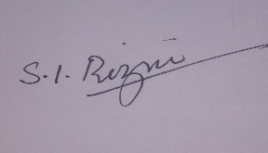
S. No. | Name of Conference/ Seminar etc. | Organized by | Dates and Year | National/  International/  State/  University  level | Attended/  Paper presented/  Chaired session/Resource person etc.
1 | Gani Kashmiri life and style of poetry | Deptt of Persian, Kashmir University | 24th -25th june, 2009 | National Level | Paper presented
2 | Sadi and his works with special reference to gulistan | Deptt of sankrit, Kashmir University | 17th -19th oct, 2011 | National Level | Paper presented
3 | Modern Persian and its status in the society of kashmir | Deptt of Persian, Kashmir University | 28th -29th nov, 2011 | National Level | Paper presented
4 | Maulana Jalal-ud-din Rumi and his teachings | Deptt of Persian, Kashmir University | 29th -31st aug,2012 | International Seminar | Paper presented
5 | 46th session of all India conference,srinagar | Deptt of sankrit, Kashmir University | 1st -3rd oct,2012 | National Level | Paper presented
6 | Basic level workshop on manuscriptology and palaeography | National mission for manuscripts New Delhi in collaboration with Deptt of Persian, Kashmir University | 15th march-4th april,2013 | National Level | Attended

Sign. Of faculty

