THE NATIONAL YOUTH PARLIAMENT FESTIVAL
(ONLINE MODE)

HOW TO UPLOAD VIDEO INTO MY GOV WEBSITE
STEP:1
Individuals has record their speech of 90-120 seconds on any one of the given subjects and upload the videos on YouTube.
DATES FOR CONDUCTING :12 th January 2019 to 18th January 2019
- How: Record their speech of 90-120 seconds on any of the given topics and upload them on YouTube. Then the participant will register at MyGov site (innovate.mygov.in/youth-parliament)and publish the YouTube link of the video.
- Language: English/Hindi/ or the official language of the State Government concerned from which the youth is participating at level of screening for DYP; DYP & SYP.
TOPICS
Topics for digital screening for DYP are as follows:
-> Swachhta & Give It Up (LPG): Inspiring attitudinal change.
-> Ayushman Bharat: Revolutionising the Health Sector.
-> Reducing Poverty through Financial Inclusion Programmes- Jan Dhan & Mudra Yojana.
-> ‘Beej Se Baazar Tak’ and ‘lab to land’ : doubling farmers income.
UPLOAD THE VIDEO IN YOUR YOUTUBE ACCOUNT
STEP:2
Click on: https://innovate.mygov.in/youth-parliament/
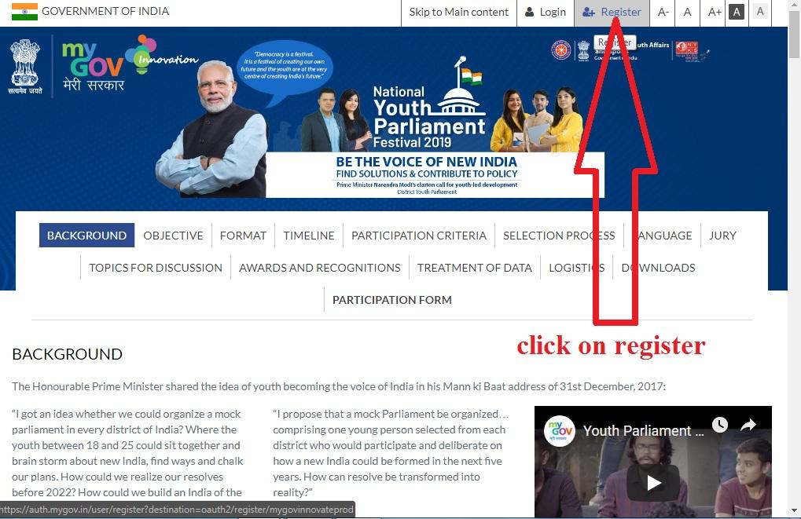
On clicking on register it will direct to: https://auth.mygov.in
Step:3
Register on my gov
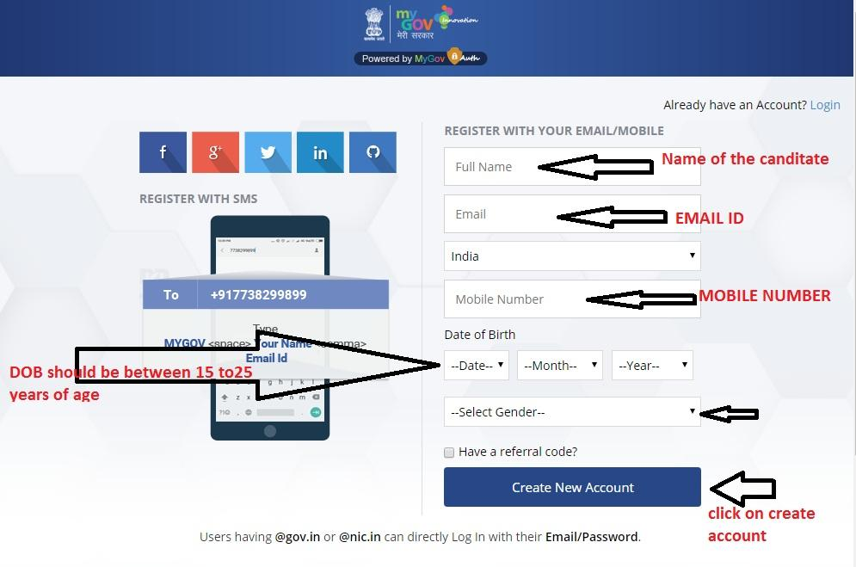
Step :4
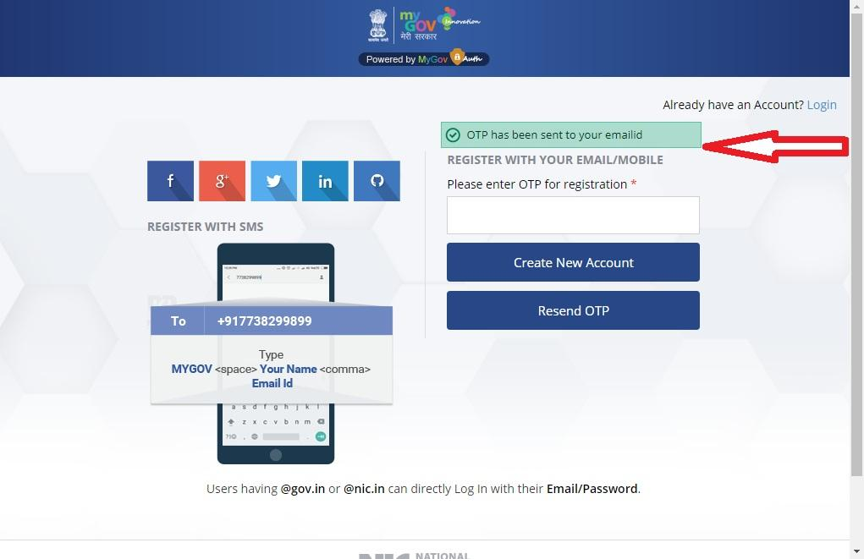
OTP Will be sent to your email id or mobile number
Step :5
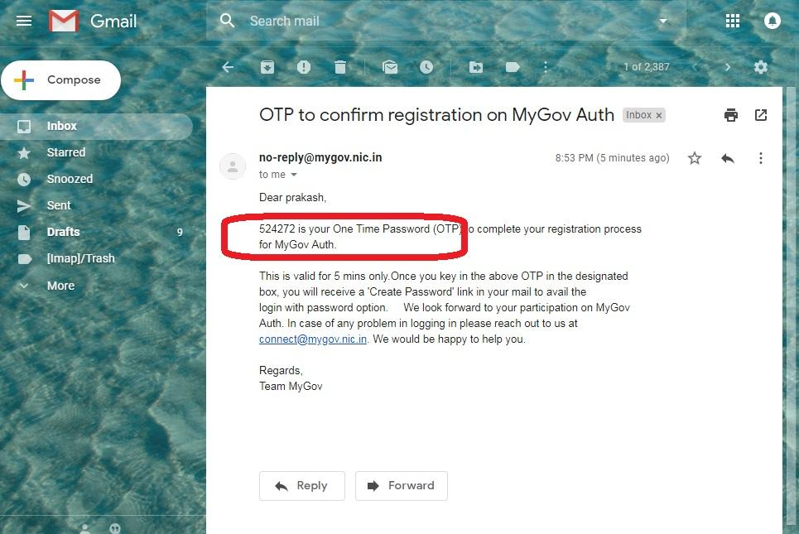
Enter the OTP

Step:6
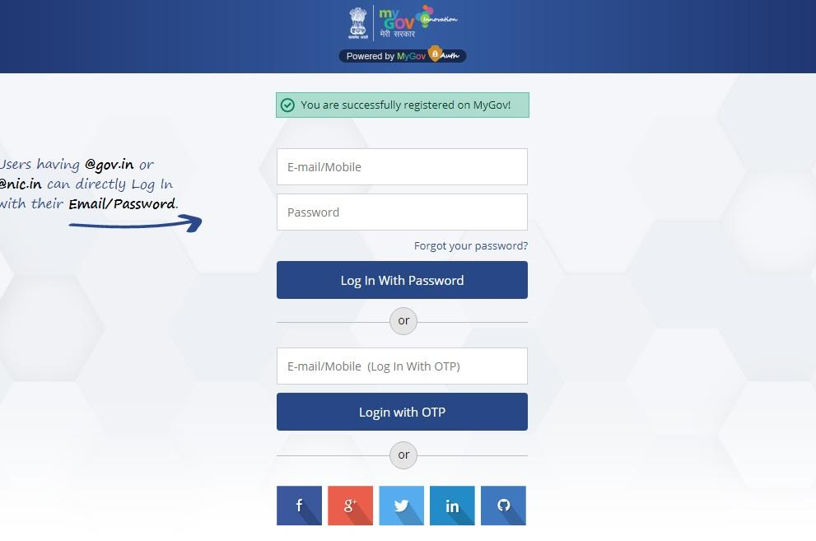
On successful completion this screen will appear
Step:7
Go to your mail id there will be a mail from my gov
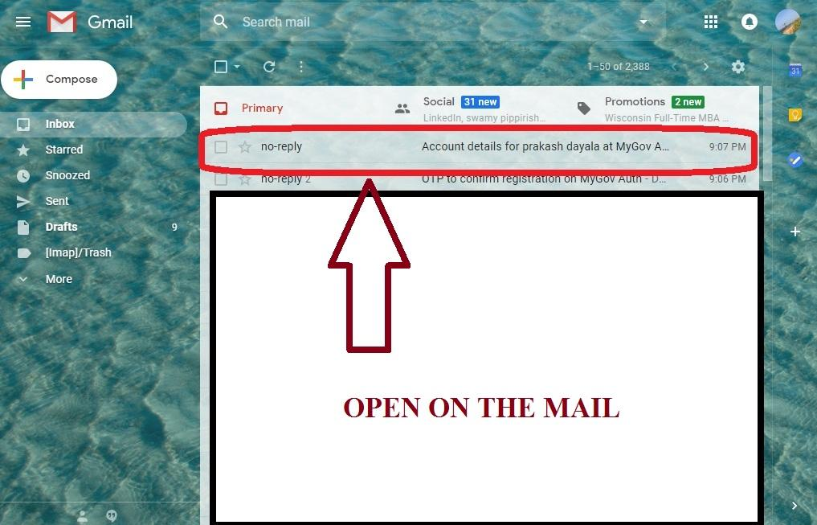

Step:8
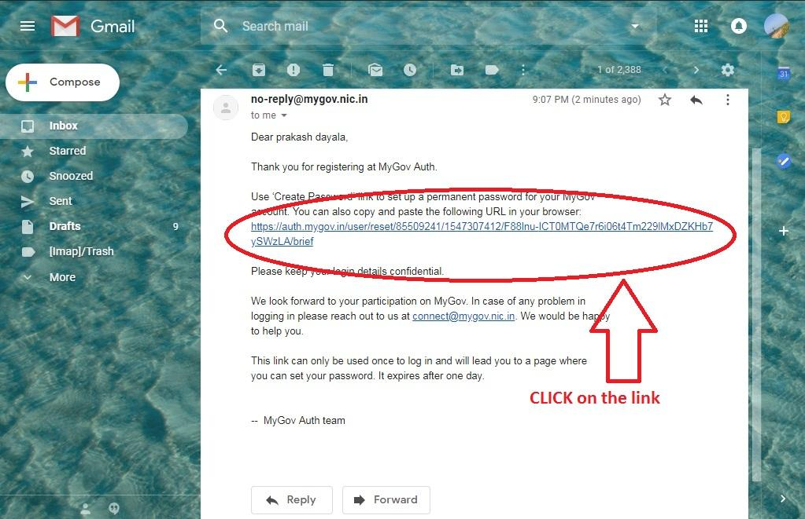

Step :9
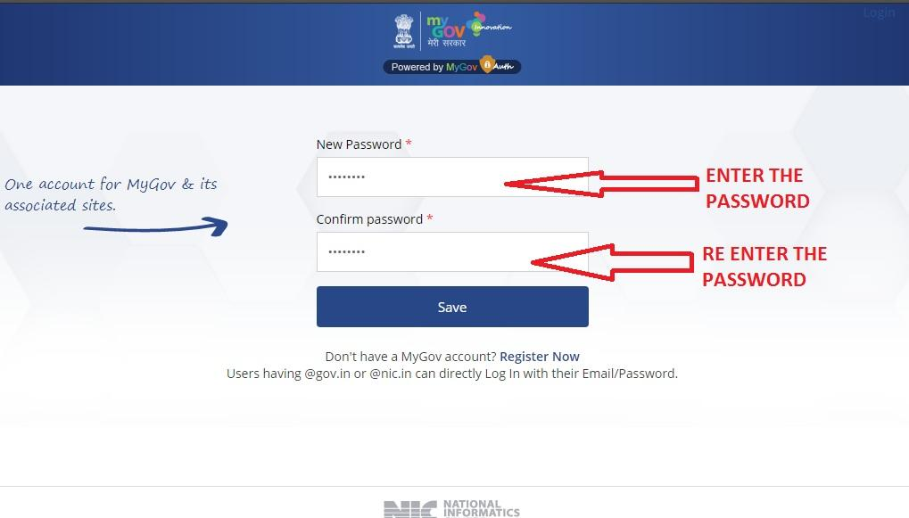

Step:10
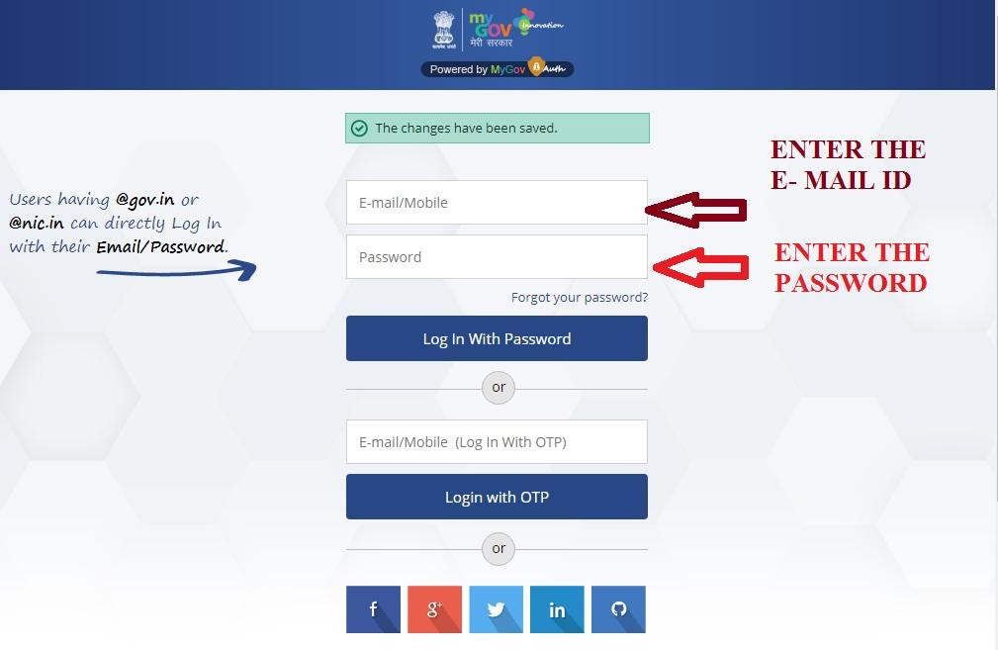

Step:11
AFTER Successful completion of registering into my gov you’ll get this page
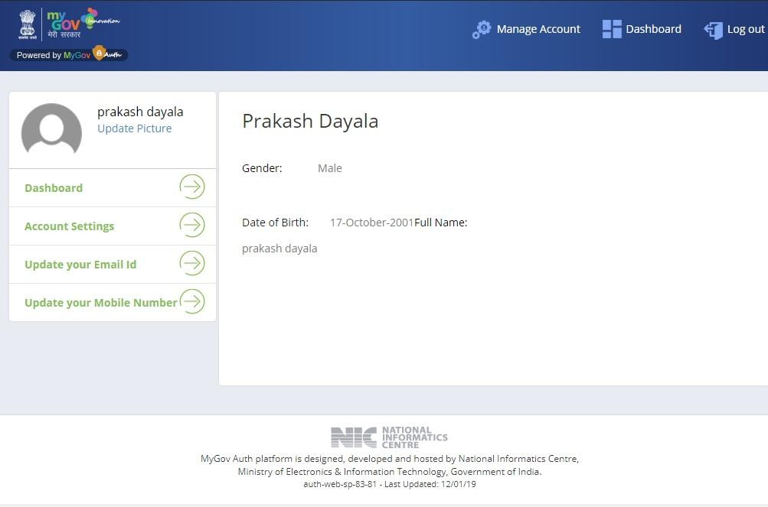
Step:12
Click on : https://innovate.mygov.in/youth-parliament/
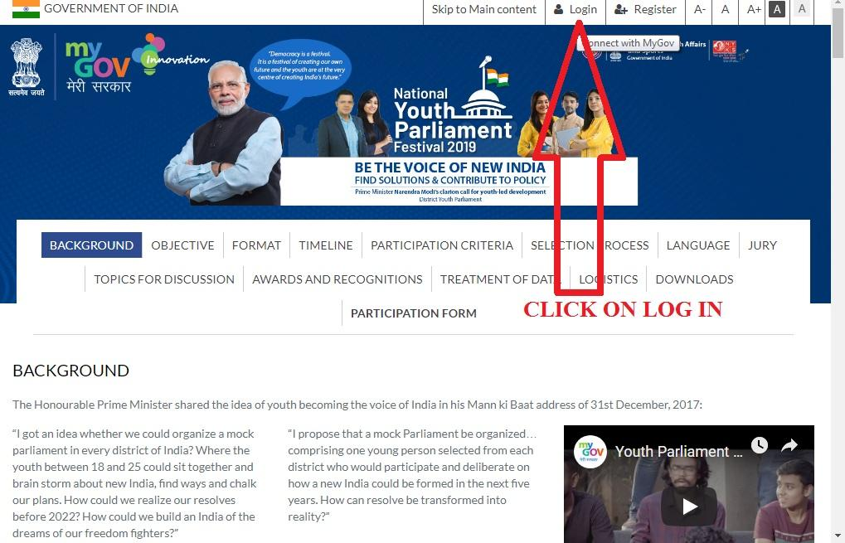
Click on log in
Step:13
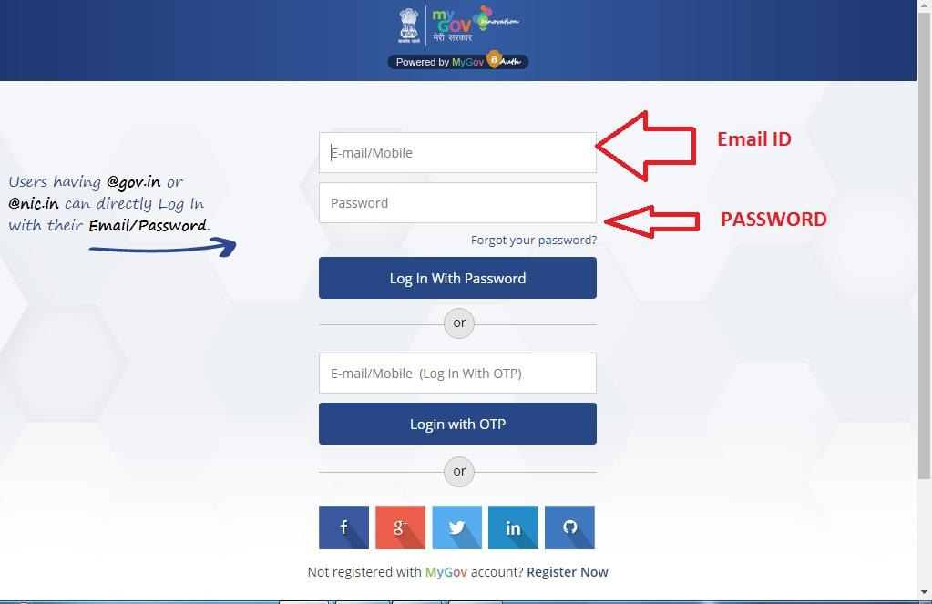

Step: 14
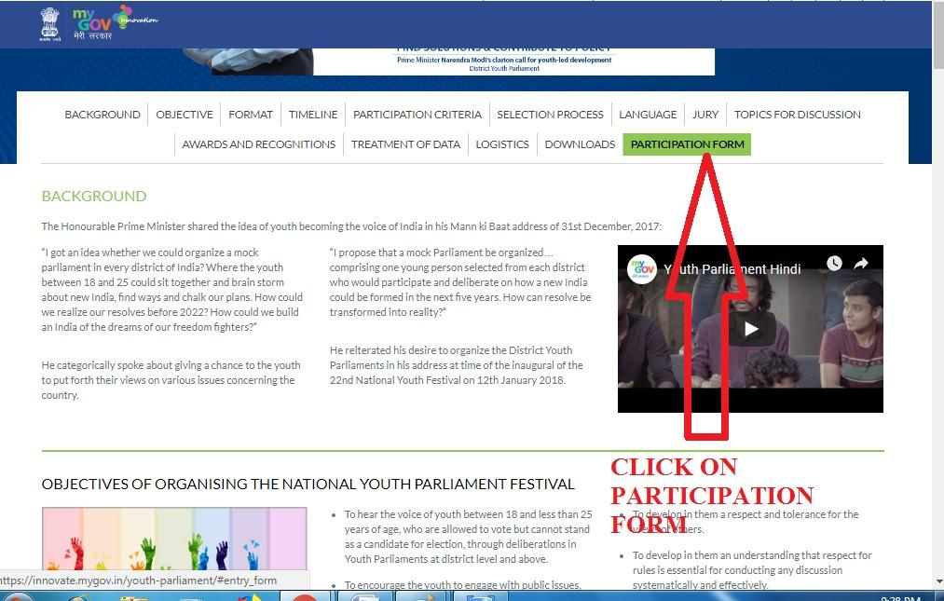
Click on the participation form
Step:15
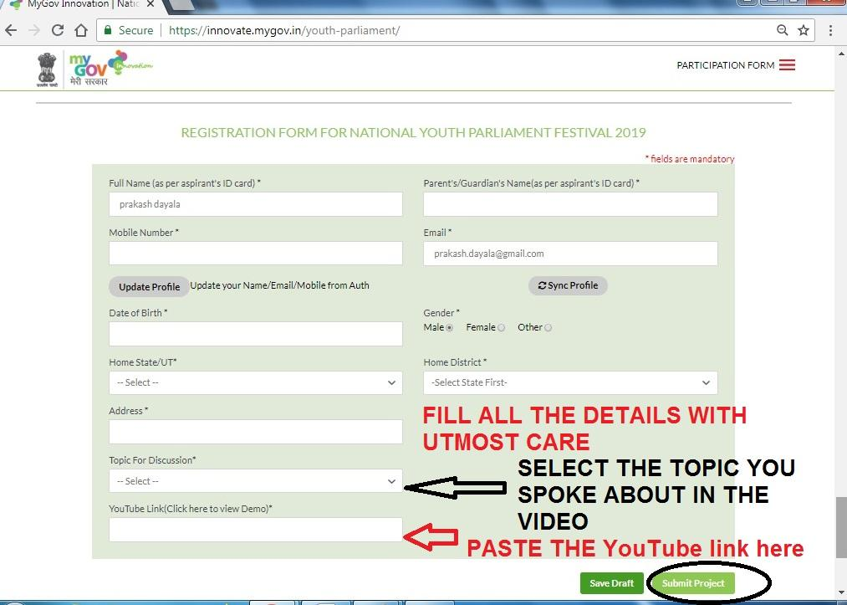
Click on submit report

ALL THE DYC’s, ACT’s, PC’s, NYV’s and individuals involved in youth activities has to guide the youth club members to upload their videos in the YouTube and in
https://innovate.mygov.in/youth-parliament/
and fill the proforma that had been sent to all the kendras

