Faculty Member Profile
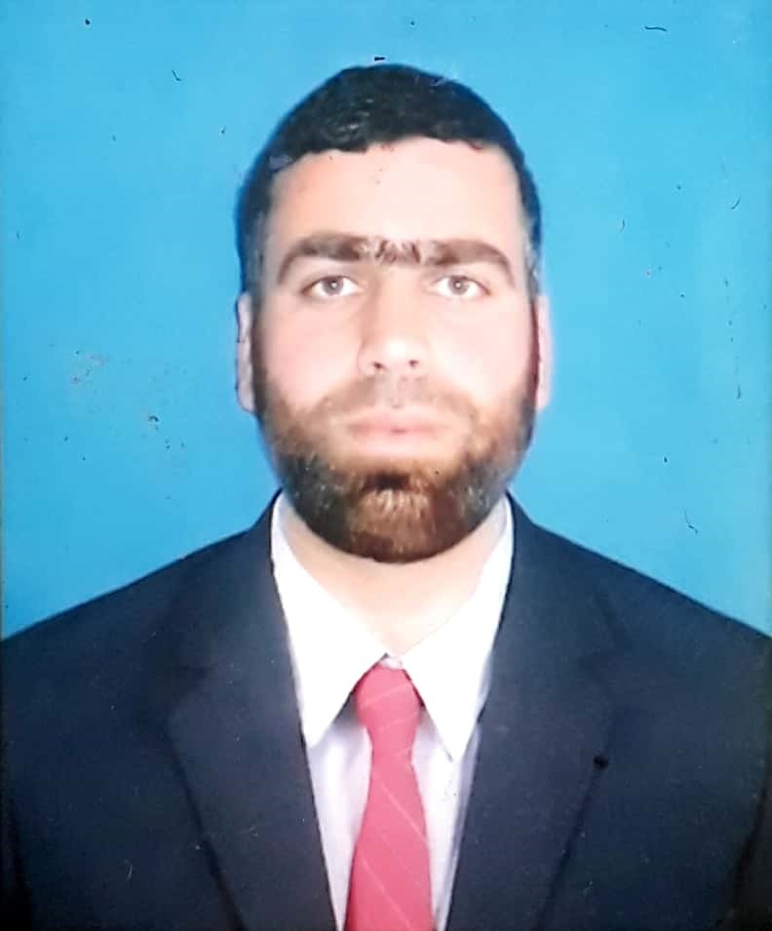
Paste your recent Photocopy

(Govt. Degree College Ganderbal)
- Name : Mehraj Din Dar
- Parentage : Ab. Razak Dar
- Date of Birth : 07-01-1984
- Marital Status : Married
- Residential Address:
Village: Wakura. Tehsil : Wakura
Town: Ganderbal District : Ganderbal Pin : 191131.
- Contact Address/No.:
Email: mdar28@gmail.com
Cell No. 7780878713
- Name of the Department: Higher Education (Education)
- Designation : Assistant Professor
- Courses taught at:
UG level: Undergraduate level.
PG level______________________________________________________________
- Educational qualifications:
Qualification/Degree | Subject | University | Year of Passing
M.Phil | Education | Kashmir university | 2013
M.A. | Education | Kashmir University | 2008-09
M. Ed | M.Ed | Kashmir University | 2009-10
UGC NET | Education |  | 2012
- Service rendered in different Colleges:(Attach Experience Certificate)
College/University | From | to | No. of Years/Months
Government Degree College Ganderbal | 27-03-2017 | Present | 02.
- Innovative processes developed in teaching and learning eg. PPTs, Study material, video lectures, Smarts Boards used etc. : PPTs and video lectures for students.
- Participation in Curricular development: _________________________________ _______________________________________________________(attach document)
- Participation in Co-Curricular development(NSS/NCC/Sports etc.): Member of sports, seminar and debates, and various other committees. (attach document)
- Research, Scholarly, Professional and Scientific Activity (Give details as per format)

Total Research experience:________________

No. of publications in peer-reviewed journals: 04 (attach list)

No. of books/ book chapters published as author or co-author: 01 book Chapter. (attach list)
- Major/Minor research projects completed: ________________
Sr. No. | Title of the project | Date of sanction and duration | Grant received | Funding agency | Status
1
2
- Participation in Conferences/Symposia/Workshops/Seminars: (Attach list)

No. of Conferences attended: 01.

No. of Symposia attended______________________

No. of Seminars attended: 05.

No. of Workshops attended: 01.
- Major Areas of Interest: Early Childhood Education and Teacher Education.
- Orientation/Refresher Course attended
Year | From | To | Name of Academic Staff College
2017 | 06-09-2017 | 06-10-2017 | UGC HRDC Kashmir University.

- Contribution towards Institution:
S. No. | Year | Area of contribution | Convener/Member
01. | 2017 | Sports , debates and seminars and college development, academic monitoring. | Member
02. | 2018 | Sports, debates &seminars, picnics and educational tours. | Co-convener.

Sign. Of faculty

Format for Research, Scholarly, Professional and Scientific Activity

S. No. | Name of Conference/ Seminar etc. | Organized by | Dates and Year | National/  International/  State/  University  level | Attended/  Paper presented/  Chaired session/Resource person etc.
1 | Humanistic Traditions in Education | PG Dept of Education. Kashmir University | 11 November 2017 | National | Presented paper
2 | National Seerah Seminar | Shahi Hamadan Institute of Islamic studies KU | 16-17 December 2017 | National | Presented paper
3 | Workshop on Teaching Learning and Evaluation | Amar-singh college Cluster University | 20-21 December 2017 | National | Participated
4 | Quranic perspective on knowledge, Education and Development | Shahi Hamadan Institute of Islamic studies KU | 14-15 March 2018 | National | Presented paper
5 | Recent developments in science humanities and management | Amar-singh college cluster university | 17-18 April 2018 | International | Presented paper
6

Sign. Of faculty

