Faculty Member Profile
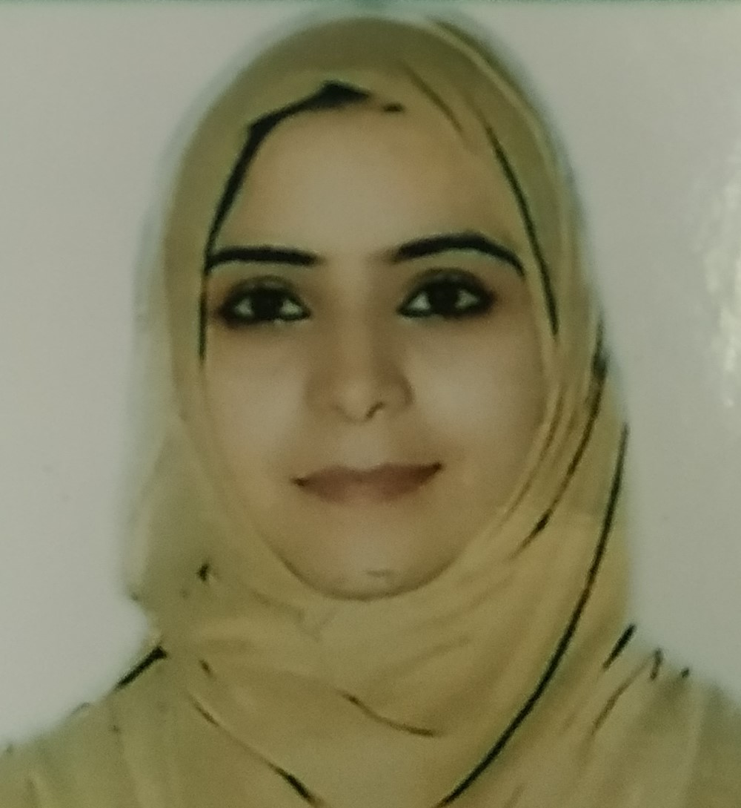
Paste your recent Photocopy

(Govt. degree College Ganderbal)
- Name :__NAZIMA_________________________________
- Parentage :GULAM MUHAMMAD DAR______________________________
- Date of Birth : 15 Oct 1990__________________________________
- Marital Status :_Single___________________________________
- Residential Address:
Village_____Nusso sayed pora_________________________Tehsil________________________________
Town: _Bandipora
District:__Bandipora______________________Pin_:_193502__________
- Contact Address/No.:
Email:nazima146.NF@gmail.com______________________.______________________________
Cell No..__9906597577___________________________.______________________________
- Name of the Department:_ Sociology___________________________________________
- Designation:_Guest Faculty_____________________________________________
- Courses taught at:
UG level:___Sociology__________________________________________________________
PG level______________________________________________________________
- Educational qualifications:
Qualification/Degree | Subject | University | Year of Passing
B.A | Sociology | University of Kashmir | 2012
M.A | Do | do | 2015
NET | Do | do | 2017
- Service rendered in different Colleges:(Attach Experience Certificate)
College/University | From | to | No. of Years/Months
- Innovative processes developed in teaching and learning eg. PPTs, Study material, video lectures, Smarts Boards used etc. :_______yes______________________________ _____________________________________________________________________
- Participation in Curricular development: _________________________________ _______________________________________________________(attach document)
- Participation in Co-Curricular development(NSS/NCC/Sports etc.): ________________yes_____________________________ _______________________________________________________(attach document)
- Research, Scholarly, Professional and Scientific Activity (Give details as per format)

Total Research experience:________________

No. of publications in peer-reviewed journals:____________(attach list)

No. of books/ book chapters published as author or co-author:_____________(attach list)
- Major/Minor research projects completed: ________________
Sr. No. | Title of the project | Date of sanction and duration | Grant received | Funding agency | Status
1
2
- Participation in Conferences/Symposia/Workshops/Seminars: (Attach list)

No. of Conferences attended___________________

No. of Symposia attended__________Nil____________

No. of Seminars attended _______________________

No. of Workshops attended ____________________
- Major Areas of Interest:_ __Sociology_______________
- Orientation/Refresher Course attended
Year | From | To | Name of Academic Staff College

- Contribution towards Institution:
S. No. | Year | Area of contribution | Convener/Member

1

2

3

Sign. Of faculty

Format for Research, Scholarly, Professional and Scientific Activity

S. No. | Name of Conference/ Seminar etc. | Organized by | Dates and Year | National/  International/  State/  University  level | Attended/  Paper presented/  Chaired session/Resource person etc.
1
2
3
4
5
6

Sign. Of faculty

