Faculty Member Profile
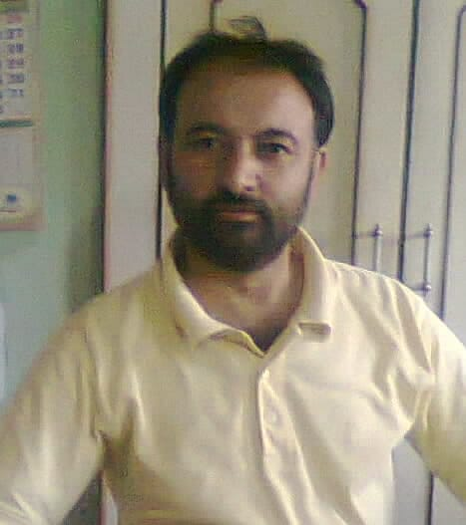
Paste your recent Photocopy

(Govt. degree College Ganderbal)
- Name :Mr Akhtar Hussain Bhat
- Parentage :G.R Bhat
- Date of Birth :26-05-1965
- Marital Status :Married
- Residential Address:Ahmad Nagar Srinagar
District :Srinagar
Pin :190011
- Contact Address/No.: Govt. Degree College, Ganderbal
Email: akhtarhussain16356@gmail.com
Cell No.. 9419094830, 7006373728
- Name of the Department: Mathematics
- Designation:Associate Professor
- Courses taught at:
UG level: Calculus, Real Analysis, Solid Geometry, Plane Geometry, Algebra
PG level: ______________
Educational qualifications:
Qualification/Degree | Subject | University | Year of Passing
M.Sc | Mathematics | University of Kashmir | 1988
- Service rendered in different Colleges:(Attach Experience Certificate)
College/University | From | to | No. of Years/Months
Govt Degree College, Ganderbal | August 2017 | Till date
Govt.Amar Singh College, Srinagar | November 2005 | August 2017 | 2 years
Govt. Degree College Kupwara | April 2005 | November 2005 | 8 months
Govt. Degree College, Bemina, Srinagar | July 1998 | April 2005 | 7 years
Govt. Degree College Anantnag | October 1994 | July 1998 | 4 years
- Innovative processes developed in teaching and learning eg. PPTs, Study material, video lectures, Smarts Boards used etc. : Lecture delivering _____________________________________________________________________
- Participation in Curricular development: _________________________________ _______________________________________________________(attach document)
- Participation in Co-Curricular development(NSS/NCC/Sports etc.): __________________________________________________________________ _______________________________________________________(attach document)
- Research, Scholarly, Professional and Scientific Activity (Give details as per format)

Total Research experience:________________

No. of publications in peer-reviewed journals: 04

No. of books/ book chapters published as author or co-author: Nil
- Major/Minor research projects completed: ________________
Sr. No. | Title of the project | Date of sanction and duration | Grant received | Funding agency | Status
1
2
- Participation in Conferences/Symposia/Workshops/Seminars: (Attach list)

No. of Conferences attended: 01

No. of Symposia attended:

No. of Seminars attended: 01

No. of Workshops attended: 02
- Major Areas of Interest: Complex Analysis and Approximation Theory
- Orientation/Refresher Course attended
Year | From | To | Name of Academic Staff College
2000 | 09-10-2000 | 30-10-2000 | Human Resource Development Centre, University of Kashmir
2001 | 10-11-2001 | 04-12-2001 | Human Resource Development Centre, University of Kashmir
2007 | 23-08-2007 | 12-09-2007 | Human Resource Development Centre, University of Kashmir
2009 | 04-03-2009 | 27-03-2009 | Human Resource Development Centre, University of Kashmir

- Contribution towards Institution:
S. No. | Year | Area of contribution | Convener/Member
1 | 2017 | Advisory/Monitoring committee, RUSA and College Canteen committee,  Purchasing committee, Discipline Committee | Convener  Member
2 | 2018 | Advisory/Monitoring committee, RUSA and College Canteen committee,  Purchasing committee and Discipline committee | Convener  Member

Sign. Of faculty

Format for Research, Scholarly, Professional and Scientific Activity

S. No. | Name of Conference/ Seminar etc. | Organized by | Dates and Year | National/  International/  State/  University  level | Attended/  Paper presented/  Chaired session/Resource person etc.
1
2
3
4
5
6

Sign. Of faculty

