Faculty Member Profile
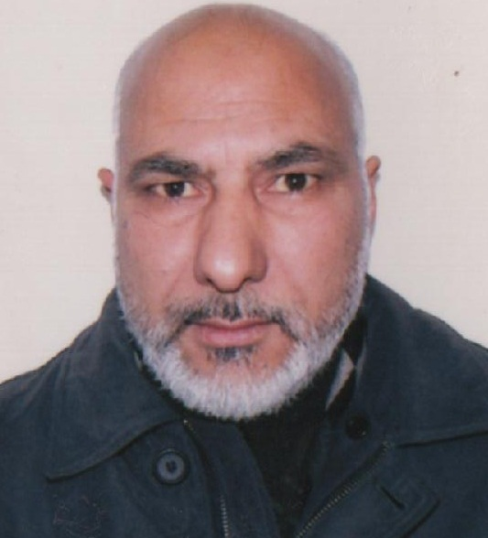

(Govt. Degree College Ganderbal)
- Name :Bashir Ahmad Mir
- Parentage : Mohammad Kamal Mir
- Date of Birth : 03-04-1963
- Marital Status : Married
- Residential Address : Kijipora, Kangan Ganderbal Kashmir

- Contact Address/No.: Kijipora, Kangan Ganderbal Kashmir
9419552094
Email:bmir589@gmail.com
Cell No. 9419552094
- Name of the Department: Geography
- Designation: Associate Professor
- Courses taught at:
UG level: Physical Geography, Human Geography, Regional Geography, Geography of India.
PG level: ______________Nil_________________________________
- Educational qualifications:
Qualification/ Degree | Subject | University | Year of Passing
M. Phil | Geography | Kashmir University | 1989
M.A | Geography | Kashmir University | 1984
B.A | General | Kashmir University | 1982
- Service rendered in different Colleges:(Attach Experience Certificate)
College/University | From | to | No. of Years/Months
G.D.C Udhampur | July 1999 | Aug-2003 | 4 years
SP College Srinagar | Aug 2003 | Sept-2007 | 4 years
Govt. College for Women, M.A Road Srinagar | Sept-2007 | Nov-2013 | 6 years
G.D.C Anantnag | Nov-2013 | Nov-2013 | 24 days
G.D.C Ganderbal, Kashmir | Nov-2013 | Till date | 6 years
- Innovative processes developed in teaching and learning eg. PPTs, Study material, video lectures, Smarts Boards used etc. : Yes
- Participation in Curricular development: (attach document)

- Participation in Co-Curricular development(NSS/NCC/Sports etc.): Yes
- Research, Scholarly, Professional and Scientific Activity (Give details as per format)

Total Research experience: 2 years (M.phil)

No. of publications in peer-reviewed journals: Nil

No. of books/ book chapters published as author or co-author: Nil
- Major/Minor research projects completed: ________________
Sr. No. | Title of the project | Date of sanction and duration | Grant received | Funding agency | Status
1

- Participation in Conferences/ Symposia/ Workshops/ Seminars (Attach list)

No. of Conferences attended: 1

No. of Symposia attended: Nil

No. of Seminars attended: Nil

No. of Workshops attended: 1
- Major Areas of Interest:__Field Studies______________
- Orientation/Refresher Course attended
Year | From | To | Name of Academic Staff College
2000 | 19-06-2000 | 15-07-2000 | ASC, Kashmir University
2004 | 28-12-2004 | 17-01-2005 | ASC, Jamia Millia Islamia, New Delhi
2008 | 26-11-2008 | 18-12-2008 | ASC, AMU, Aligarh
2012 | 10-01-2012 | 31-01-2012 | ASC, Kashmir University

- Contribution towards Institution:
S. No. | Year | Area of contribution | Convener/Member
1 | 2013-19 | Field Studies | Convener
2 | 2013-19 | Advisory Committee | Member
3 | 2013-17 | Time Table Committee | Convener

Signature of Faculty

Format for Research, Scholarly, Professional and Scientific Activity
S. No. | Name of Conference/ Seminar etc. | Organized by | Dates and Year | National/  International/State/  University level | Attended/Paper presented/  Chaired session/Resource person etc.
1 | Two Days Conference on Education | Govt. College for Women, MA Road Srinagar | 25-26 May, 2009 | State | Attended
2 | Two Days Short term course on Disaster Management | ASC Kashmir University | 19-20-Oct-2011 | State | Attended

Signature of Faculty

