Faculty Member Profile
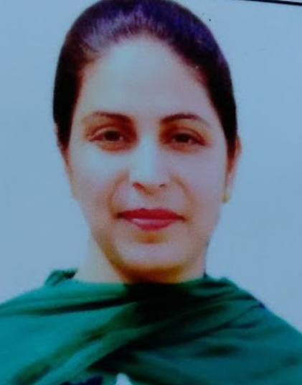
Paste your recent Photocopy

(Govt. degree College Ganderbal)
- Name :RahilaKhurshid
- Parentage :Khurshid Ahmed
- Date of Birth :12//11/1979
- Marital Status :Married
- Residential Address
Village: Ishber Tehsil:
Town: District: Srinagar Pin: 191121
- Contact Address/No.:IshberSrinagar Kashmir
Email:rahizulfi@gmail.com
Cell No. 7006441501
- Name of the Department: Department of Computer applications
- Designation:Asst. Lecturer
- Courses taught at:
UG level: BCA
PG level:
- Educational qualifications:
Qualification/Degree | Subject | University | Year of Passing
PG | MCA | IGNOU | 2006
UG | B.ED. | KU | 2012
- Service rendered in different Colleges:(Attach Experience Certificate)
College/University | From | to | No. of Years/Months
Womens College M.A Road | May 2008 | April 2009
A.s college GogjiBagh | 2009 | 2010
A.s college GogjiBagh | 2010 | 20111
A.s college GogjiBagh | 2011 | 2012
G.D.C Ganderbal | 2014 | Till date
- Innovative processes developed in teaching and learning eg. PPTs, Study material, video lectures, Smarts Boards used etc. :_____________________________________ _____________________________________________________________________
- Participation in Curricular development: _________________________________ _______________________________________________________(attach document)
- Participation in Co-Curricular development(NSS/NCC/Sports etc.): __________________________________________________________________ _______________________________________________________(attach document)
- Research, Scholarly, Professional and Scientific Activity (Give details as per format)

Total Research experience:________________

No. of publications in peer-reviewed journals:_____________(attach list)

No. of books/ book chapters published as author or co-author:_____________(attach list)
- Major/Minor research projects completed: ________________
Sr. No. | Title of the project | Date of sanction and duration | Grant received | Funding agency | Status
1
2
- Participation in Conferences/Symposia/Workshops/Seminars: (Attach list)

No. of Conferences attended_____________________

No. of Symposia attended______________________

No. of Seminars attended _______________________

No. of Workshops attended _____________________
- Major Areas of Interest:________________________
- Orientation/Refresher Course attended
Year | From | To | Name of Academic Staff College

- Contribution towards Institution:
S. No. | year | Area of contribution | Convener/Member
01 | 2016 | CCC | Prof. Naseer (Physics)
02 | 2017 | CCC | Prof Junaid (CS)
03 | 2018 | CCC | Prof. Asiya (CS)

Sign. Of faculty

Format for Research, Scholarly, Professional and Scientific Activity
S. No. | Name of Conference/ Seminar etc. | Organized by | Dates and Year | National/  International/  State/  University  level | Attended/  Paper presented/  Chaired session/Resource person etc.
1
2
3
4
5
6

Sign. Of faculty

