Faculty Member Profile
(Govt. degree College Ganderbal)
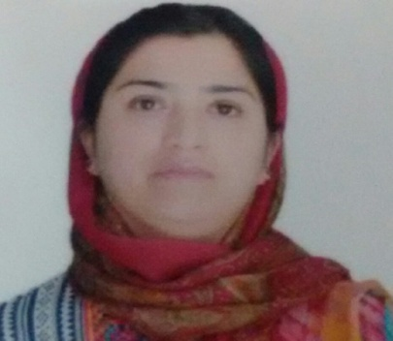
1. Name: Shaiesta Shah
2. Parentage: Mushtaq Ahmed Shah
3. Date of Birth: 17-05-1980
4. Marital Status: Married
5. Residential Address: Friends Colony near Green Park, Harwan
District:_Srinagar Pin - 190012
6. Contact Address : same as above
Email:¬¬¬¬¬¬¬¬ shaiestashah@gmail.com
Cell No: 9419056777
Department: Botany
Designation: Lecturer
Courses taught at UG level:
a) Botany
b) Medicinal Botany
Educational qualifications:
Qualification/Degree | Subject | University | Year of Passing
B.Sc | medical | University of kashmir | 2002
M.Sc | Botany | Baba Saheb Ambedkar Marathwada University | 2005
PhD | Botany | Baba Saheb Ambedkar Marathwada University | 2011

7. Service rendered in different Colleges: (Attach Experience Certificate)
College/University | From | To | No. of Years/Months
G.D.C Bemina | 23-05-2006 | 31-12-2006 | 7 months
G.D.C Bemina | 24-04-2009 | 07-11-2009 | 7 months
G.W.C M.A. Road | June 2014 | Nov 2017 | 3 years 4 months
G.D.C Ganderbal | 05-04-2018 | Till date

8. Innovative processes developed in teaching and learning eg. PPTs, Study material, video lectures, Smarts Boards used etc.:_____________________________________ _____________________________________________________________________
9. Participation in Curricular development: _________________________________ _______________________________________________________(attach document)
10. Participation in Co-Curricular development(NSS/NCC/Sports etc.): __________________________________________________________________ _______________________________________________________(attach document)
11. Research, Scholarly, Professional and Scientific Activity (Give details as per format)

Total Research experience: 7 months as RA
No. of publications in peer-reviewed journals:_____13_____(attach list)
No. of books/ book chapters published as author or co-author:_____________(attach list)
12. Major/Minor research projects completed: ________________
Sr. No. Title of the project Date of sanction and duration Grant received Funding agency Status
1
2
13. Participation in Conferences/Symposia/Workshops/Seminars: (Attach list)
No. of Conferences attended_______4____________
No. of Symposia attended__________3____________
No. of Seminars attended __________2_____________
No. of Workshops attended _________2____________
14. Major Areas of Interest:________________________
15. Orientation/Refresher Course attended
Year From To Name of Academic Staff College

16. Contribution towards Institution:
S. No. year Area of contribution Convener/Member

Format for Research, Scholarly, Professional and Scientific Activity

S. No. Name of Conference/Seminar etc. Organized by Dates and Year National/International/
State/University level Attended/ Paper presented/Chaired session/Resource person etc.
1
2
3
4
5
6

Sign. Of faculty

