Faculty Member Profile
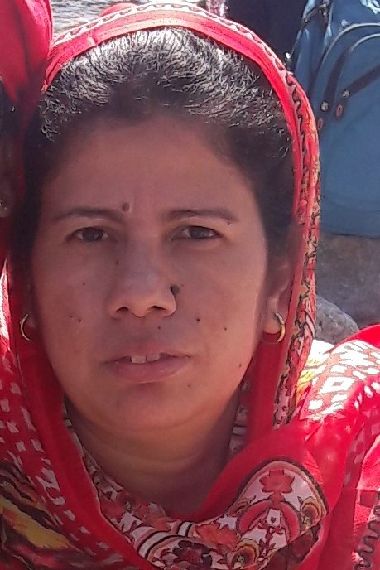
Paste your recent Photocopy

(Govt. degree College Ganderbal)
- Name :__TABASUM BASHIR_______________________________
- Parentage :BASHIR AHMAD______________________________
- Date of Birth : 4th May 1975__________________________________
- Marital Status :_Single___________________________________
- Residential Address:
Village_________Vicharnag_____________________Tehsil________________________________
Town: _Nowshera
District:__Srinagar______________________Pin_:_190011__________
- Contact Address/No.:9797224691
Email:Tabasumbashir1986@gmail.com______________________.______________________________
Cell No..__9797224691____________________________.______________________________
- Name of the Department:_ Sociology___________________________________________
- Designation: Teaching Assistant_____________________________________________
- Courses taught at:
UG level:___Sociology__________________________________________________________
PG level______________________________________________________________
- Educational qualifications:
Qualification/Degree | Subject | University | Year of Passing
B.A | Sociology | University of Kashmir | 2001
M.A | do | do | 2004
M.Phil | do | do | 2006
- Service rendered in different Colleges:(Attach Experience Certificate)
College/University | From | to | No. of Years/Months
Govt.Degree College Ganderbal | 28-05-2007 | 31-12-2007 | 7 months
GDC Pulwama | 01-04-2008 | 31-01-2009 | 9 months
GDC Ganderbal | 02-04-2009 | 28-02-2010 | 11 months
Govt.College for Women Nawa Kadal | 25-05-2010 | 28-02-2011 | 9 months
GDC Ganderbal | 16-07-2011 | 29-02-2012 | 8 months
GDC Kangan | 12-03-2012 | 28-02-2013 | 1 year
GDC Baghi Dilawar Khan | 29-03-2013 | 28-02-2014 | 1 year
GDC Ganderbal | 24-03-2014 | 30-04-2015 | 1 year
GDC Baghi Dilawar Khan | 13-06-2015 | 29-02-2016 | 8 months
Govt.College for Women Nawa Kadal | 11-04-2016 | 13-03-2017 | 1 year
GDC Ganderbal | 17-04-2017 | Till date | 2 years
- Innovative processes developed in teaching and learning eg. PPTs, Study material, video lectures, Smarts Boards used etc. :_______yes______________________________ _____________________________________________________________________
- Participation in Curricular development: _________________________________ _______________________________________________________(attach document)
- Participation in Co-Curricular development(NSS/NCC/Sports etc.): ________________yes_____________________________ _______________________________________________________(attach document)
- Research, Scholarly, Professional and Scientific Activity (Give details as per format)

Total Research experience:___2 years_____________

No. of publications in peer-reviewed journals:___________(attach list)

No. of books/ book chapters published as author or co-author:_____________(attach list)
- Major/Minor research projects completed: ________________
Sr. No. | Title of the project | Date of sanction and duration | Grant received | Funding agency | Status
1
2
- Participation in Conferences/Symposia/Workshops/Seminars: (Attach list)

No. of Conferences attended____________________

No. of Symposia attended__________________

No. of Seminars attended _____________________

No. of Workshops attended ___________________
- Major Areas of Interest:_ __________Sociology___________
- Orientation/Refresher Course attended
Year | From | To | Name of Academic Staff College

- Contribution towards Institution:
S. No. | Year | Area of contribution | Convener/Member

1

2

3

Sign. Of faculty

Format for Research, Scholarly, Professional and Scientific Activity

S. No. | Name of Conference/ Seminar etc. | Organized by | Dates and Year | National/  International/  State/  University  level | Attended/  Paper presented/  Chaired session/Resource person etc.

Sign. Of faculty

