Faculty Member Profile
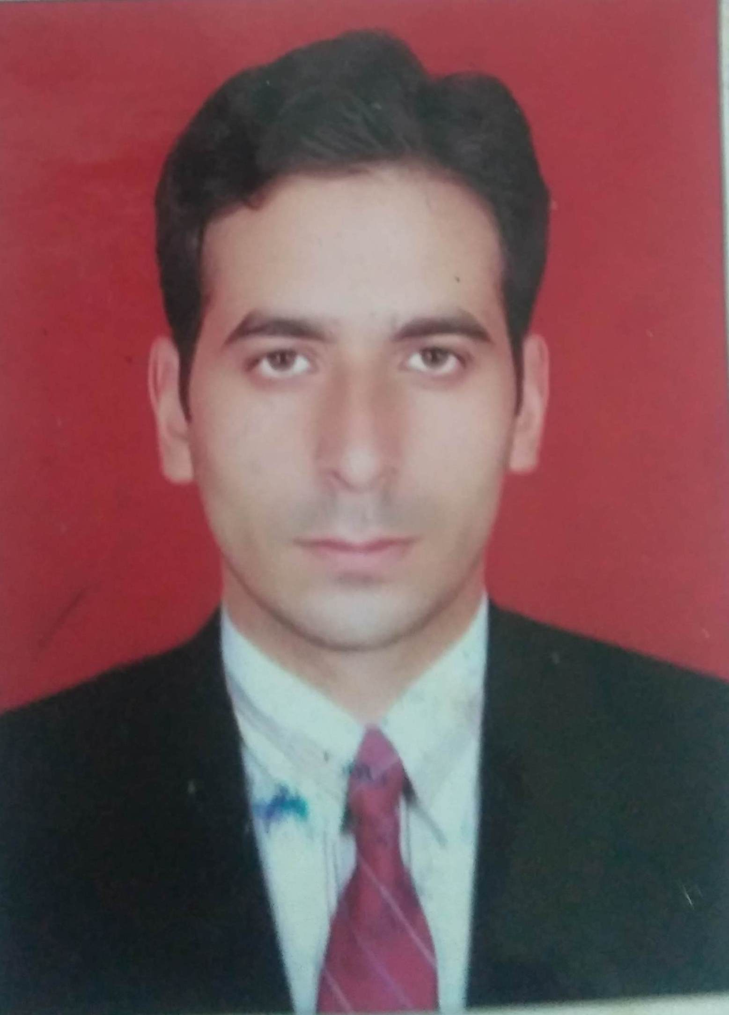

(Govt. degree College Ganderbal)
- Name :- Ajaz Ahmad Dar
- Parentage :- Abdul Ahad Dar
- Date of Birth 05 Dec. 1986
- Marital Status: Married
- Residential Address:
Village Qazigund Tehsil Kakapora .
Town Kakapora .District Pulwama .Pin 192304
- Contact Address/No.:
Email:.ajazahmad123@gmail.com
Cell No..8491040468
- Name of the Department:Chemistry
- Designation: Assistant Lecturer.
- Courses taught at:
UG level: B.Sc. 1st Semester, 2nd Semester, 3rd semester, 4th semester, 5th semester,
PG level: Nil.
- Educational qualifications:
Qualification/Degree | Subject | University | Year of Passing
M. Sc. | Chemistry | Barkatullah university(Bhopal) | 2011
M.Phil. | Chemistry | APSU Rewa (bhopal) | 2012
- Service rendered in different Colleges:(Attach Experience Certificate)
College/University | From | to | No. of Years/Months
G.D.C Bandipora | 26-04-2016 | 31-03-2017 | 11 Months
G.D. C. Handwara | 15-06-2017 | 31-03-2018 | 11 Months
G.D .C . Ganderbal | 09-05-2018 | Till date | 12 Months
- Innovative processes developed in teaching and learning e.g. PPTs, Study material, video lectures, Smarts Boards used etc.:- Smart board, PPT, C assignment, Class tests, Group discussions etc.
- Participation in Curricular development: Nil . (attach document)
- Participation in Co-Curricular development(NSS/NCC/Sports etc.): Nil .(attach document)
- Research, Scholarly, Professional and Scientific Activity (Give details as per format)

Total Research experience: Nil.

No. of publications in peer-reviewed journals: Nil (attach list)

No. of books/ book chapters published as author or co-author Nil (attach list)
- Major/Minor research projects completed: ________________
Sr. No. | Title of the project | Date of sanction and duration | Grant received | Funding agency | Status
1
- Participation in Conferences/Symposia/Workshops/Seminars: (Attach list)

No. of Conferences attended__Nil__________________

No. of Symposia attended___Nil___________________

No. of Seminars attended Nil .

No. of Workshops attended Nil .
- Major Areas of Interest: _____________
- Orientation/Refresher Course attended
Orientation | From | To | Name of Academic Staff College

- Contribution towards Institution:
S. No. | year | Area of contribution | Convener/Member

Sign. Of faculty

Format for Research, Scholarly, Professional and Scientific Activity

S. No. | Name of Conference/ Seminar etc. | Organized by | Dates and Year | National/  International/  State/  University  level | Attended/  Paper presented/  Chaired session/Resource person etc.

Sign. Of faculty

