Faculty Member Profile
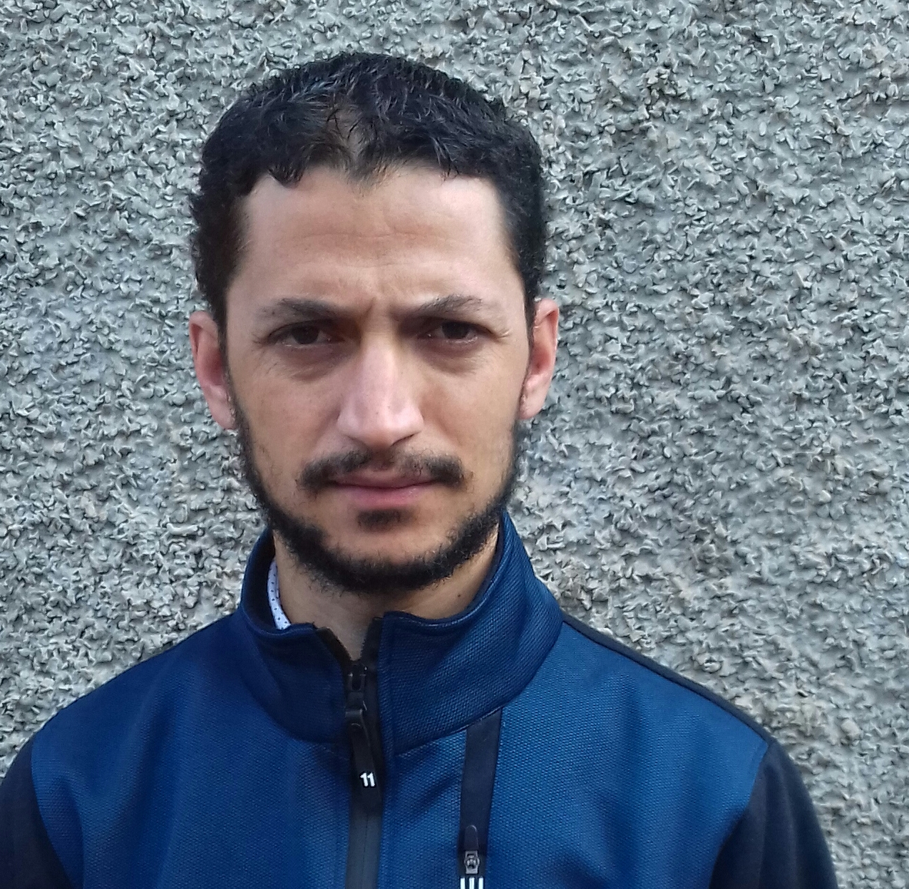
Paste your recent Photocopy

(Govt. degree College Ganderbal)
- Name :MOHD AJAZ MANDOO__________________________________
- Parentage :_MOHD AMIN MANDO__________________________________
- Date of Birth :____16-01-1984_______________________________
- Marital Status :__Unmarried __________________________________
- Residential Address:
Village___Buchpora____Tehsil____Ganderbal_____________________________
Town_____Buchpora______________District.Srinagar____Pin: 190020
- Contact Address/No.:
Email:.___ajazmadoo17commerce@gmail.com
Cell. No: 8825093915

- Name of the Department: Commerce
- Designation:___Assistant Professor _______
- Courses taught at:
UG level: Income Tax laws and Practice, Business statistics, Corporateaccounting , Investment management , Human resource management etc. .
- Educational qualifications:
Qualification/Degree | Subject | University | Year of Passing
SET | Commerce | University of Kashmir | 2016
NET | commerce | UGC | 2012
M.COM | commerce | University of Kashmir | 2010
B.COM | commerce | University of Kashmir | 2006
- Service rendered in different Colleges:(Attach Experience Certificate)
College/University | From | to | No. of Years/Months
GDC GANDERBAL | 02-04-2013 | 28-02-2014 | 11 Months
GDC SUMBAL | 01-04-2014 | 30-04-2015 | 13 Months
GDC GANDERBAL | 06-06-2015 | 29-02-2016 | 09 Months
GDC GANDERBAL | 06-04-2016 | 14-02-2017 | 11 Months
- Innovative processes developed in teaching and learning eg. PPTs, Study material, video lectures, Smarts Boards used etc. :study material developed for human resourcemanagement under learning management system .
- Participation in Curricular development: Observer in various sports events
- Participation in Co-Curricular development(NSS/NCC/Sports etc.): NIL
- Research, Scholarly, Professional and Scientific Activity (Give details as per forma

Total Research experience:____NIL____________

No. of publications in peer-reviewed journals:______NIL_______

No. of books/ book chapters published as author or co-author:_____NIL_______
- Major/Minor research projects completed: ____NIL____________
- Participation in Conferences/Symposia/Workshops/Seminars:

No. of Conferences attended____01_________________

No. of Symposia attended: _______NIL_______________

No. of Seminars attended _______NIL________________

No. of Workshops attended ____01_________________
- Major Areas of Interest: Finance and Taxation
- Orientation/Refresher Course attended
Year | From | To | Name of Academic Staff College
2017 | 26/12/217 | 23/01/2018 | University of kashmir

- Contribution towards Institution:
S. No. | year | Area of contribution | Convener/Member
 | 2017 | Time table Framing and calculation of taxation of employees. | Convener
 | 2018 | Time table Framing and calculation of taxation of employees. | Convener
 | 2019 | Time table Framing and calculation of taxation of employees. | Convener

Sign. Of faculty

Format for Research, Scholarly, Professional and Scientific Activity

S. No. | Name of Conference/ Seminar etc. | Organized by | Dates and Year | National/  International/  State/  University  level | Attended/  Paper presented/  Chaired session/Resource person etc.
1 | Sustainable development and environmental issues in jammu and kashmir problems and prospects | GDC Ganderbal | 20-03-2017 | State | Attended
2 | Nil

Sign. Of faculty

