Faculty Member Profile
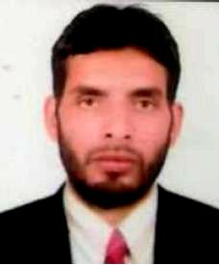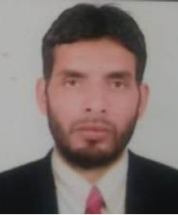

(Govt. Degree College Ganderbal)
- Name :Khursheed Ahmad Dar
- Parentage :Abdul Ahad Dar
- Date of Birth : 06-02-1985
- Marital Status : Married
- Residential Address:
- Village: Mughalpora Tehsil: Pulwama
Town: Pulwama District: Pulwama Pin: 192301
- Contact Address/No.:
Email:akhursheed354@gmail.com
Cell No. +91 7889693803
- Name of the Department: Urdu
- Designation: Assistant lecturer
- Courses taught at:
UG level: Poetry, Prose, and Mil Urdu (language).
PG level: Nil
- Educational qualifications:
Qualification/Degree | Subject | University | Year of Passing
12th | Geography, Urdu, English and P. Science | BOSE | 2003
B.A. | Arabic , Urdu, English and Education | University of Kashmir | 2010
M. A. | Urdu | Barkatullah University | 2012
B.Ed. | Phylosophy, E. technology, Development of Education and Teaching of education | University of Kashmir | 2014
M.Phil | Urdu | Bhajwat University Ajmeer | 2015

- Service rendered in different Colleges:(Attach Experience Certificate)
College/University | From | to | No. of Years/Months
Degree college Uri | 17th April 2014 | 28 February 2015
Degree college Khurd | 2nd Nov 2015 | 12th August 2016
Degree college Baggha | 19th August 2016 | 4th April 2017
Degree college Pampore | 8th April 2017 | 31st March 2018
Degree college Ganderbal | 23rd April 2018 | Till date
- Innovative processes developed in teaching and learning eg. PPTs, Study material, video lectures, Smarts Boards used etc. : Nil
- Participation in Curricular development: _________________________________ _______________________________________________________(attach document)
- Participation in Co-Curricular development(NSS/NCC/Sports etc.): __________________________________________________________________ _______________________________________________________(attach document)
- Research, Scholarly, Professional and Scientific Activity (Give details as per format)

Total Research experience:________________

No. of publications in peer-reviewed journals:_____________(attach list)

No. of books/ book chapters published as author or co-author:_____________(attach list)

- Major/Minor research projects completed: ________________
Sr. No. | Title of the project | Date of sanction and duration | Grant received | Funding agency | Status
1
2
- Participation in Conferences/Symposia/Workshops/Seminars: (Attach list)

No. of Conferences attended: 1

No. of Symposia attended______________________

No. of Seminars attended _______________________

No. of Workshops attended _____________________
- Major Areas of Interest:________________________
- Orientation/Refresher Course attended
Year | From | To | Name of Academic Staff College

- Contribution towards Institution:
S. No. | year | Area of contribution | Convener/Member

Format for Research, Scholarly, Professional and Scientific Activity

S. No. | Name of Conference/ Seminar etc. | Organized by | Dates and Year | National/  International/  State/  University  level | Attended/  Paper presented/  Chaired session/Resource person etc.
1 | Urdu Mushaira | Iqbal Library Bhopal | 2012 | National | Paper presented
2
3
4
5
6

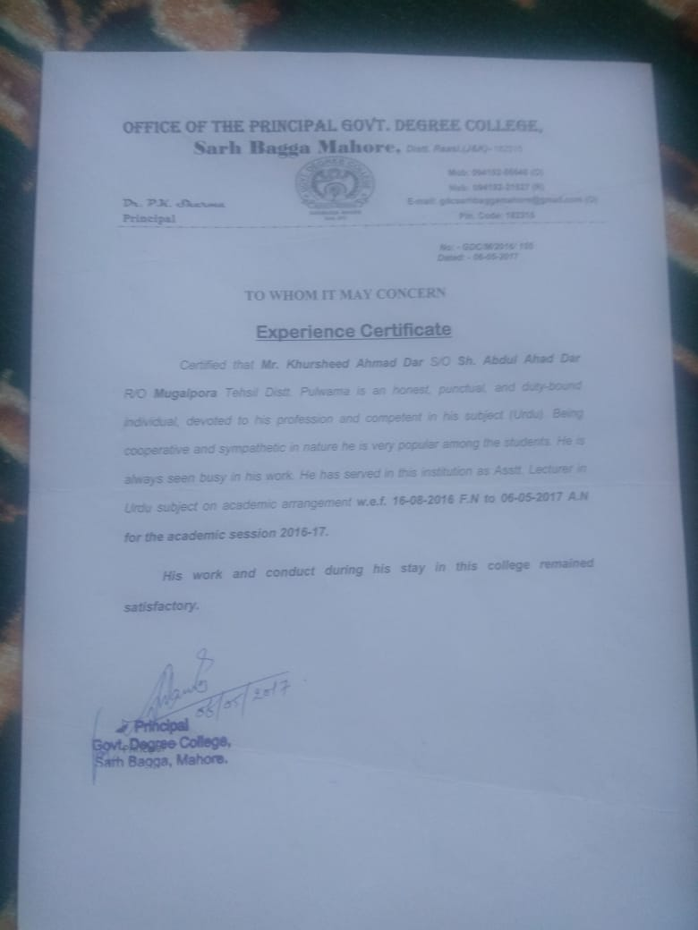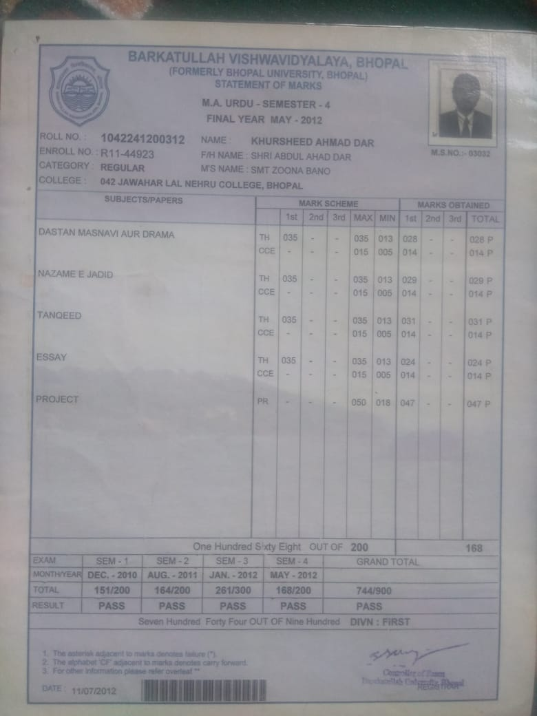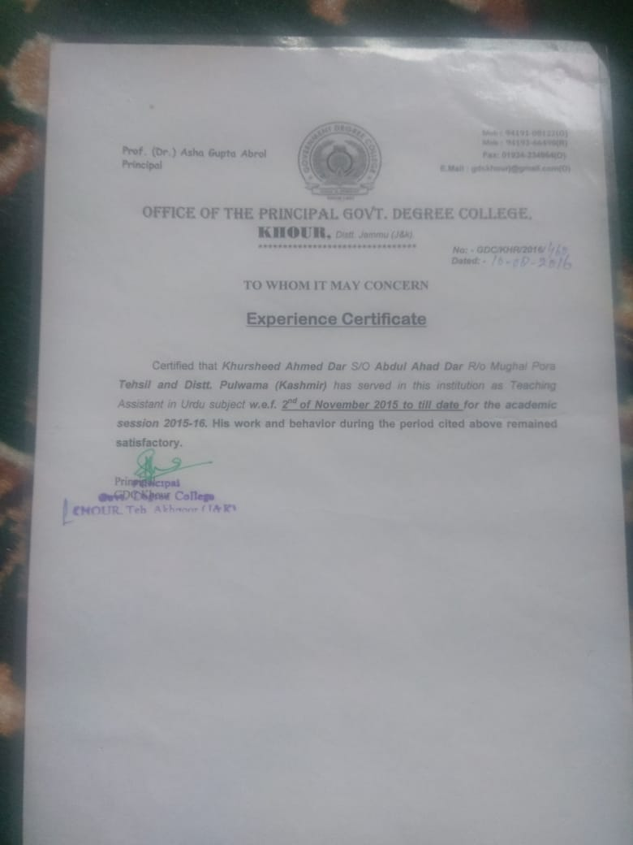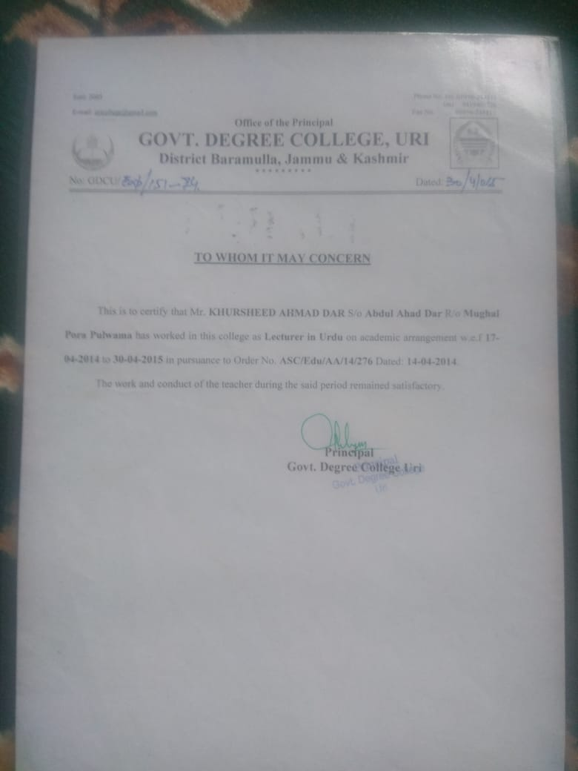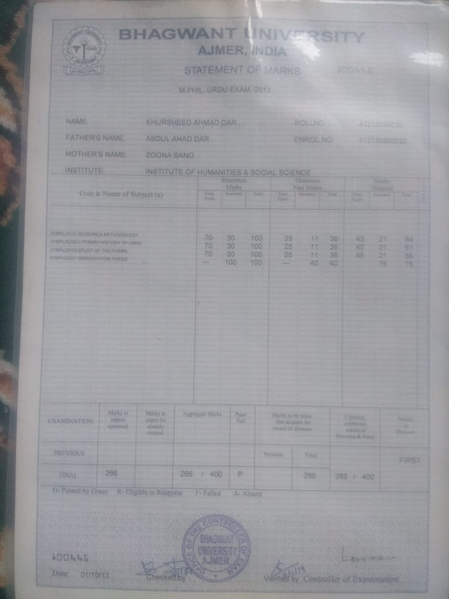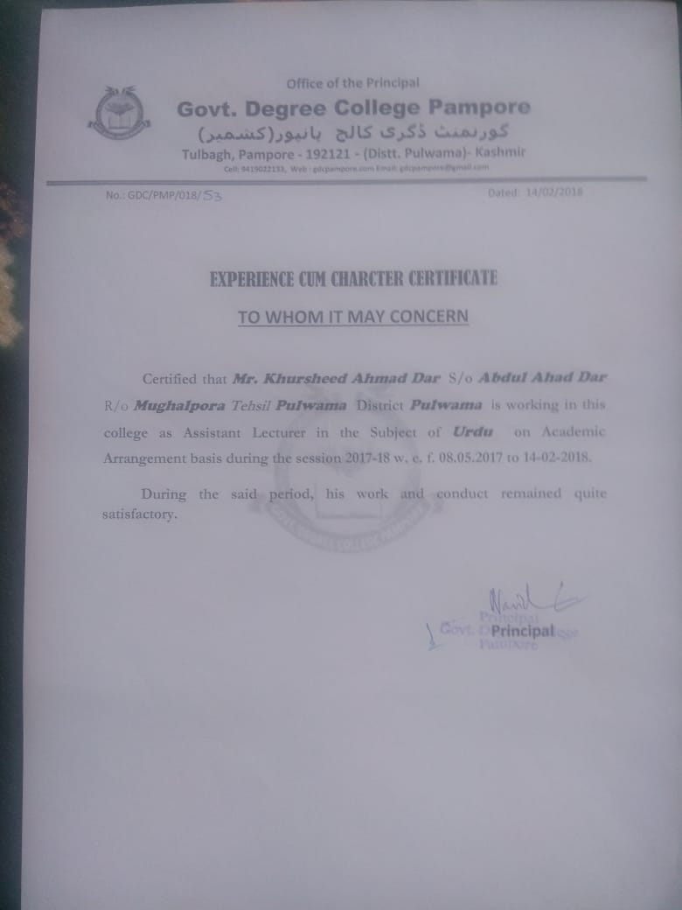

Sign. Of faculty

