Faculty Member Profile
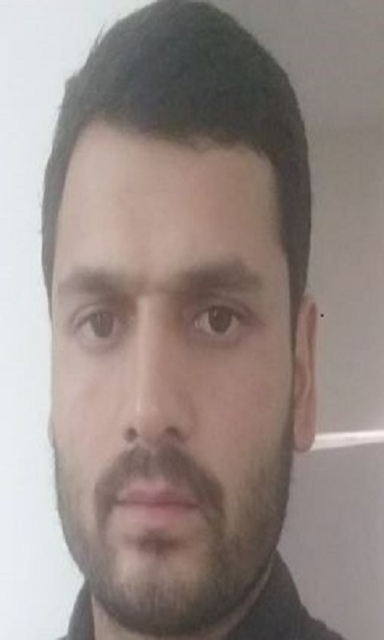
Paste your recent Photocopy

(Govt. degree College Ganderbal)
- Name : Mehraj Ud Din Bhat
- Parentage :Abdul Aziz Bhat
- Date of Birth :26th January 1987
- Marital Status :Married
- Residential Address :
Village: Youngoora Tehsil: Lar
Town: Ganderbal District: Ganderbal Pin:191131
- Contact Address/No.:9906999557
Email: mairajbhatt@gmail.com
Cell No. 990699957
- Name of the Department: Political Science
- Designation: Assistant Professor
- Courses taught at:
UG level: Indian Politics, Political Theory, Indian Constitution, Legislative support, Public opinion and Survey Research, Kashmir Politics
PG level.Nil
- Educational qualifications:
Qualification/Degree | Subject | University | Year of Passing
MA | Pol. Science | Kashmir University | 2011
M.phil | Pol. Science | Kashmir University | 2014
PhD (persuing ) | Pol. Science | Kashmir University | 2014 Oct. till now
SET | Pol. Science | SET Agency, KU | 2014
BED |  | Distance Education KU | 2013
- Service rendered in different Colleges:(Attach Experience Certificate)
College/University | From | to | No. of Years/Months
Nil | Nil | Nil | Nil
- Innovative processes developed in teaching and learning eg. PPTs, Study material, video lectures, Smarts Boards used etc. :PPT, study material and smart boards
- Participation in Curricular development: Nil
- Participation in Co-Curricular development(NSS/NCC/Sports etc.): Nil
- Research, Scholarly, Professional and Scientific Activity (Give details as per format)

Total Research experience:06 years

No. of publications in peer-reviewed journals:04 (attach list)

No. of books/ book chapters published as author or co-author:01 ( attach list)
- Major/Minor research projects completed: 01
Sr. No. | Title of the project | Date of sanction and duration | Grant received | Funding agency | Status
1 | Governance in Kashmir sine 1947: Lessons from the past and Insights for the future | 2013 | 8.00 lacs | ICSSR | Completed
2
- Participation in Conferences/ Symposia/ Workshops/ Seminars: (Attach list)

No. of Conferences attended: 04

No. of Symposia attende: Nil

No. of Seminars attended :01

No. of Workshops attended :04
- Major Areas of Interest: State Politics, electoral Politics
- Orientation/Refresher Course attended
Year | From | To | Name of Academic Staff College
2019 | 1st January 2019 | 29th January, 2019 | HRDC, Punjabi University Patiala

- Contribution towards Institution:
S. No. | Year | Area of contribution | Convener/Member
1 | 2018 | Ogninising seminars | Member
2 | 2019 | Organized SVEEP programme by delivering lectures and registering students for the programme | Recourse person
3 | 2019 | Chief Guest on women’s day celebration/ delivered key note address on the day | Chief Guest

Sign. Of faculty

Format for Research, Scholarly, Professional and Scientific Activity

S. No. | Name of Conference/ Seminar etc. | Organized by | Dates and Year | National/  International/  State/  University  Level | Attended/  Paper presented/  Chaired session/Resource person etc.
1 | Growth and Development in North Western Region: Issues and Perspectives” | Department of Economics, University of Kashmir and ICSSR, New Delhi | 16th and 17th March, 2016. | National | Presented paper
2 | Decentralization and Development | Kerla Institute of Local Administration (KILA) | 20-21 January, 2016 | International | Presented Paper
3 | The New Rural Paradigm: Policies and Governance from | National Institute of Rural Development & Panchayat Raj (NIRDPR), Rajendernagar, Hyderabad | 3-4 February, 2016. | National | Presented paper
4 | State Politics in India | Guru Nank Dev University, Amritsar | 2nd & 3rd April | National | Presented paper
5
6

Sign. Of faculty

