Faculty Member Profile
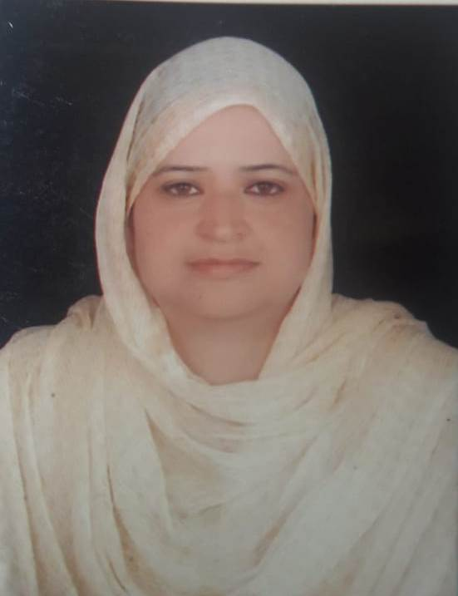

(Govt. degree College Ganderbal)
- Name :- Prof. Mubashir Koul
- Parentage Mr. Sharief Ahmad Koul.
- Date of Birth 01 December 1970
- Marital Status : Married____
- Residential Address:
Village Soura Tehsil Srinagar .
Town Srinagar .District Srinagar .Pin 190011
- Contact Address/No.:
Email:.mubashirchemistry786@gmail.com
Cell No..7006403552
- Name of the Department:Chemistry
- Designation: Associate Professor.
- Courses taught at:
UG level: B.Sc. 1st Semester, 2nd Semester, 5th semester.
PG level: Nil.
- Educational qualifications:
Qualification/Degree | Subject | University | Year of Passing
M. Sc. | Chemistry | Kashmir University | 1996 – 1997
- Service rendered in different Colleges:(Attach Experience Certificate)
College/University | From | to | No. of Years/Months
G.D.C. for Women M.A. Road | May - 1998 | Oct. - 2000 | 03 Years
G.D.C. Anantnag | March – 2001 | June – 2004 | 03 years
G.D.C. Nawakadal | June – 2004 | March – 2013 | 09 Years
G.D.C. Ganderbal | March – 2013 | Till date | 06 years
- Innovative processes developed in teaching and learning e.g. PPTs, Study material, video lectures, Smarts Boards used etc.:- Smart board, PPTC assignment, Class tests, Group discussions etc.
- Participation in Curricular development: Convener, Co-convener and member of various committees. (attach document)
- Participation in Co-Curricular development(NSS/NCC/Sports etc.): NCC officer girls wing 2013 – 2017, NSS Programme officer.(attach document)
- Research, Scholarly, Professional and Scientific Activity (Give details as per format)

Total Research experience: Nil.

No. of publications in peer-reviewed journals: 01 ( one) (attach list)

No. of books/ book chapters published as author or co-author Nil (attach list)
- Major/Minor research projects completed: ________________
Sr. No. | Title of the project | Date of sanction and duration | Grant received | Funding agency | Status
1
2
- Participation in Conferences/Symposia/Workshops/Seminars: (Attach list)

No. of Conferences attended_____________________

No. of Symposia attended______________________

No. of Seminars attended _______________________

No. of Workshops attended _____________________
- Major Areas of Interest:________________________
- Orientation/Refresher Course attended
Orientation | From | To | Name of Academic Staff College
Orientation | 15 – 01 – 2007 | 14 – 03 – 2007 | ASC – K.U
Refresher | 04 – 08 – 2005 | 26 – 08 – 2007 | ASC – K.U
Refresher | 04 – 03 – 2009 | 27 – 03 – 2009 | ASC – K.U
Refresher | 14 – 12 – 2009 | 04 – 01 – 2010 | ASC – K.U

- Contribution towards Institution:
S. No. | year | Area of contribution | Convener/Member
01 | 2013 | Convener Examination Protocol | Convener
02 | 2014 | Development Advisory | Member

Sign. Of faculty

Format for Research, Scholarly, Professional and Scientific Activity

S. No. | Name of Conference/ Seminar etc. | Organized by | Dates and Year | National/  International/  State/  University  level | Attended/  Paper presented/  Chaired session/Resource person etc.
1 | One day state level seminar on “Right to Information” | Organized by G.W.C. Nawakadal Sgr. In collaboration with J&K State Information Commission | November 23, 2011.
2 | Red Ribbon Club  World Aids Day 2013 | GDC Ganderbal | 03 Dec 2013 | State Level

Sign. Of faculty

