Faculty Member Profile
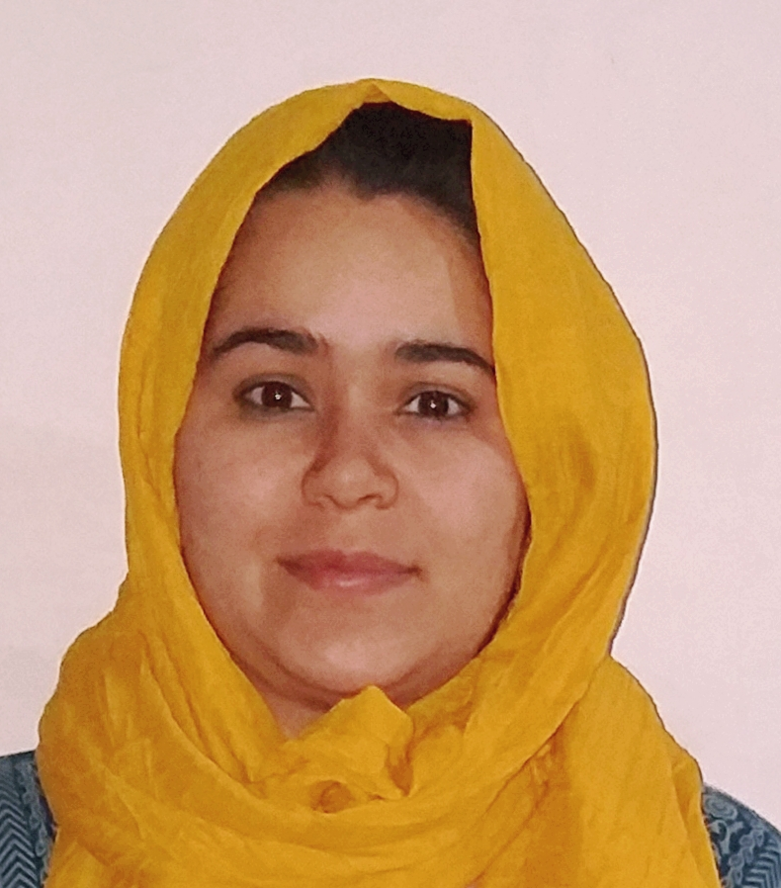

(Govt. degree College Ganderbal)
- Name :Mursila Hussain
- Parentage : Mohammad Hussain Butta
- Date of Birth : 12.07.1991
- Marital Status : Single
- Residential Address : Near Masjid Umar Aadil, Madina Colony,
90 Feet Road, Ellahi Bagh,
Srinagar – 190011 J&K
- Contact Address/No. :mursilhussain1@gmail.com
9622629010 / 7006502369

- Name of the Department : Economics
- Designation : Guest Lecturer
- Courses taught at:
UG level :Micro Economics, Public Finance, General Economics
PG level :
- Educational qualifications:
Qualification/Degree | Subject | University | Year of Passing
UG | BA | KASHMIR UNIVERSITY | 2013
PG (M.A.) | ECONOMICS | KASHMIR UNIVERSITY | 2016
B-ed | B-ed | KASHMIR UNIVERSITY | 2015
- Service rendered in different Colleges:(Attach Experience Certificate)
College/University | From | to | No. of Years/Months
FRESHER | - | - | -
- Innovative processes developed in teaching and learning eg. PPTs, Study material, video lectures, Smarts Boards used etc. :_____________________________________ _____________________________________________________________________
- Participation in Curricular development: _________________________________ _______________________________________________________(attach document)
- Participation in Co-Curricular development(NSS/NCC/Sports etc.): __________________________________________________________________ _______________________________________________________(attach document)
- Research, Scholarly, Professional and Scientific Activity (Give details as per format)

Total Research experience:________________

No. of publications in peer-reviewed journals:_____________(attach list)

No. of books/ book chapters published as author or co-author:_____________(attach list)
- Major/Minor research projects completed: ________________
Sr. No. | Title of the project | Date of sanction and duration | Grant received | Funding agency | Status
1
2
- Participation in Conferences/Symposia/Workshops/Seminars: (Attach list)

No. of Conferences attended_____________________

No. of Symposia attended______________________

No. of Seminars attended _______________________

No. of Workshops attended _____________________
- Major Areas of Interest:________________________
- Orientation/Refresher Course attended
Year | From | To | Name of Academic Staff College

- Contribution towards Institution:
S. No. | year | Area of contribution | Convener/Member

Sign. Of faculty

Format for Research, Scholarly, Professional and Scientific Activity

S. No. | Name of Conference/ Seminar etc. | Organized by | Dates and Year | National/  International/  State/  University  level | Attended/  Paper presented/  Chaired session/Resource person etc.
1
2
3
4
5
6

Sign. Of faculty

