Faculty Member Profile
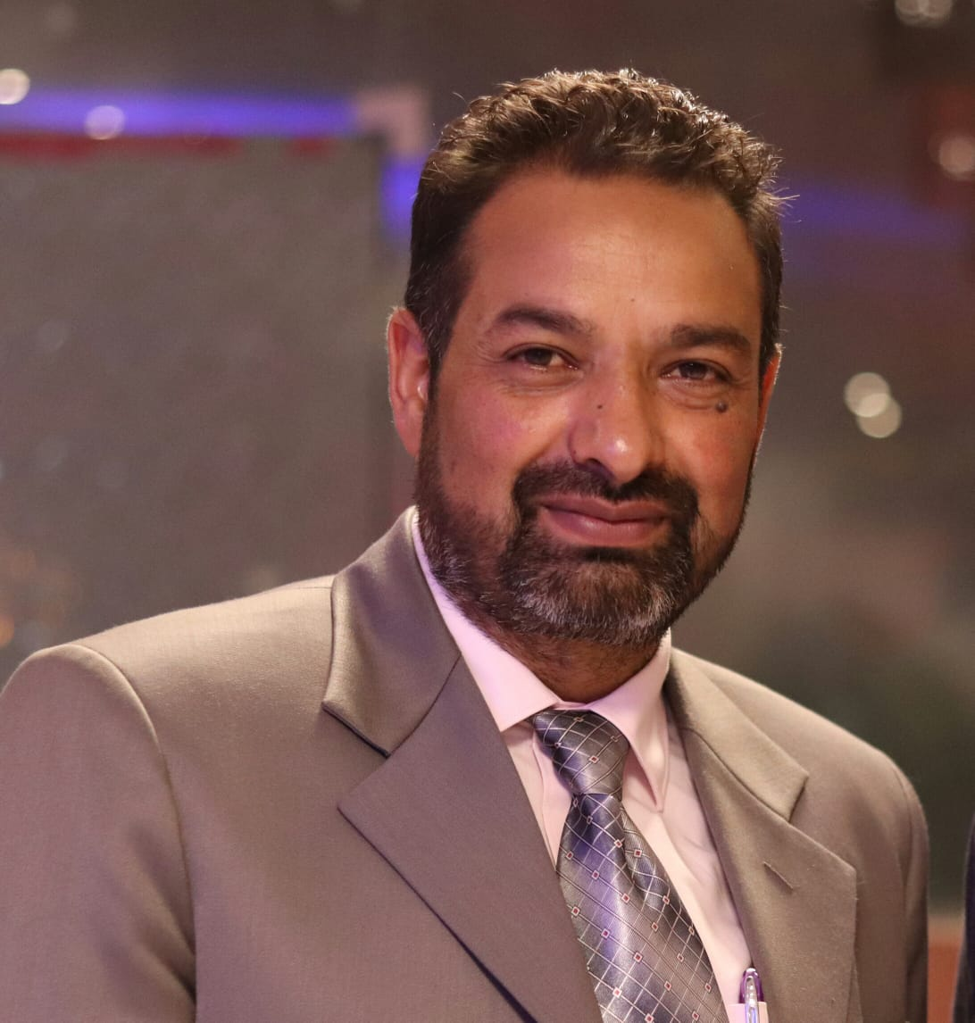

(Govt. degree College Ganderbal)
- Name ` : Dr. Mushtaq_Ahmad Rather____
- Parentage :_Mr. Ghulam Hassan Rather____________
- Date of Birth :___24-08-1974________
- Marital Status :___Married_______________
- Residential Address :
Village_Dialgam_____________Tehsil_Anantnag_
Town_____________District Anantnag_____________Pin__192210____________
- Contact Address/ LF-9 Teachers Hostel Kashmir University.
Email: . rathermushtak5@ gmail.com_________ .________
Cell No.._9906403071____________________________
- Name of the Department: Political Science
- Designation: Assistant Professor________
- Courses taught at:
UG level : Political Theory, Indian Political System, International relations,Western Political Thought, Comparative Politics.
PG level : International Relations

- Educational qualifications:
Qualification/Degree | Subject | University | Year of Passing
B.Sc | Zoo.Bot.Chem. | Kashmir University | 1998
M.A | Political Science | A.M.U, Aligarh | 2001
Ph.D | Political Science | A.M.U, Aligarh | 2013
SLET, UGC NET | Political Science |  | 2005, 2006
- Service rendered in different Colleges:(Attach Experience Certificate)
College/University | From | To | No. of Years/Months
GDC Anantnag | 15.4.2002 | 30.11.2002 | 08 months
GDC Anantnag | 11.4.2005 | 30.12.2005 | 09 months
GDC Anantnag | 27.3.2006 | 30.12.2006 | 09 months
`GDC Anantnag | 18.5.2007 | 10.9.2007 | 05 months
GDC Anantnag | 1.4.2008 | 03.7.2008 | 03 months
GDC Ganderbal | 03.02.2018 | Present | 01 year 03 months
- Innovative processes developed in teaching and learning eg. PPTs, Study material, video lectures, Smarts Boards used etc. :_____________________________________ _____________________________________________________________________
- Participation in Curricular development: _________________________________ _______________________________________________________(attach document)
- Participation in Co-Curricular development(NSS/NCC/Sports etc.): __Participated in SVEEP Programme as Resource person _ (attach document)
- Research, Scholarly, Professional and Scientific Activity (Give details as per format)

Total Research experience:________________

No. of publications in peer-reviewed journals:_____________(attach list)

No. of books/ book chapters published as author or co-author:_____________( attach list)
- Major/Minor research projects completed: ________________
Sr. No. | Title of the project | Date of sanction and duration | Grant received | Funding agency | Status
1
2
- Participation in Conferences/ Symposia/ Workshops/ Seminars: (Attach list)

No. of Conferences attended_ 03____________________

No. of Symposia attended______________________

No. of Seminars attended ____01___________________

No. of Workshops attended _____________________
- Major Areas of Interest:__International Relations ,_Political Theory, Indian Political System.
- Orientation/Refresher Course attended
Year | From | To | Name of Academic Staff College
2018 | 25.06.2018 | 24.7.2018 | HRDC Kashmir Uni.

- Contribution towards Institution:
S. No. | year | Area of contribution | Convener/Member
1. | 2018 | College Dean Students Welfare committee | Member
2. | 2018 | Carrier Counselling Committee | Member
3. | 2018 | NAAC Committee | Member
4. | 2018 | Subject Tour/ Excursion committee | Member

Sign. Of faculty

Format for Research, Scholarly, Professional and Scientific Activity

S. No. | Name of Conference/ Seminar etc. | Organized by | Dates and Year | National/  International/  State/  University  level | Attended/  Paper presented/  Chaired session/Resource person etc.
1 | 2nd International conference on Research and development in Arts,Social Science and humanities | Punjab University Chandigarh | 8th-9th April 2018 | International | Paper presentation
2 | Ist. International conference on Recent Developments in Science, Humanities and Management-2018 | Amar Singh College, Cluster University Srinagar | 17th-18th April 2018 | International | Paper Presentation
3 | International conference on recent research and innovations in social science and education | Osmania University Hyderabad. | 19th May 2018 | International | Paper Presentation
4 | Two day National Seminar on Ageing and elderly care | Kashmir University | 29th -30th March 2018 | National | Paper presentation
5
6

Sign. Of faculty

