Faculty Member Profile
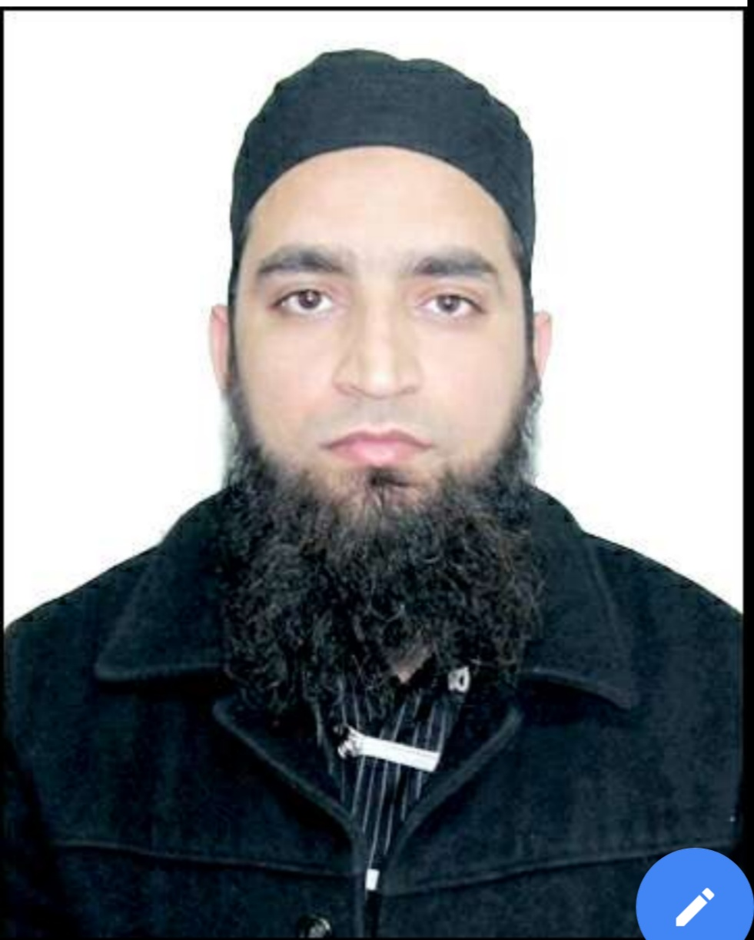
Paste your recent Photocopy

(Govt. degree College Ganderbal)
- Name : ________Dr Muzamil Ahmad___________________________
- Parentage :______Abdul Rashid Kakroo_____________________________
- Date of Birth :______18-11-1981_____________________________
- Marital Status :_______Married_____________________________
- Residential Address : Umar Colony A Lal Bazar Srinagar
Village______________________________Tehsil___Srinagar______________________________
Town_______________________District_Srinagar_______________________Pin__190023____________
- Contact Address/No.: 7006935030
Email: .____memuzamil@gmail.com___________________________ .______________________________
Cell No..______ 7006935030________________________ .______________________________
- Name of the Department: ____Psychology___________________________________________
- Designation: __Lecturer_______________________________________________________
- Courses taught at:
UG level:______Expermental Psychology, Clinical Psychology,_Personality, Crime and Delinquency and Psychological Assessment______________________________________________________
PG level: Diagnostics techniques, psychotherapeutic interventions, non-exp. Designs in psy. Researches and current research in memory and forgetting______________________________________________________________
- Educational qualifications:
Qualification/Degree | Subject | University | Year of Passing
PhD | Psychology | A.M.U. | 2010
M.A | Psychology | A.M.U. | 2006
B.A. (Hons) | Psychology | A.M.U. | 2004
- Service rendered in different Colleges:(Attach Experience Certificate)
College/University | From | to | No. of Years/Months
G.D.C Ganderbal | March 2011 | Till date | 8 years
Amarsingh College | March 2010 | Jan. 2011 | 11 months
Govt. College for women Anantnag | June 2009 | Feb. 2010 | 9 months
- Innovative processes developed in teaching and learning eg. PPTs, Study material, video lectures, Smarts Boards used etc. :______yes______________________________ _____________________________________________________________________
- Participation in Curricular development: __Participated in Three week Refresher Course in Behavioural Sciences(ID) organized by UGC-Human resource Development Centre, University of Kashmir, Srinagar from 9th January, 2017 to 30th January, 2017 and obtained Grade A_______________________________ _______________________________________________________(attach document)
- Participation in Co-Curricular development(NSS/NCC/Sports etc.): __________________________________________________________________ _______________________________________________________(attach document)
- Research, Scholarly, Professional and Scientific Activity (Give details as per format)

Total Research experience:______9 years__________

No. of publications in peer-reviewed journals:___13__________(attach list)

No. of books/ book chapters published as author or co-author:_____________( attach list)
- Major/Minor research projects completed: ________________
Sr. No. | Title of the project | Date of sanction and duration | Grant received | Funding agency | Status
1
2
- Participation in Conferences/ Symposia/ Workshops/ Seminars: (Attach list)

No. of Conferences attended______2_______________

No. of Symposia attended______________________

No. of Seminars attended ____4___________________

No. of Workshops attended ____1_________________
- Major Areas of Interest:________________________
- Orientation/Refresher Course attended
Year | From | To | Name of Academic Staff College
2017 | 9 January | 30 January | University of Kashmir

- Contribution towards Institution:
S. No. | year | Area of contribution | Convener/Member
1 | 2018 | Organizing member | Member

Sign. Of faculty

Format for Research, Scholarly, Professional and Scientific Activity

S. No. | Name of Conference/ Seminar etc. | Organized by | Dates and Year | National/  International/  State/  University  level | Attended/  Paper presented/  Chaired session/Resource person etc.
1 | First International Conference on Recent Developments In science , Humanities and Management | Amar Singh College Srinagar Kashmir India | 17-18 April 2018 | International Conference | Religiosity and Depression Among Youth
2 | National Sirah Seminar on “Prophet Muhammad () and Social Justice” | Shah-i- Hamadan Institute of Islamic Studies University of Kashmir, Srinagar | December 16-17, 2017 | National Sirah Seminar
3 | Seminar on Stress Management | Govt. Degree College, Ganderbal J&K | November 02, 2017. | Seminar | Stress and its Management
4 | Seminar on Ethics of Social Support | Govt. Degree College, Ganderbal J&K | October 31, 2017. | Seminar | Social support as moderator of Stress among Cancer Patients
5
6

Sign. Of faculty
RESEARCH PAPERS PUBLISHED:

- Ahmad,M.(2018). Religiosity and depression among youth. International journal of movement education and social science,7,1.
- Amin,N. & Ahmad,M.(2018). A study on assessment of stress and its management in hospital employes. International journal of Indian Psychology,6,1, 2349-3429.
- Amin,N. & Ahmad,M.(2017). A comparative study- to assess the psychosocial problems among adolescents of selected rural and urban schools of Kashmir. International journal of Indian Psychology, 4,4.
- Khan, M. A., & Ahmad, M. (2015). Locus of Control and Stress among Cancer Patients. Asian Journal of Research in Social Sciences and Humanities, 5, 2, 137-14.
- Khan, M. A., & Ahmad, M. (2014). Gender differences in stress and social support among Kashmiri cancer patients. Indian Journal of Positive Psychology, 5, 4, 484-48
- Ahmad, M., Khan, M. A., Khan, M, J. (2013). Mental health: A cross-cultural study on Indian and Iranian students. Indian Journal of Health and Wellbeing, 4,7, 1445-1447.
- Ahmad, M., Khan, M. A., & Shirazi, M., (2013). Perception of social support by cancer patients. International Journal of Psychology and Behavioral Sciences, 3, 5,
- Ahmad, M. & Muzamil, H. (2013). A study of social support among cancer patients. Indo- Indian Journal of Social Science Researches, 9, 1, 133-139.
- Ahmad, M. (2012). Economic difference in stress and social support among Kashmiri cancer patients. Indian Journal of Health & Wellbeing, 3,4, 1001-1003.
- Khan, M. A., Shirazi, M., & Ahmad, M. (2011). Spirituality and life satisfaction among Adolescents in India. Journal of Subcontinent Researches, 3,7, 71-84.
- Hassan, M., Khan, M, J., & Ahmad, M. (2010). Job satisfaction as a function of organisational commitment of bank employees of kashmir, Magadh journal of social research. 2, 2, 37-44.
- Khan, R.A., Ahmad, M., & Hassan, M. (2010). A study of stress among cancer patients. Indian journal of psychology and mental health, 4, 84-89.
- Ahmad, M., Azam, A. A. S., & Khan, J. (2009). Relation between home environment and resilience among adolescents. Human Behaviour Journal of Applied Psychology, 4, 1, 121-128.

