Faculty Member Profile
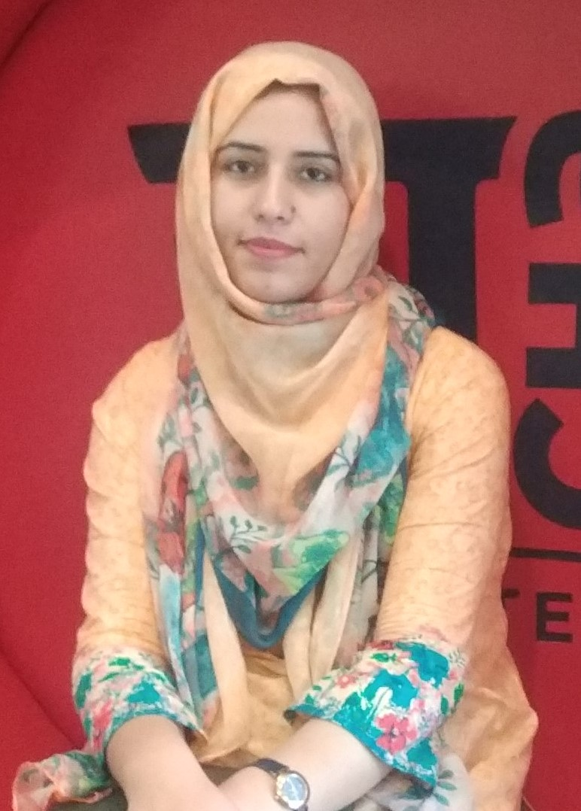
Paste your recent Photocopy

(Govt. degree College Ganderbal)
- Name :__SHAFIYA MOHI UD DIN_________________________________
- Parentage :GHULAM MOHI UD DIN BHAT______________________________
- Date of Birth : 29th Dec 1990__________________________________
- Marital Status :_Single___________________________________
- Residential Address:
Village______________________________Tehsil________________________________
Town: _Lal Bazar
District:__Srinagar______________________Pin_:_190023__________
- Contact Address/No.
Email:shafiyamohiuddin@gmail.com______________________.______________________________
Cell No..__9419714983____________________________.______________________________
- Name of the Department:_ Sociology___________________________________________
- Designation:_AssistantProfessor_____________________________________________
- Courses taught at:
UG level:___Sociology__________________________________________________________
PG level______________________________________________________________
- Educational qualifications:
Qualification/Degree | Subject | University | Year of Passing
B.A | Sociology | University of Kashmir | 2011
M.A | do | do | 2014
JKSET/NET | do | do | 2013/2014
JRF | do | do | 2015
- Service rendered in different Colleges:(Attach Experience Certificate)
College/University | From | to | No. of Years/Months
Govt.Degree College Ganderbal | 15-06-2015 | 29-02-2016 | 8.5 months
Do | 13-06-2017 | Present | 2 years
- Innovative processes developed in teaching and learning eg. PPTs, Study material, video lectures, Smarts Boards used etc. :_______yes______________________________ _____________________________________________________________________
- Participation in Curricular development: _________________________________ _______________________________________________________(attach document)
- Participation in Co-Curricular development(NSS/NCC/Sports etc.): ________________yes_____________________________ _______________________________________________________(attach document)
- Research, Scholarly, Professional and Scientific Activity (Give details as per format)

Total Research experience:___1.5 years_____________

No. of publications in peer-reviewed journals:___01__________(attach list)

No. of books/ book chapters published as author or co-author:_____________(attach list)
- Major/Minor research projects completed: ________________
Sr. No. | Title of the project | Date of sanction and duration | Grant received | Funding agency | Status
1
2
- Participation in Conferences/Symposia/Workshops/Seminars: (Attach list)

No. of Conferences attended_____02________________

No. of Symposia attended__________Nil____________

No. of Seminars attended ________03_______________

No. of Workshops attended _______02______________
- Major Areas of Interest:_ __________Gender_ Studies____________
- Orientation/Refresher Course attended
Year | From | To | Name of Academic Staff College
2018 | 28th Sep-2018 | 1stNov.2018 | UGC- Human Resource Development Centre, University of Kashmir, Srinagar.

- Contribution towards Institution:
S. No. | Year | Area of contribution | Convener/Member
1 | 2017-2018 | Participated in the maintenance of discipline in the institution by doing regular rounds of the campus and monitoring the activities of students | Member
2 | Do | Being the member of college sports committee I extended my full support to the conduct of various sports activities. I also helped for the promotion of cultural activities and cleanliness campaign for serene environment in the campus. | Member
3 | Do | Worked for the smooth conduct of Seminars, Debates and other counselling programmes | Member

Sign. Of faculty

Format for Research, Scholarly, Professional and Scientific Activity

S. No. | Name of Conference/ Seminar etc. | Organized by | Dates and Year | National/  International/  State/  University  level | Attended/  Paper presented/  Chaired session/Resource person etc.
1 | Media Depiction And Emergence Of Gender Based Social Violence. | Department Of Sociology, University Of Kashmir. | 08-09 March 2017 | National | Paper presented
2 | Consumerism And Environmental Sustainability: Discourse Of Youth In Kashmir. | Indian Science Congress Association “Srinagar Chapter” | 25-26 Sep.2017 | National | do
3 | Globalization And Indian Higher Education: Challenges And Opportunities. | Amar Singh College: Cluster University, Srinagar. | 17-18 April 2018. | International | do
4 | Portrayal of Muslims in media: An overview in Indian context. | St.Philomena’s College Bannimantap, Mysure,Karnataka | 27th -29th Dec. 2018 | National | do
5 | Two days Workshop On Engendering Higher Education. | Internal Complaints Committee, Central University Of Kashmir. | 2 days  2nd and 3rd August 2018 | Regional | participant
6 | One day Seminar On Drug Addiction: Consequences and Remedies. | Govt. Degree College Ganderbal, J&K. | 23rd July 2018 | Regional | do

Sign. Of faculty

