Faculty Member Profile
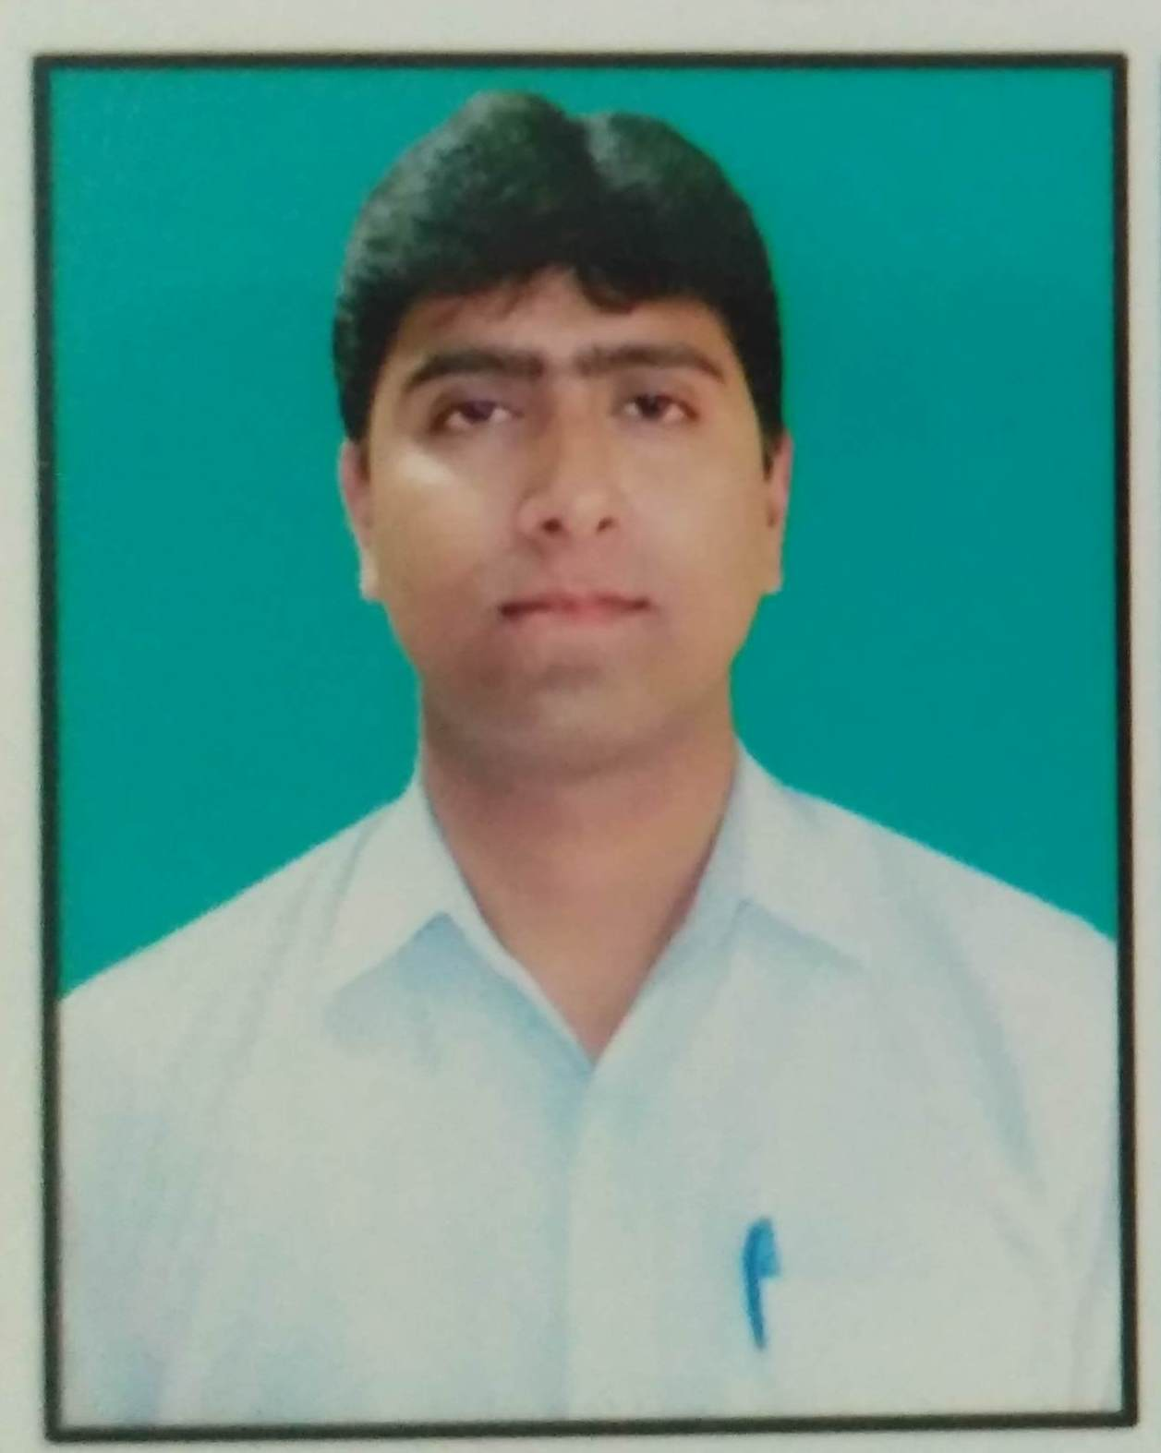

(Govt. degree College Ganderbal)
- Name :- Mr. Younce Shafi Kannu.
- Parentage Mr. Mohammad Shafi Kannu.
- Date of Birth 01 April 1982
- Marital Status : Married____
- Residential Address:
Village Khanyar Tehsil Srinagar .
Town Srinagar .District Srinagar .Pin 190003
- Contact Address/No.:
Email:.yonusshafi@gmail.com
Cell No..9906672455
- Name of the Department:Chemistry
- Designation: Assistant Lecturer.
- Courses taught at:
UG level: B.Sc. 1st Semester, 2nd Semester, 3rd semester,th semester, 5th semester.
PG level: Nil.
- Educational qualifications:
Qualification/Degree | Subject | University | Year of Passing
M. Sc. | Chemistry | Dr. Bhim Rao Ambedkar University Agra | 2005
M.Phil. | Chemistry | Vinayka Mission University Tamil Nadu | 2009
B.Ed. |  | Kashmir University | 2008
Diploma In Software Technology | Computers | Infopark | 2001
DPISM | Computers | Massey Supremo Onfotech, Agra | 2005
- Service rendered in different Colleges:(Attach Experience Certificate)
College/University | From | to | No. of Years/Months
G.D.C. Bemina | 22 – April 2006 | 30 – Nov. 2006 | 07 Months
A.S. College, Gogibagh | 22 – May 2007 | 31 – Dec. 2007 | 07 Months
G.D.C. Sopore, A.S. College, Gogibagh | 17 – May 2008 | 31 – Jan 2009 | 09 Years
S.P. College, M.A. Road | 18 – April 2009 | 28 – Feb 2010 | 10 Months
G.D. C. Nawakadal | 31 – March 2010 | 28 – Feb 2011 | 11 Months
Islamia college, Hawal Srinagar | 21 – June 2011 | 19 – Oct. 2011 | 04 months
G.D. C. Nawakadal | 01 – April 2013 | 28 – Feb 2014 | 11 Months
G.D. C. Nawakadal | 22 – March 2014 | 30 – April 2015 | 13 months
G.D. C. M.A. Road | 15 – June 2015 | 29 – Feb 2016 | 09 months
G.D. C. M.A. Road | 18 – April 2016 | 30 – April 2017 | 12 Months
G.D. C. Ganderbal | 05 – May 2018 | 31 – March 2018 | 11 Months
G.D. C. Ganderbal | 05 – April 2018 | Till date | 13 Months
- Innovative processes developed in teaching and learning e.g. PPTs, Study material, video lectures, Smarts Boards used etc.:- Smart board, PPTC assignment, Class tests, Group discussions etc.
- Participation in Curricular development: Nil . (attach document)
- Participation in Co-Curricular development(NSS/NCC/Sports etc.): Nil .(attach document)
- Research, Scholarly, Professional and Scientific Activity (Give details as per format)

Total Research experience: Nil.

No. of publications in peer-reviewed journals: Nil (attach list)

No. of books/ book chapters published as author or co-author Nil (attach list)
- Major/Minor research projects completed: ________________
Sr. No. | Title of the project | Date of sanction and duration | Grant received | Funding agency | Status
1
2
- Participation in Conferences/Symposia/Workshops/Seminars: (Attach list)

No. of Conferences attended__02_(two)__________________

No. of Symposia attended___Nil___________________

No. of Seminars attended 01 (one) .

No. of Workshops attended Nil .
- Major Areas of Interest: Analytical Chemistry
- Orientation/Refresher Course attended
Orientation | From | To | Name of Academic Staff College

- Contribution towards Institution:
S. No. | year | Area of contribution | Convener/Member

Sign. Of faculty

Format for Research, Scholarly, Professional and Scientific Activity

S. No. | Name of Conference/ Seminar etc. | Organized by | Dates and Year | National/  International/  State/  University  level | Attended/  Paper presented/  Chaired session/Resource person etc.
1 | Two days national Level conference on Animal Diseases, Food Safety and Public Health. | I.A.H & B.P. | 2004 | National
2 | Second J & K Science Congress | Department Of Chemistry, University Of Kashmir. | 25 – 27 July 2006 | National | Resource person.
3 | Two days seminar on Dynamics of Science Education, Current problems and Future Challenges | Department Of Chemistry, University Of Kashmir. | 23 – 24 Oct. 2007
4
5
6

Sign. Of faculty

