Govt. Degree College, Ganderbal
Department of Physical Education & Sports

Report of Yoga day organized by Department of Physical Education in collaboration with District Ayush Office, Ganderbal, (Men & Women), 2023
Today as on 25th May, 2023, Department of Physical Education and Sports in collaboration with District Ayush office, Ganderbal conducted one day YOGA programme for the college students. In the said event a total of 150 students participated and showed much interest.
In the event various types of Asanas and Pranayamas were showed by the Ayush experts and accordingly were practised by the students...
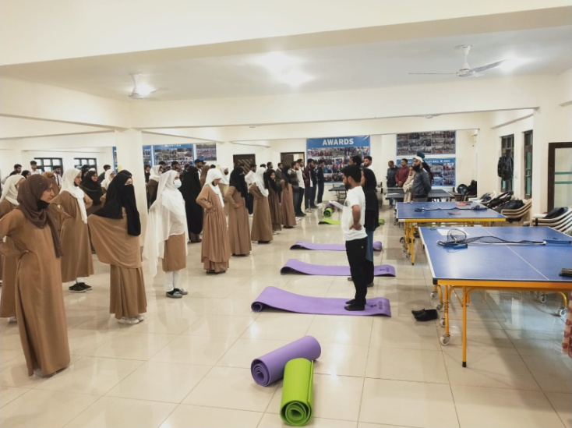
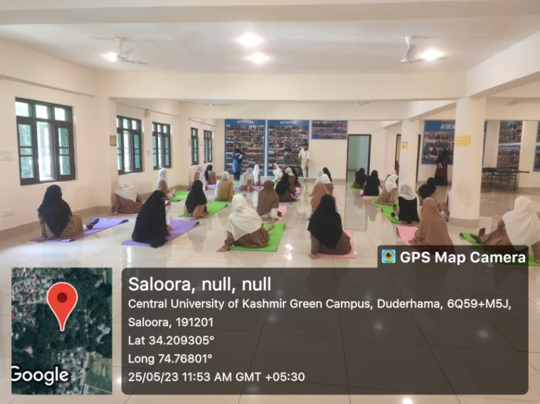
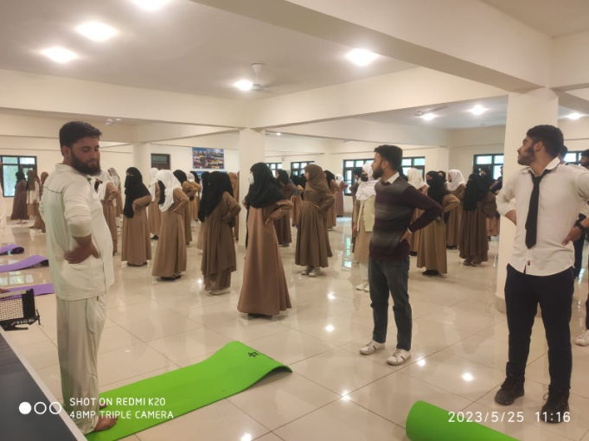
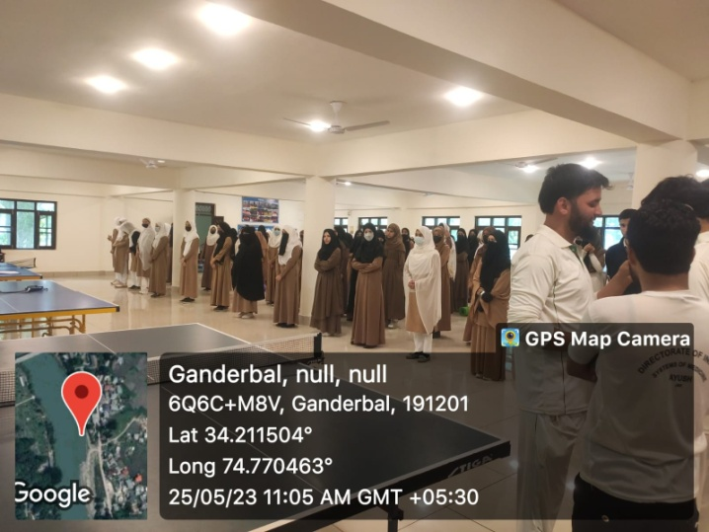
Worthy Principal of the College, Prof. Fouziya Fatima while speaking on the occasion apprised the students about various health benefits of the yoga and encouraged them to continue it with at home also so that the benefits will be evident and also emphasized on conduction of Yoga Camps in future al so in th e college premises.

