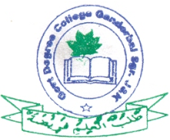Govt. Degree College, Ganderbal

**Department of Physical Education & Sports**

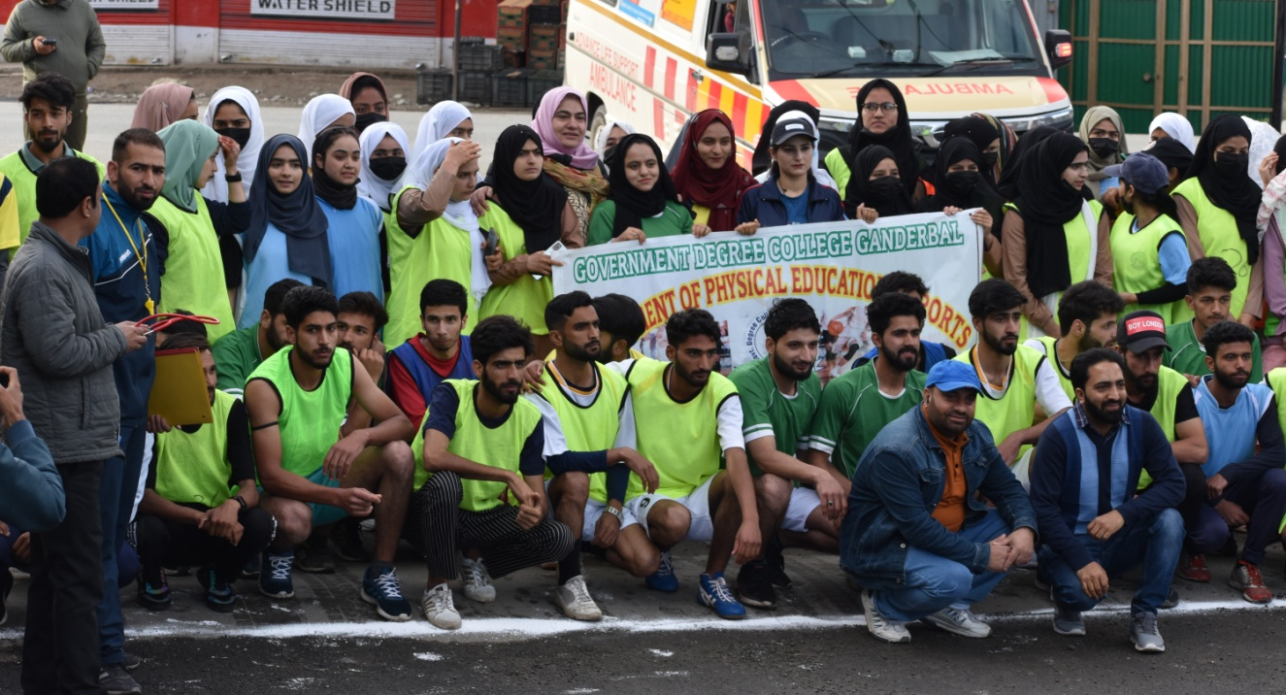**Report: Annual College Road Race, 2023**

The Department of Physical Education and Sports, GDC, Ganderbal organized the **Annual College Road Race** as on **3rd June, 2023** for both the boys and girls with a short interval in between. The race started at **6:30 a.m** from the **Baroosa Crossing**, Gbl and culminated at **Manasbal Park** comprising a stretch of about **5 kms.** The race was flagged off by the worthy principal of the college **Prof. Fouziya Fatima.**

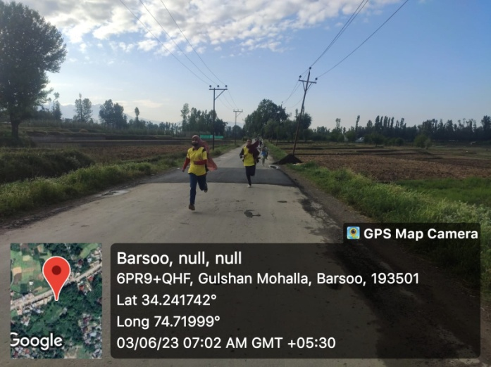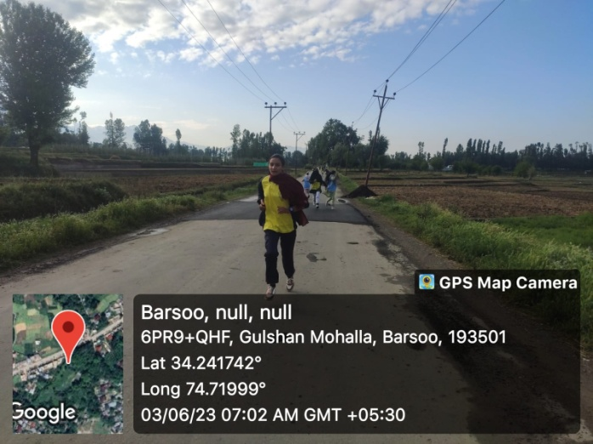 The students overwhelmingly & enthusiastically (43 Boys & 45 Girls) participated in the race. The staff members who were deployed on the route encouraged the students in the course of race. In addition the Police Department, Health Department, Traffic Department all assisted in the successful conduction of the event. The prize distribution ceremony of the event was held in the vicinity of Manasbal Guest House where the position holders were awarded with the trophies.

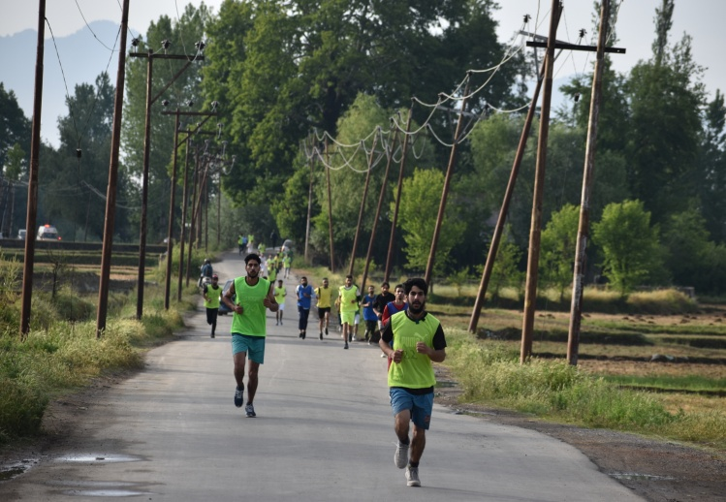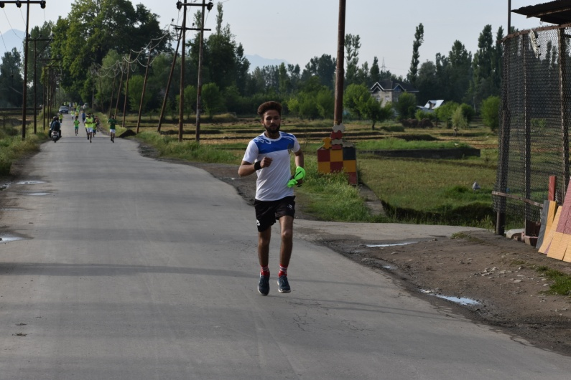

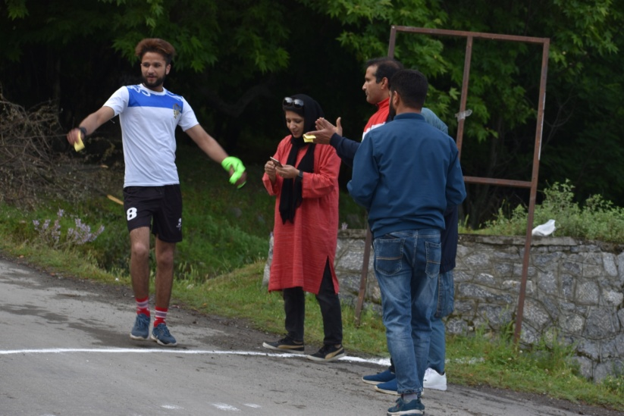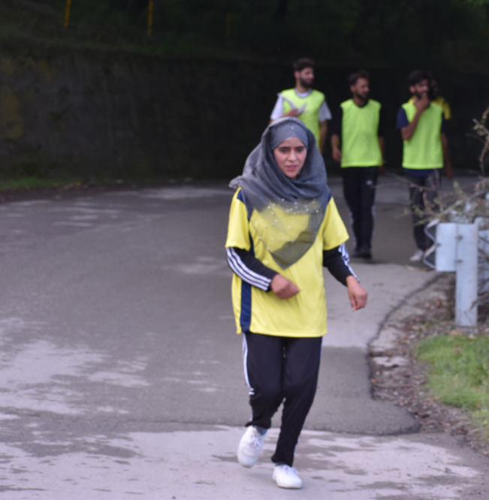

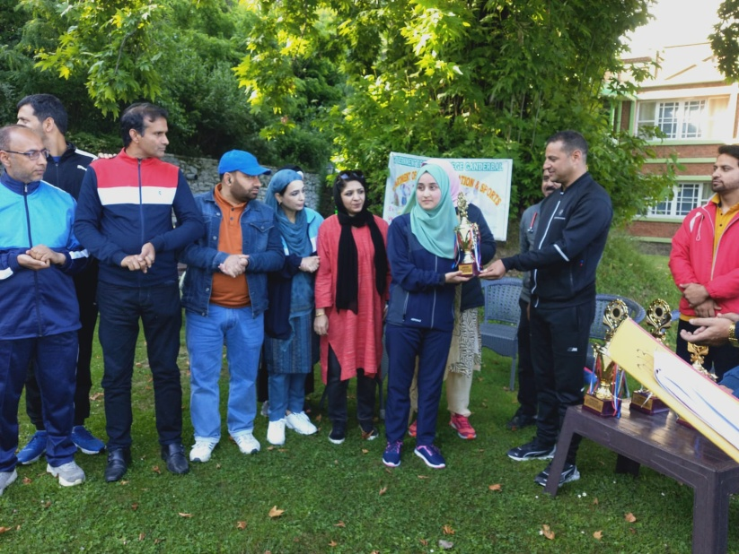

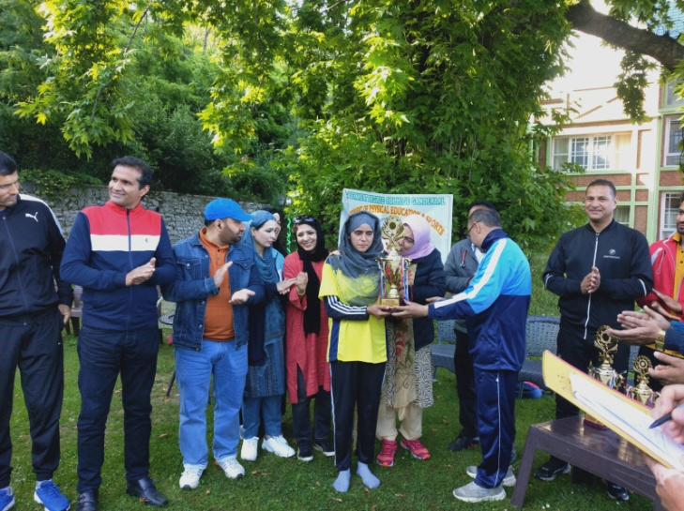

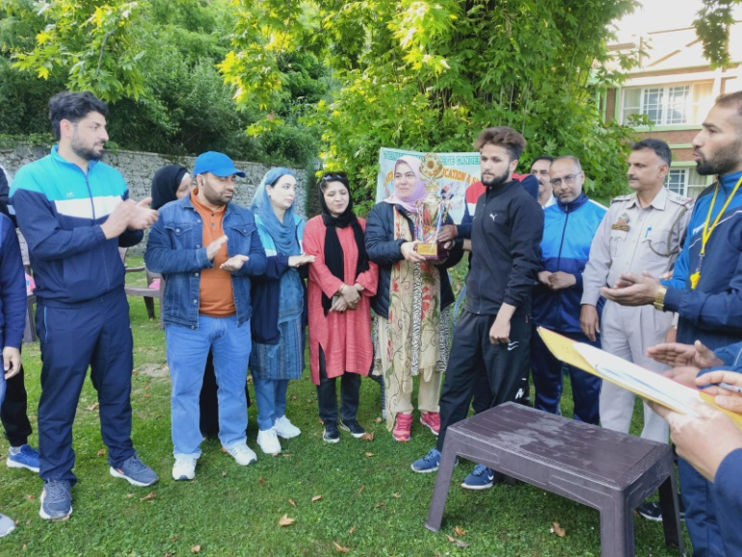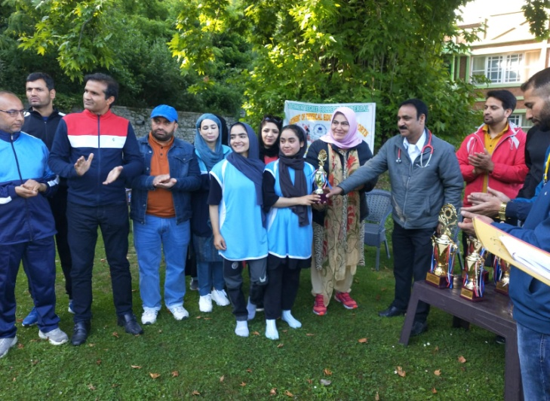

In the Girls category, **Farnaza Nazir (4th Sem)** got 3rd Position, **Fouziya zahoor** (6th Sem) secured 2nd Position while as **Tehmeena Lateef** (2nd Sem) clinched 1st Position.

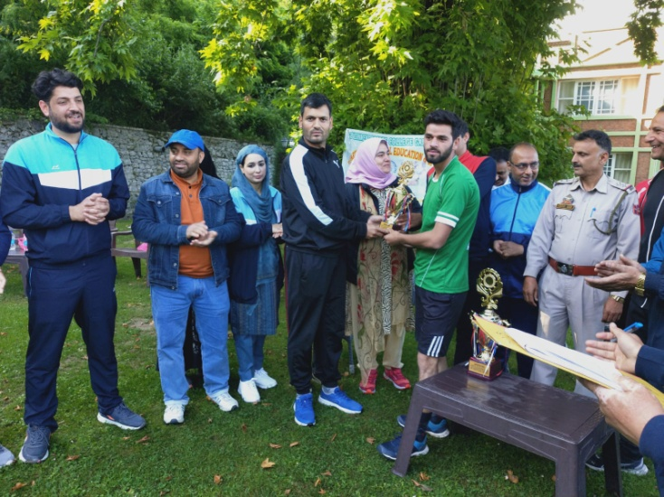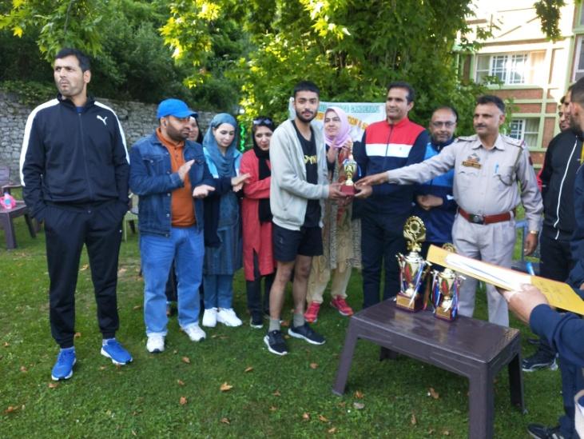In Boys category **Mir Gowher** (4th Sem) got 3rd Position, **Jameel Ahmad** (2nd Sem) secured 2nd Position) while as **Abid Nazir Ganie** (4th Sem) clinched 1st Position.

At the conclusion of the ceremony, worthy principal of the college Prof. Fouziya Fatima highlighted the benefits of participating in the physical activities and the role it plays in shaping the behavior and character of an individual and also encouraged the students to actively participate in these kind of activities both at college and home. Lastly the worthy principal thanked all the stakeholders who assisted in making the event a successful one.