Report of Drawing Competition on Drug De-addiction
11th April 2022
Debates, Seminars, and the Cultural Committee of the College organized Drawing Competition on Drug De-addiction in the College front lawns. A total number of fifty students participated in the event and expressed their imaginative perceptions around the theme through their drawing skills. The event was attended by the principal, the staff, and the college students. On the occasion the Principal, Prof. Bashir Ahmad Parray. In his inaugural speech, he emphasized the importance of student imagination and creativity that can help in advancing the civic duty of anti-drug awareness.
The first four candidates were felicitated with mementos and achievement certificates. With the distribution of the awards, the students explained the idea behind their sketches. All the participants were provided with certificates of participation. In the end, all the drawings were displayed in College Lawn for publicity and awareness generation.
The event concluded with the appreciation of the students by the principal and his concluding remarks on the purpose of conducting the event.

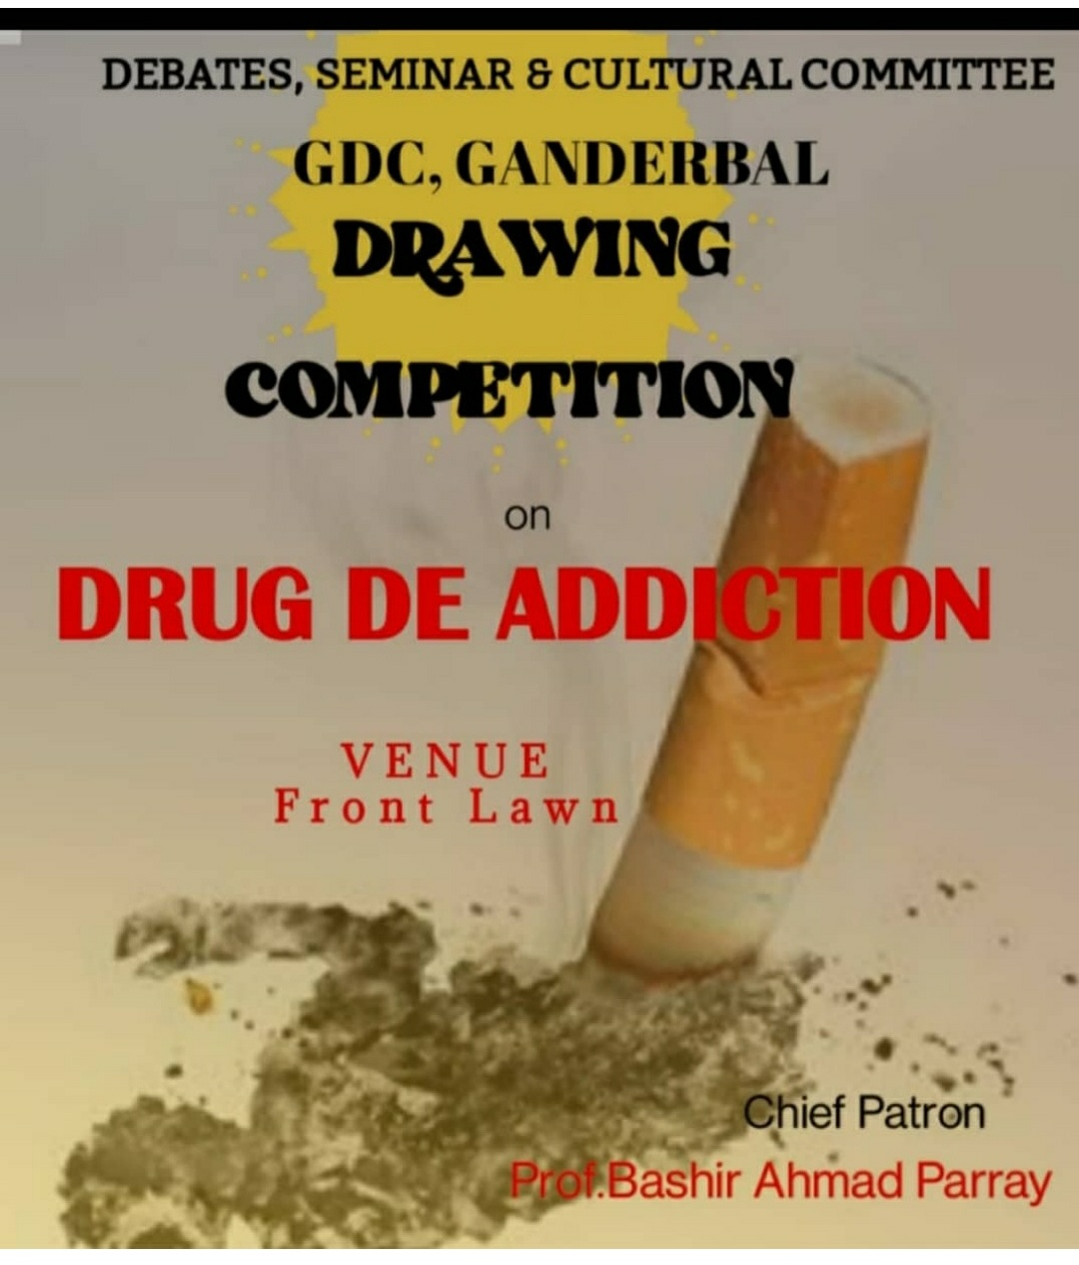
Event Flyer

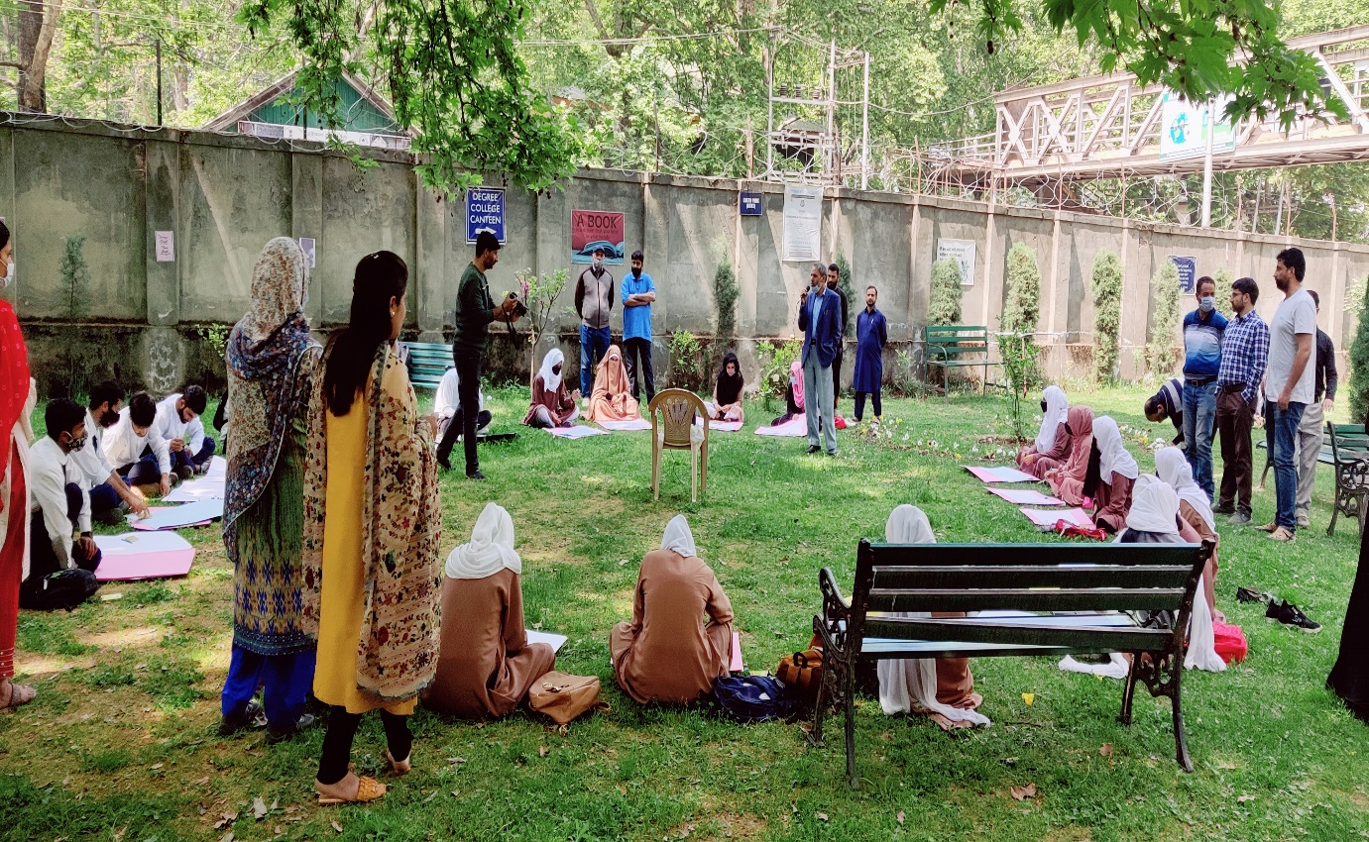
Principal, Prof. Bashir Ahmad Parray inaugurating the event

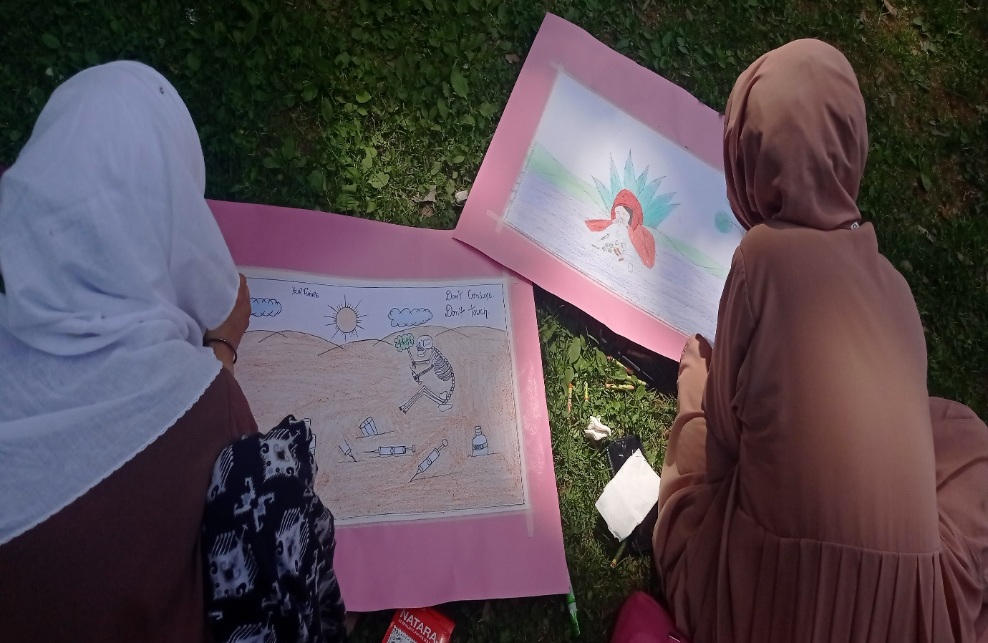
Students working on their drawings
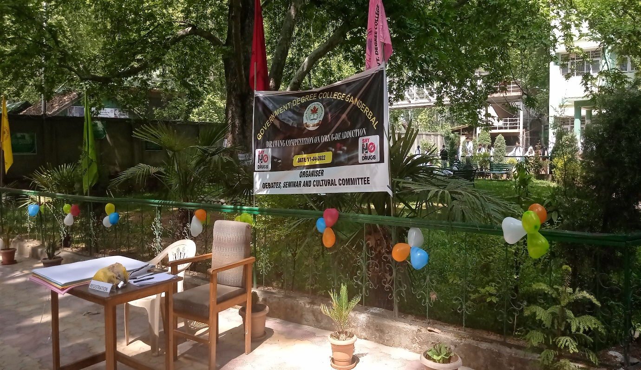
Registration counter

