Personality: Nature and Theories
Personality—it’s who we are. Our personalities determine how we act and react, as well as how we interact with and respond to the world. Despite much research, the origins of personality are still a mystery, though there are many theories which attempt to explain them. Some researchers propose that children inherit personality from their parents; others believe personality is fixed from birth. Some theories address how environment, genetics, and culture influence the development of personality.
What does it mean to have “personality”? Someone with personality could be funny, passionate, daring, extroverted, aggressive, egoistical, hot-tempered, or insecure. He or she might be altruistic, humble, mellow, shy, or wary. He or she might even be all or any of these things at different times and in different places, depending on the situation. Researchers have developed many ways of assessing personality, but even if we do gain an understanding of who we are, the question of why we’re that way remains.
A brief definition would be that personality is made up of the characteristics patterns of thoughts, feelings and behaviour that make a person unique. In addition to this, personality arises from within the individual and remains fairly consistent throughout life.

Early Philosophical Roots:
The word ‘personality’ originates from the Latin word persona, which means ‘mask’. Personality as a field of study began with Hippocrates, a physician in ancient Greece, who theorized that personality traits and human behaviours are based on four separate temperaments associated with four fluids of the body known as ‘humors’. This theory, known as humorism, proposed that an individual's personality was the result of the balance of these humors (yellow bile, black bile, phlegm, and blood), which corresponded to four dispositions (grumpy, melancholy, calm, and cheer, respectively).
While this theory is no longer held to be true, it paved the way for further discoveries and insight into human personality. Interestingly, several words in the English language that describe personality traits are rooted in humorism: ‘bilious’ means bad-tempered, which is rooted in humorists' thought that yellow bile was associated with grumpiness; ‘melancholic’ is from the Greek words for ‘black bile’, again rooted in humorists' thought that black bile was associated with depression. Similarly, ‘phlegmatic’ describes a calm personality and ‘sanguine’ (from the Latin for ‘blood’) a cheerful or playful one. A great deal of modern personality psychology is influenced by, and attempts to answer, the following five philosophical questions about what really determines personality:
➢ Freedom versus determinism: How much, if any, of an individual's personality is under their conscious control?
➢ Heredity versus environment: Do internal (biological) or external (environmental) influences play a larger role in determining personality?
➢ Uniqueness versus universality: Are individuals generally more alike (similar to each other) or different (unique) in nature?
➢ Active versus reactive: Is human behaviour passively shaped by environmental factors, or are humans more active in this role?
➢ Optimistic versus pessimistic: Are human’s integral in the changing of their own personalities (for instance, can they learn and change through human interaction and intervention).

Approaches to Study Personality:
Research into these five philosophical questions has branched into several different approaches to studying personality. The major theories include the psychodynamic, Neo-Freudian, learning (or behaviourist), humanistic, biological, trait (or dispositional), and cultural perspectives.
➢ Neo-Freudian theorists, such as Adler, Erikson, Jung, and Horney, expanded on Freud's theories but focused more on the social environment and on the effects of culture on personality.
➢ Psychodynamic theory, originating with Sigmund Freud, poses that human behaviour is the result of the interaction among various components of the mind (the id, ego, and superego) and that personality develops according to a series of psycho sexual developmental stages.
➢ Learning theories, such as behaviourism, regard an individual' actions as ultimately being responses to external stimuli. Social learning theory believes that personality and behaviour are determined by an individual's cognition about the world around them.
➢ Humanistic theory argues that an individual's subjective free will is the most important determinant of behaviour. Humanistic psychologists such as Abraham Maslow and Carl Rogers believed that people strive to become self-actualized— the "best version" of themselves.
➢ Biological approaches focus on the role of genetics and the brain in shaping personality. Related to this, evolutionary theories explore how variation in individual personality’s variance may be rooted in natural selection.
➢ Trait theorists believe personality can be conceptualized as a set of common traits, or characteristic ways of behaving, that every individual exhibits to some degree. In this view, such personality traits are different from person to person but within an individual are stable over time and place.
With any of these theories, it is important to keep in mind that the culture in which we live is one of the most important environmental factors that shapes our personalities. Western ideas about personality are not necessarily applicable to other cultures, and there is evidence that the strength of personality traits varies across cultures.

Definitions of Personality:

Personality is a set of individual differences that are affected by the development of an individual: values, attitudes, personal memories, social relationships, habits, and skills. Different personality theorists present their own definitions of the words based on their theoretical positions. The term ‘personality trait’ refers to enduring personal characteristics that are revealed in a particular pattern of behaviour in a variety of situations.
Most of the definitions refer to a mental system – a collection of psychological parts including motives, emotions and thoughts. The definitions vary a bit as to what those parts might be, but they come down to the idea that personality involves a pattern or global operations of mental systems.
Leading personality theorists like Cattell (1950), Eysenck (1982), Allport (1961), Walter Mischel (1981) etc. have defined personality according to their theoretical viewpoints.

Lahey (1998) defines personality as “the sum – total of all the ways of acting, thinking, and feeling that are typical for that person and makes that person different from all other individuals”.

According to Cattell (1950), “Personality is that which permits a prediction of what a person will do in a given situation”.

Eysenck (1951) defines it as “more or less stable and enduring organization of a person’s character, temperament, intellect and physique which determines his unique adjustment to the environment”.

“Personality is the dynamic organization within the individual of those psycho-physical systems that determine his unique adjustments to his environment”.
- Gordon W. Allport

“Personality is a stable set of characteristics and tendencies that determine those commonalities and differences in the psychological behaviour (thoughts, feelings and actions) of people that have continuity in time and that may not be easily understood as the sole result of the social and biological pressures of the moment”. - Salvatore Maddi

“Personality should include both the person and the role”. - Fred Luthans

According to Floyd Ruch human personality includes:
a) External appearance and behaviour or social stimulus value.
b) Inner awareness of self as a permanent organizing force.
c) The particular pattern or organization of measurable traits, both ‘inner’ and ‘outer’.

“Personality is the entire mental organization of a human being at any stage of his development. It embraces every phase of human character: intellect, temperament, skill, morality and every attitude that has been built up in course of one’s life.”
- Warren and Carmichael

“Personality is an essence of human being.”
- Gordon Allport

“Personality consists of the distinctive patterns of behaviour that characterize each individual’s adaptation to the situation of his/her life.”
- Mitchel

“Personality is the set of psychological traits and mechanisms within the individual that are organized and relatively enduring and that influence his or her interactions with, and adaptations to, the intra psychic, physical, and social environments”.
- Larsen & Buss

“Personality is the organized, developing system within the individual that represents the collective action of that individual’s major psychological subsystems”.
- Mayer, 2007

“Personality refers to those characteristics of the person that account for consistent patterns of feelings, thinking, and behaving”.
- Pervin, Cervone & John

There is one central definition of personality in use today within our discipline. Although it is worded differently by various psychologists, its central idea remains the same.
The system of parts includes such components as motives, emotions, mental and self. It’s through behaviour of an individual that his/her personality can be observed, defined, understood and analyzed. In this comparative world emphasis is given to the positive or optimistic traits in an individual, these traits are considered to be mandatory, desirable and competitive. Undoubtly, people around the world insists and wish to see mostly the positive aspects of personality that have been identified and defined by psychologists all over the world. It is necessary to understand the meaning of personality.

Personality is something unique, specific and dynamic. It determines our thinking, reasoning and actions; it varies in degrees of achievement and motivation in an individual and makes him/her different from others.

Features or Ideas related to Personality:
Researchers have identified fifty different definitions of personality. They have categorized these definitions into five approaches and labeled them as follows:
• Omnibus: These definitions view personality as the “sum total”, “aggregated” or “constellation” of properties or qualities.
• Integrative and Configurationally: Under this view of personality, the organization of personal attributes is stressed.
• Hierarchical: These definitions specify the various levels of integration or organization of personality.
• Adjustment: This view emphasizes the adjustment (adaptation, survival, and evolution) of the person to the environment.
• Distinctiveness: These definitions stress the uniqueness of each personality.

Regardless of how personality is defined, certain ideas are generally accepted among psychologists. These are:

- Personality represents the ‘whole person’ concept. It includes perception, learning, motivation and more.
- Personality seems to be a case where the whole is greater than the sum of the parts.
- Personality always creates the synergistic effect.
- Personality emphasizes the person-situation interaction.
- Personality is a very diverse and complex psychological concept.
- Personality often implies social or interpersonal skills.
- Even though it is a stable pattern of characteristics and behaviours, personality is constantly developing and changing.
- The personality is a major influence on tendencies to behave. It helps to explain why specific behaviour occurs.
- Personality is an organized whole, otherwise the individual would have no meaning.
- Personality appears to be organized into patterns. These are top some degree observable and measurable.
- Although there is a biological basis to personality, the specific development is a product of social and cultural environments.
- Personality has superficial aspects, such as attitudes towards being a team leader and a deeper core, such as sentiments about authority or the protestant work ethic.
- Personality involves both common and unique characteristics. Every person is different from every other person in some respects, while being similar in other respects.
- Personality is possessed by every person.
- Personality is partially inborn and partially acquired.
- Personality is influenced by internal, external adjustment processes. It is dynamic rather than static.
- Personality can be described by characteristic behaviour traits or constellations of “related” traits.
- Personality predisposes an individual to certain behavioural patterns.
- Personality provides defenses-and outlets-for the self-concept and acquitted motives.

Allport’s 4,000 Traits:
Gordon Allport was one of the pioneers of formal personality psychology, and is considered a trait theorist. Allport in 1936 went through a dictionary and picked out more than 4,000 words that describe the human personality. While these would make up the greater toolbox of Allport’s trait theory, he was able to group them into three main categories, and believed that only a few traits really define who we are. He called these defining traits, Central Traits, a small number of traits that together dominate a person’s behavior. The traits share the makeup of a personality, and can be descriptions like shy, intelligent or honest. Coming in at a less influential level are Secondary Traits. These are aspects of a personality that may be situational, or of limited importance, such as disliking being in closed spaces or crowds.
Finally, Allport theorized that occasionally but notably, one central trait will emerge as a dominant force in a personality. He called this a Cardinal Trait, which becomes a person’s defining personality trait that overshadows all others.

Freud's Theory:
Personality involves several factors:
- Instinctual drives – food, sex, aggression
- Unconscious processes
- Early childhood influences (re: psychosexual stages) – especially the parents
Personality development depends on the interplay of instinct and environment during the first five years of life. Parental behaviour is crucial to normal and abnormal development. Personality and mental health problems in adulthood can usually be traced back to the first five years.
• Psychosexual Development:
People – including children – are basically hedonistic – they are driven to seek pleasure by gratifying the Id’s desires (Freud, 1920). Sources of pleasure are determined by the location of the libido (life-force).
As a child moves through different developmental stages, the location of the libido, and hence sources of pleasure, change (Freud, 1905).
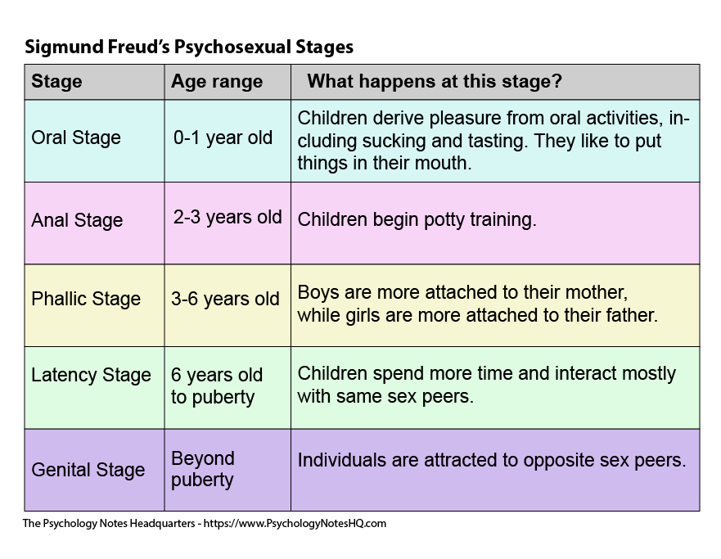
Environmental and parental experiences during childhood influence an individual's personality during adulthood.
For example, during the first two years of life the infant who is neglected (insufficiently fed) or who is over-protected (over-fed) might become an orally-fixated person (Freud, 1905).
• Tripartite Theory of Personality:
Freud (1923) saw the personality structured into three parts (i.e. tripartite), the id, ego and superego (also known as the psyche), all developing at different stages in our lives.
These are systems, not parts of the brain, or in any way physical.
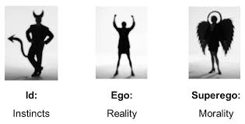

The id is the primitive and instinctive component of personality. It consists of all the inherited (i.e. biological) components of personality, including the sex (life) instinct – Eros (which contains the libido), and aggressive (death) instinct - Thanatos. It operates on the pleasure principle (Freud, 1920) which is the idea that every wishful impulse should be satisfied immediately, regardless of the consequences.
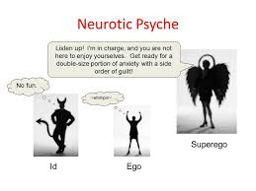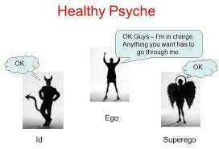

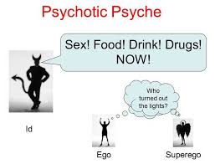

The ego develops in order to mediate between the unrealistic id and the external real world (like a referee). It is the decision making component of personality.
The ego operates according to the reality principle, working our realistic ways of satisfying the id’s demands, often compromising or postponing satisfaction to avoid negative consequences of society. The ego considers social realities and norms, etiquette and rules in deciding how to behave.
The superego incorporates the values and morals of society which are learned from one's parents and others. It is similar to a conscience, which can punish the ego through causing feelings of guilt.

Carl Rogers’s Person-Centered Theory:
Carl Rogers, a humanistic psychologist, proposed a theory called the person-centered theory. Like Freud, Rogers drew on clinical case studies to come up with his theory. He also drew from the ideas of Maslow and others. In Rogers’s view, the self-concept is the most important feature of personality, and it includes all the thoughts, feelings, and beliefs people have about themselves. Rogers believed that people are aware of their self-concepts.

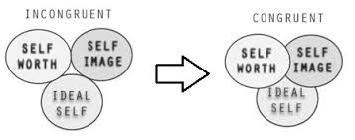

The Big Five Traits:
Costa, Jr., and Robert R. (Jeff) McCrae believe that all personality traits derive from five basic personality traits, which are commonly referred to as the Big Five:
Extraversion | Outgoing and stimulation-oriented  Vs.  Quiet and stimulation-avoiding
Neuroticism | Emotionally reactive, prone to negative emotions  Vs.  Calm, imperturbable, optimistic
Agreeableness | Affable, friendly, conciliatory  Vs.  Aggressive, dominant, disagreeable
Conscientiousness | Dutiful, painful, and orderly  Vs.  Laidback, spontaneous and unreliable
Openness to Experience | Open to new ideas and change  Vs.  Traditional and oriented toward routine.
The first of the five factors is extraversion. As is true of several traits, extraversion has different emphases in different measures. Sometimes it is based on assertiveness, sometimes on spontaneity and energy. Sometimes it is based in dominance, confidence, and agency, sometimes on a tendency toward happiness.
Extraversion is often thought of as implying sociability. Some see a sense of agency and a sense of sociability as two facets of extraversion others argue sociability is a byproduct of other features of extraversion a connection has also been drawn between extraversion and the approach temperament; some now view extraversion as reflecting relative sensitivity of a general approach system.
The second factor, neuroticism, concerns the ease and frequency with which a person becomes upset and distressed. Moodiness, anxiety, and depression reflect higher neuroticism. Measures often include items or facets pertaining to hostility and other negative feelings, but they are dominated by vulnerability to experiences of anxiety and general distress. Neuroticism has been linked to the avoidance temperament discussed above, suggesting that anxiety and sensitivity to threat is indeed in its emotional core.
The next factor is agreeableness. Agreeable people are friendly and helpful, empathic, and able to inhibit their negative feelings. Agreeable people get less angry over others' transgressions than do less agreeable people, and this seems to short-circuit aggression. At the opposite pole is an oppositional or antagonistic quality. People low in agreeableness use displays of power to deal with social conflict. Agreeableness as a dimension is often characterized as being broadly concerned with the maintaining of relationships.
The most commonly used label for the next factor is conscientiousness, although this label does not fully reflect the qualities of planning, persistence, and purposeful striving toward goals that are part of it. Other suggested names include constraint and responsibility, reflecting qualities of impulse control and reliability. Specific qualities included in this trait vary considerably across measures.
The fifth factor, most often called openness to experience, is the one about which there is most disagreement on content. Some measures (and theories) imbue this factor with greater overtones of intelligence, terming it intellect. It involves curiosity, flexibility, imaginativeness, and willingness to immerse oneself in atypical experiences (for a review of its involvement in social experience.
The Big Five traits remain quite stable over the life span, particularly after the age of thirty. Although researchers have identified the Big Five traits by using a list of English words, these traits seem to be applicable in many.

