UNDERGRADUATE COURSE
SUBJECT: PSYCHOLOGY.
SEMESTER: BG FIRST.
PAPER: Foundations of Psychology.
TOPIC: MEMORY.
LESSON: MEMORY-PROCESSES; INFORMATION PROCESSING MODEL.

Introduction:
Welcome students and very good Moring today we will discuss about human memory. So for as the objectives of the todays lecture is concerned we start with the importance of memory in our life then we proceed to define the memory, basic processes of memory and finally we shall go through information processing model of memory.
Life is all memory, except for the one present moment that goes by so quickly you hardly catch it going? our memory of the past not only provides a record of a lifetime of events we have experienced and knowledge we have learned, but also even affects “each passing moment” by enabling us to do things that are happening “right now,” such as having conversations, solving problems, and making decisions.
Importance:
So for as the importance of memory is concern, if the question is asked to many people regarding the use of memory answer to this will vary from individual to individual depending upon their work and profession for example students may react to this question, as memory is used to store the study material which learned and will be helpful is facing examinations. Remembering mobile numbers etc. similarly other people like politicians, scientists, and common people will give different answers. But it is not just enough to cover the importance of memory.
Perhaps the most powerful way to demonstrate the importance of memory is to consider what happens to people’s lives when they lose their memory. Consider, for example, the case of Clive Wearing (Annenberg, 2000; D. Wearing, 2005). Wearing was a highly respected musician and choral director in England who, in his 40s, contracted viral encephalitis, which destroyed parts of his temporal lobe that are important for forming new memories. Because of his brain damage, wearing lives totally within the most recent one or two minutes of his life. He remembers what just happened and forgets everything else. When he meets someone, and the person leaves the room and returns three minutes later, Wearing reacts as if he hadn’t met the person earlier. Because of his inability to form new memories, he constantly feels he has just become conscious for the first time.
Meaning:
Memory is the processes involved in retaining, retrieving, and using information about stimuli, images, events, ideas, and skills after the original information is no longer present. The fact that memory retains information that is no longer present means that we can use our memory as a “time machine” to go back just a moment—to the words which I used at the beginning of this sentence—or many years—to events as early as a childhood birthday party. This “mental time travel” afforded by memory can place you back in a situation, so you feel as though you are reliving it, even to the extent of experiencing feelings that occurred long ago. But memory goes beyond re-experiencing events. We also use memory to remember what we need to do later in the day, to remember facts we have learned, and to use skills we have acquired.
The Basic Processes of Memory:
There are three basic processes: getting the information into the memory system, storing it there, and getting it back out.
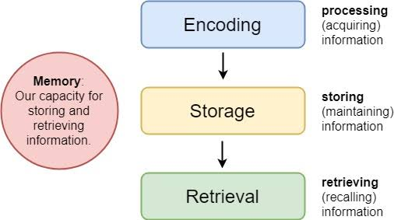
Putting it in (encoding)
The first process in the memory system is to get sensory information (sight, sound, etc.) into a form that the brain can use. This is called encoding. Encoding is the set of mental operations that people perform on sensory information to convert that information into a form that is usable in the brain’s storage systems. For example, when people hear a sound, their ears turn the vibrations in the air into neural messages from the auditory nerve (transduction), which make it possible for the brain to interpret that sound.
Encoding is not limited to turning sensory information into signals for the brain. Encoding is accomplished differently in each of three different storage systems of memory. In one system, encoding may involve rehearsing information over and over to keep it in memory, whereas in another system, encoding involves elaborating on the meaning of the information—but let’s elaborate on that later.

Keeping it in (storage)
The next step in memory is to hold on to the information for some period of time in a process called storage. The period of time will actually be of different lengths, depending on the system of memory being used. For example, in one system of memory, people hold on to information just long enough to work with it, about 20 seconds or so. In another system of memory, people hold on to information more or less permanently.
Getting it out (retrieval):
Retrieval refers to locating information in storage and assessing that information. It is, getting the information out of storage. Memory would be useless without the ability to retrieve the memories that we have created.
Information processing model.
Information-processing model of memory assumes that processing of information for memory storage is similar to the way a computer processes memory in a series of three stages. The most prominent information processing model of memory was designed by Richard Atkinson and Richard Shiffrin (1968). The information-processing model assumes that the length of time that a memory will be remembered depends on the stage of memory in which it is stored.
Richard Atkinson and Richard Shiffrin (1968). This model called the modal model of memory because it included many of the features of memory models that were being proposed in the 1960s. This model became extremely influential and shaped research on memory for many years. The stages in the model are called the structural features of the model. There are three major structural features:
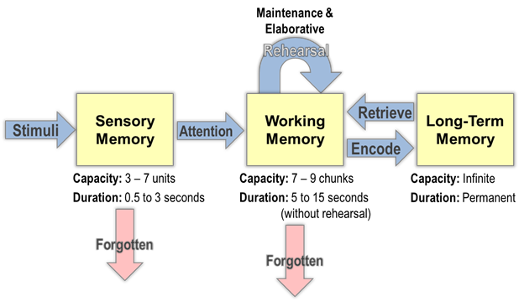

Sensory Memory: Sensory memory is an initial stage that holds all incoming information for seconds or fractions of a second. Sensory memory refers to the brief storage of sensory information. Unless it is attended to and passed on for more processing, the memory is quickly forgotten. The purpose of sensory memory is to give the brain some time to process the incoming sensations, and to allow us to see the world as an unbroken stream of events rather than as individual pieces.
Short Term Memory: Short-term memory (STM) is the system involved in storing small amounts of information for a brief period of time (Baddeley et al., 2009). Thus, whatever you are thinking about right now, or remember from what you have just listened, is in your short-term memory. Short-term memory (STM) is a temporary storage system that processes incoming sensory memory; sometimes it is called working memory. Short-term memory takes information from sensory memory and sometimes connects that memory to something already in long term memory. Short-term memory storage lasts about 20 seconds. George Miller (1956), in his research on the capacity of memory, found that most people can retain about 7items in STM. Some remember5, some9, so he called the capacity of STM7plus or minus 2.
Chunking:
Miller introduced the concept of chunking to describe the fact that small units (like words) can be combined into larger meaningful units, like phrases, or even larger units, like sentences, paragraphs, or stories. A chunk has been defined as a collection of elements that are strongly associated with one another but are weakly associated with elements in other chunks.
Research has shown that chunking in terms of meaning can increase our ability to hold information in STM. Thus, we can recall a sequence of 5–8 unrelated words, but arranging the words to form a meaningful sentence so that the words become more strongly associated with one another increases the memory span to 20 words or more (Butterworth et al., 1990).
Long Term Memory:
The third stage of memory is long-term memory (LTM), the system into which all the information is placed to be kept more or less permanently. In terms of capacity, LTM seems to be unlimited for all practical purposes. Long term memory has a large capacity and contains memories that are decades old, in addition to memories that arrived several minutes ago. Atkinson shiffrin proposed that information stored in long term memory is relatively permanent, and not likely to be lost.
Control processes:
Atkinson and Shiffrin also described the memory system as including control processes, which are active processes that can be controlled by the person and may differ from one task to another. An example of a control process is rehearsal—repeating a stimulus over and over, as you might repeat a telephone number in order to hold it in your mind after looking it up in the phone book or on the Internet
Maintenance rehearsal is the process of repeating information mentally or out loud with the goal of keeping it in memory. We engage in maintenance rehearsal to keep something that we want to remember (e.g., a person’s name, e-mail address, or phone number) in mind long enough to write it down, use it, or potentially transfer it to long-term memory. If we continue to rehearse information, it will stay in STM until we stop rehearsing it, but there is also a capacity limit to STM.
Elaborative rehearsal is a way of transferring information from STM into LTM by making that information meaningful in some way (Postman, 1975).The easiest way to do this is to connect new information with something that is already well known.
Conclusion:
Memory is a system or process that stores what we learn for future use. Our memory has three basic functions: encoding, storing, and retrieving information. Encoding is the act of getting information into our memory system through automatic or effortful processing. Storage is retention of the information, and retrieval is the act of getting information out of storage and into conscious awareness through recall, recognition, and relearning. The idea that information is processed through three memory systems is called the Atkinson-Schifrin (A-S) model of memory. First, environmental stimuli enter our sensory memory for a period of less than a second to a few seconds. Those stimuli that we notice and pay attention to then move into short-term memory (also called working memory). According to the A-S model, if we rehearse this information, then it moves into long-term memory for permanent storage. Finally retrieval is the act of getting memories out of storage and back into conscious awareness. This is done through recall, recognition, and relearning.
Frequently Asked Questions (FAQS):
What is memory?
A: A cognitive processes of encoding storing and retrieving information.
What is information processing model?
A: Model which assumes that processing of information for memory storage is similar to the way a computer processes memory in a series of three stages.
Mention the three basic functions of memory
A: The tree basic functions or processes of memory are, encoding, storing and retrieving information.
What are the three stages of memory storage?
A: Sensory memory Short term memory. Long term memory.
What is maintenance rehearsal?
A: The process of repeating information to keep the information in STM.

Glossary:
Memory: The processes involved in retaining, retrieving, and using information about stimuli, images, events, ideas, and skills, after the original information is no longer present.
Cognition: The mental processes involved in perception, attention, memory, language, problem solving, reasoning, and making decisions.
Encoding: The process of acquiring information and transferring it into memory.
Storage: Storage is retention of the information.
Retrieval: The process of remembering information that has been stored in long-term memory.
Control processes: In Atkinson and Shiffrin’s modal model of memory, active processes that can be controlled by the person and may differ from one task to another. Rehearsal is an example of a control process.
Rehearsal: The process of repeating a stimulus over and over, usually for the purpose of remembering it that keeps the stimulus active in short-term memory.
Maintenance Rehearsal: The process of repeating information mentally or out loud with the goal of keeping it in memory.
Elaborative Rehearsal: Transferring information from STM into LTM by making that information meaningful in some way.
Chunking: Combining small units into larger ones, such as when individual words are combined into a meaningful sentence. Chunking can be used to increase the capacity of memory.
Sensory Memory: Sensory memory is an initial stage that holds all incoming information for seconds or fractions of a second.
Short-term memory: Short-term memory takes information from sensory memory and sometimes connects that memory to something already in long term memory. Short-term memory storage lasts about 20 seconds.
Long-term memory (LTM): the system into which all the information is placed to be kept more or less permanently.

