CURRICULUM VITAE
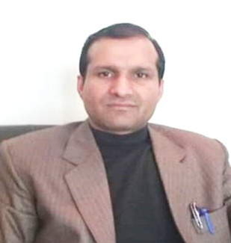
Dr. Mohammad Aslam Chowdhary

E-mail: draslam111@gmail.com
Government Degree College Mobile No.: +91-9419394999
Ganderbal, Kashmir- 191131

Personal Information
Father’s Name : Dr. Mohammad Aslam Chowdhary
Designation : Sr.Assistant professor
Department : Urdu
AREA of SPECIALISATION : Urdu Poetry
Date of Appointment : 19 - 12-2007
Date of joining : 26 - 12-2007
Ist posting : Govt. Degree College kargil (26-12-2007 to 9-10-2009
2nd posting : Govt. Degree College Thanamandi (19-10-2009 to 18-01-2010)
3rd posting : Govt. Degree College Ganderbal (05-02-2010 to till Date
Marital Status : Married
State of Domicile : Jammu and Kashmir
Nationality : Citizen of India
Area of Speclization : Urdu Poetry
Qualification
- M.A,Ph.D,NET
- Passed Matriculation (1994) from J&K Bose Jammu
- Passed TDC (1996) From J&K Bose Jammu
- Passed Graduation from university of Jammu in year 2000.
- Passed Post Graduation from university of Kashmir in year 2003-04.
- Awarded with PhD from university of Kashmir in year 2007

Research Work
- Research topic “ The effect of Urdu Gazal on Gojri Gazal”

Teaching Experience
- 11 Years

Oreintation Courses

- Participated in general orientation course organized by ASC university of Kashmir from 22-11-2010 To 20-12-2010

Refresher Courses

- Participated in Refresher Course (Special winter School) organized by UGC- Human resource development centre , university ok Kashmir from 15th of Feb, 21017 To 8th March 2017
- Participated in Refresher Course organized by UGC- Human Resource development Center, Aligarh Muslim university, Aligarh from 24th of October 2017 To 15th November 2017
Conferences
- Presented Paper in the two days international Conference held at PG College Rajouri on 10th of September 2017.
- Presented Paper in the Confrence Held at information office Kashmir organized by Director of field Publicity, ministry of information and broadcasting dehli on 25th of april 2017.
- Parcipated in first national congress held in pune (Maharashtra) india from September 23th to 25th of September 2016.

Seminars

- Presented paper in national seminar held on 11th &12th November 2017 at ST.johns College Agra organized by “Fakh Ruddin Ali Ahamad Memorial committee,Lacknow” on the topic of “Hussain Ahsan juzbi Saksh Wa Shayir”

